**The Mystery Powders Lab: Physical and Chemical Changes (28 pts)**

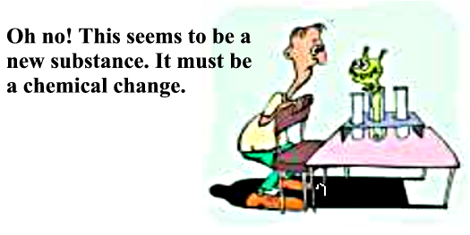

***Background Information:*** *You have learned how to describe matter based on its physical and chemical properties. You have also learned some clues that tell you whether a physical change or a chemical change is occurring. Remember a* ***physical change involves a change in a physical property but the substance does not change its identity. When a chemical change occurs a new substance is produced.*** *There are hints like a color change or fizzing (a gas) that indicate a chemical change has taken place because a new substance is produced.*

**Objective:** To determine the identity of four mystery powders which are similar in appearance by *observing a physical property (solubility) and a chemical property (reactivity).* You will also determine whether mixing these “mystery powders” with water, vinegar or iodine causes a physical or chemical *change.* **(2 pts)**

**Materials:**

**Procedure:**

**(Before starting get a good size piece of paper towel to use to clean the spatula in between stirring)**

1. Find the spatula labeled **“A”**. Using the cut end of the spatula scoop up a **very small** amount of **Powder “A”** and place it in **well #1**. The powder should just cover the bottom.
2. Place the same amount of **Powder “A”** in **well #5** and **well #9**.
3. Find the spatula labeled **“B**” for and place the same amount of **Powder “B”** in **well # 2, 6, and 10**.
4. Find the spatula labeled **“C”** and place the same amount of **Powder “C”** in **wells # 3,7,and 11**.
5. Find the spatula labeled **“D”.** Place **Powder “D”** in wells **# 4,8,and 12.**
6. Use an eyedropper to place **water** into the well **#1 so that it fills most of the well.** Use a spatula to stir the mixture. **RECORD YOUR OBSERVATIONS IN THE DATA TABLE.**
7. **Clean the spatula after stirring with a paper towel.**
8. Use the dropper in the **vinegar** bottle to add **10 drops** of vinegar to the **powder** in **well # 5.** Stir with spatula and **record observations.**
9. Use the dropper in the **iodine** bottle to add 10 drops of iodine to well **#9. BE CAREFUL BECAUSE IODINE WILL STAIN**. Stir with the metal spatula. **Record observations and WIPE THE SPATULA CLEAN WITH A PAPER TOWEL.**
10. Repeat the same process with the **Powder “B” (#2,6,10**), **Powder “C” (#3,7,11)** and the **Powder “D”(#4,8,12)**
11. **Always clean the spatula after stirring.**
12. **RECORD ALL OBSERVATIONS.**

**CLEAN UP**: 1. Rinse spot plate with water in the sink. Dry with paper towel.

2. Place all materials in box.

# SET UP DATA

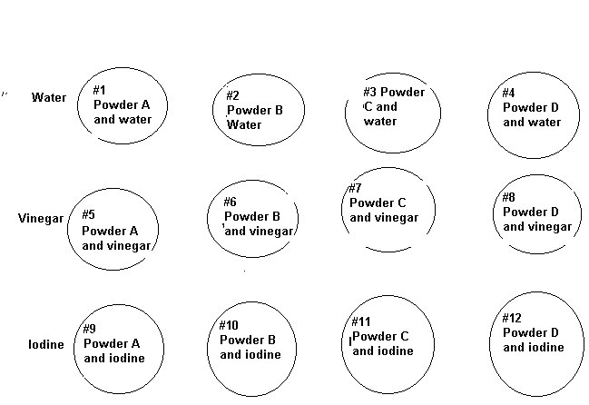

# TABLE 1: OBSERVATIONS (4 pts)

|  |  |  |  |  |
| --- | --- | --- | --- | --- |
| SUBSTANCE | **POWDER “A”** | **POWDER “B”** | **POWDER “C”** | **POWDER “D”** |
| **UNMIXED** | **White**  **Powder** | **White**  **Powder** | **White Powder** | **White Powder** |
| **MIXED WITH WATER** |  |  |  |  |
| **MIXED WITH VINEGAR** |  |  |  |  |
| **MIXED WITH IODINE** |  |  |  |  |
| **NAME OF SUBSTANCE** |  |  |  |  |

## TABLE 2: RESULTS (4 pts)

**PROPERTY:** SOLUBLE OR REACTIVE **CHANGE:**PHYSICAL OR CHEMICAL

|  |  |  |  |  |  |
| --- | --- | --- | --- | --- | --- |
| **SUBSTANCE** | |  |  |  |  |
| **MIXED WITH WATER** | **PROPERTY** |  |  |  |  |
| **CHANGE** |  |  |  |  |
| **MIXED WITH VINEGAR** | PROPERTY |  |  |  |  |
| CHANGE |  |  |  |  |
| **MIXED WITH IODINE** | PROPERTY |  |  |  |  |
| CHANGE |  |  |  |  |

**LAB QUESTIONS**

#### Complete in Cornell Note Style on Separate Page

1. How were all of the **unmixed** substances (baking powder, baking soda, cornstarch, and sugar) similar to each other in terms of their physical properties? **(2 pts)**
2. What was the only **physical property** that you tested? What is the definition of this physical property? **(2 pts)**
3. What was the only **chemical property** you tested? What is the definition of this chemical property? **(2 pts)**
4. Describe the difference between a physical change and a chemical change. **(2 pts)**
5. What clues did you see that indicated a chemical change? **(2 pts)**
6. What does fizzing indicate the formation of? **(2 pts)**
7. What does a color change indicate the formation of? **(2 pts)**
8. Explain how you were able to identify the mystery powders. **(2 pts)**
9. Explain why it was important to clean the plastic spatula after you stirred each powder in a liquid. **(2 pts)**

**STEP FURTHER (OPTIONAL, BUT EXTRA Credit) – (5 pts)**

Find the chemical formula for Baking Soda, Baking Powder, Cornstarch and Sugar (glucose). List the names of the elements that are found in each.

Find the chemical formula for water, vinegar, and iodine. List the elements that are found in each.

Which mystery powder is a combination of two of the other powders? Name the two powders that make it up and explain why you think this is true.

##### Mystery Powder Data

|  |  |  |  |  |
| --- | --- | --- | --- | --- |
| Substance | Unmixed | **Mixed with water** | **Mixed with vinegar** | **Mixed with iodine** |
| **Baking Powder**  **(A)** | Fine white powder | Fizzing (reactive) | Fizzing (reactive with the water in vinegar) | Color change to greenish-black and fizzing (reactive) |
| Baking Soda (B) | Fine white powder | Dissolves in water (soluble) | A lot of fizzing  (reactive) | Dissolves in iodine (soluble) |
| Cornstarch (C) | Fine white powder | Does not dissolve in water-forms a white mixture (non-soluble) | Does not dissolve in vinegar- forms a white mixture (non-soluble) | Color change to purplish-black (reactive) |
| **Powdered Sugar**  (D) | Fine white powder | Dissolves in water (soluble) | Dissolves in vinegar (soluble) | Color change to greenish-brown or yellow (reactive) |