Electrochemistry - Galvanic Cells

Objectives:

Students will be able to

- Define oxidation and reduction in terms of loss or gain of electrons.
- Describe the operation of a galvanic cell (using such terms as anode, cathode, electron flow, salt bridge, and ions).
- Interpret the activity series in terms of elements that are more or less easily oxidized.
- Relate cell potential to the activity series.
- Build simple galvanic cells and measure cell potential.
- Describe, write, and balance anode and cathode half reactions.

Background:

One of the most important types of chemical reactions is the oxidation-reduction reaction (redox). Single replacements are examples of redox reactions you have encountered previously. An oxidation-reduction reaction involves the transfer of one or more electrons from one atom to another. The substance that loses electrons is being oxidized; the substance gaining electrons is reduced. All reduction reactions must occur with a corresponding oxidation (i.e. the electrons must come from somewhere). It is often useful to consider redox reactions in two parts called half reactions. Added together, these two half reactions make up the overall oxidation-reduction reaction:

A⁺ + e⁻ → A (reduction)
B → B⁺ + e⁻ (oxidation)
B + A⁺ → B⁺ + A (overall reaction)

Consider single replacement reactions in which you used the activity series of metals to determine whether a particular reaction would occur. In such reactions a metal in a salt was replaced by an elemental metal that was higher on the series or “more active.”
“More active” in this case means more readily oxidized.
A galvanic cell is an electrochemical device that can produce electrical energy from spontaneous oxidation-reduction reactions. All electrochemical cells have two electrodes, a cathode and an anode. Reduction always occurs at the cathode, and oxidation occurs at the anode. In galvanic cells the cathode is charged positive and the anode is negative. The identity of the anode and cathode when two different metals are used is determined by their relative position in the activity series. The electrode that is higher in the series (more easily oxidized) is the anode.
In this experiment you will construct a series of galvanic cells using metals and metal salt solutions. Each cell will consist of two half cells, each containing a metal electrode and its corresponding ion in solution (i.e. a piece of copper in a Cu²⁺ solution). Pairs of half cells will be connected together by a salt bridge which will supply inert cations and anions to each of the half cells, providing a pathway for ion flow (see diagram below). By examining your results, you will be able to place four metals on a list, which should correspond to the activity series.
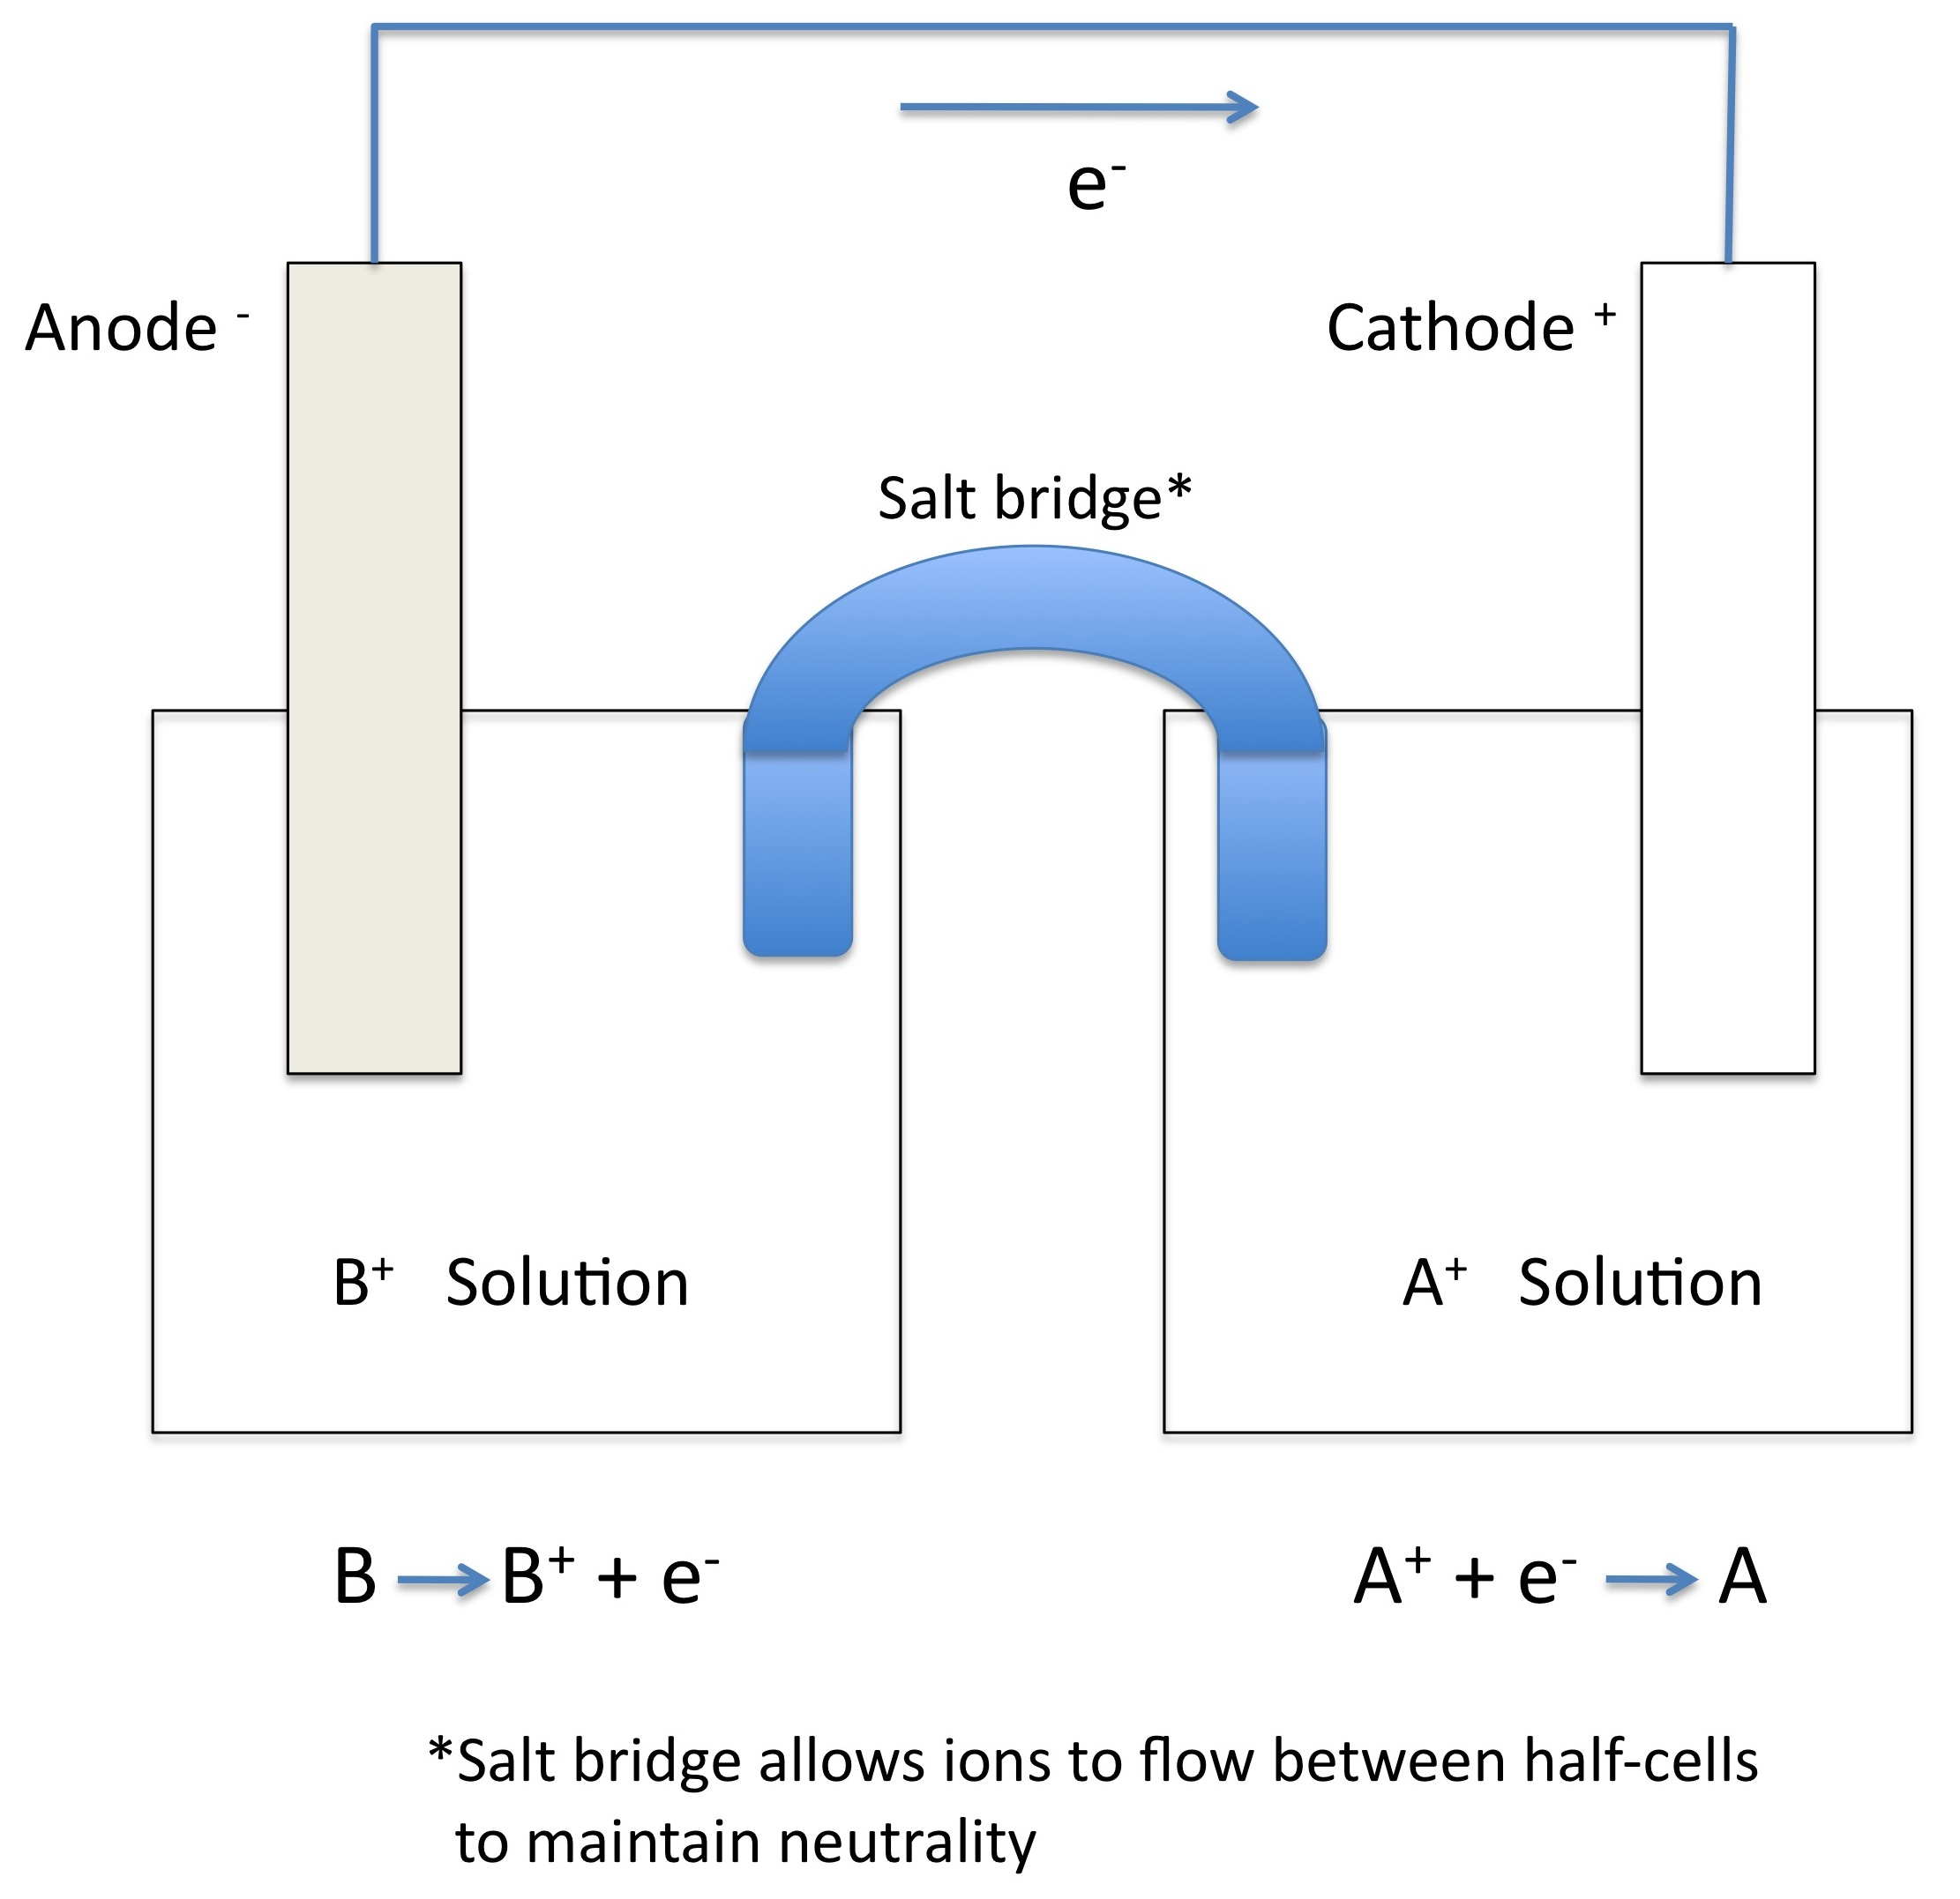

Materials:
- Voltmeter or multimeter w/ alligator clip wires
- One 12-well reaction plate
- Filter paper (for salt bridge) soaked in 1M KCl
- Small beakers for KCl
- Plastic forceps (for handling the salt bridge)
- 1-2 cm metal strips of Zn, Mg, Cu, and Sn
- 15 drops of each of the following .1M solutions: ZnSO₄, MgSO₄, CuSO₄, and SnCl₂
- Sandpaper (fine)

Procedure: Put on your goggles!

- Fill the wells you will use with15 drops of the appropriate metal ion solution.
(Recommended arrangement below)

1
Mg
2
Zn
3
Cu
4
5
Cu
6
Sn
7
Mg
8
9
10
11
12
- Identify each of the four metals you will use in the experiment.
- Clean each of the metal strips with sandpaper and place the on a piece of paper which identifies the metal
- Make a salt bridge by soaking a 2cm strip of filter paper in the KCl solution
Use the forceps. (Make separate salt bridges for each cell.)
- Select the two wells to be tested (See student worksheet), and place the salt bridge so that it is immersed in both solutions.
- Attach the alligator clips from the multi-meter to the metal strips of the corresponding solutions.
- Immerse the metal electrodes into their metal ion solutions and record the voltage.

Reference: Institute for Chemical Education (Chemistry Fundamentals), Mt. San Antonio College,
Walnut CA, 1995
Galvanic Cells Lab (Student Sheet)

Background:
Attach notes on redox and cells as given in class as part of an introduction to the lab.

Procedure:

1
Mg
2
Zn
3
Cu
4
5
Cu
6
Sn
7
Mg
8
9
10
11
12
- Place about 15 drops of solution in the indicated wells.
- For the wells to be tested, set up a salt bridge.
- Attach clip leads from multi-meter to metals. (Red + Black -)
- Immerse the metal electrodes in their metal ion solutions
and record the voltage.
(Note: be sure to use the correct metal electrode for each solution)

Data:
Cell | Anode  (Black -) | Cathode  (Red +) | Volts
A | Mg | Zn
B | Zn | Cu
C | Mg | Cu
D | Zn | Sn
E | Mg | Sn
F | Sn | Zn
G | Sn | Cu
H | Zn | Mg

Questions:

- Why is the salt bridge necessary?

- Which cell produced the highest (positive) voltage? Lowest?

How does this relate to the difference in “activity?” (Refer to the activity series)

- Examine your data. Was there a metal which was oxidized by each of the others? (Anode in a cell producing + voltage with all other metals)

Compare the voltages for the cells above and arrange the metals in order, from most easily oxidized (most “active”) to least.

- Explain cells F and H.

- Draw a diagram for cell C. Write the anode and cathode reactions.

- Wreckage of the iron ship Monitor was discovered in 1987, and scientists attached Zn anodes to protect it from corrosion. Why would this protect it?

