**POGIL- Stoichiometry**

*What happened to Avogadro when he got bit by 6.02 x 10 23 mosquitoes?*

*He got Mol-aria*

#### **How do chemists use balanced chemical equations?**

#### **Why?**

#### Chemists use balanced chemical equations as a basis to calculate how much reactant is needed or product is formed in a reaction. This is called **Stoichiometry- (stoi-key-ah-meh-tree)** Another way of looking at it is using the mole ratio from the balanced equation and information about one compound in the reaction to determine information about another compound in the equation. A **mole rati**o is a conversion factor derived from the coefficients of a balanced chemical equation interpreted in terms of moles. In chemical calculations, mole ratios are used to convert between moles one thing and moles of another.

**Purpose:** In this activity we will address the question: *How do I convert between different chemical species in a given reaction?*

**MODEL 1: Mole-to-Mole Stoichiometry (1-step)**

**Example: mole-to-mole**

**Question:** Given the following equation:

**1 N2 (*g*) + 3 H2 (*g*) → 2 NH3 (*g*)**

How many moles of H2 are needed to produce 34.8 moles of NH3?

Mole ratio

**Answer:**

34.8 mol NH3 3 mol H2__= 52.2mol H2

2 mol NH3

**Key Questions:**

1. What was the given in the example above?
2. Where did the $\frac{3 molH_{2}}{2 mol{NH}_{3}}$, come from?
3. Double check to see if 52.2 moles of H2 is the correct answer. SHOW the math below.
4. What units are mole ratios used to convert between? What should you write with the unit mol to distinguish between moles of one substance and another to ensure proper unit cancellation?

**You Try…**

1. Given the following chemical equation

4P + 5O2 🡪 2 P2O5

1. How many **moles of P2O5** are formed from **3.4 moles of** O2? SHOW the math below
2. How many **moles of P** are needed to react with **30.1 moles of O2**? SHOW the math below.

#### Aluminum reacts with copper(II) chloride to make aluminum chloride and copper

1. Write the balanced equation
2. Given 6 **moles** of CuCl2, how many **moles** of AlCl3 were made? SHOW the math below
3. If 4.5 **moles** of AlCl3 were made, how many **moles** of CuCl2 were used? SHOW the math below
4. Methane (CH4) and sulfur (S8) react to produce carbon disulfide and hydrogen sulfide, a liquid often used in the production of cellophane
5. Write the balanced equation
6. Calculate the **moles** of CS2 produced when 1.50 **mol** of S8 are used. SHOW the math below
7. How many **moles** of H2S are produced? SHOW the math below
8. Summarize model 1 in 2-3 sentences:

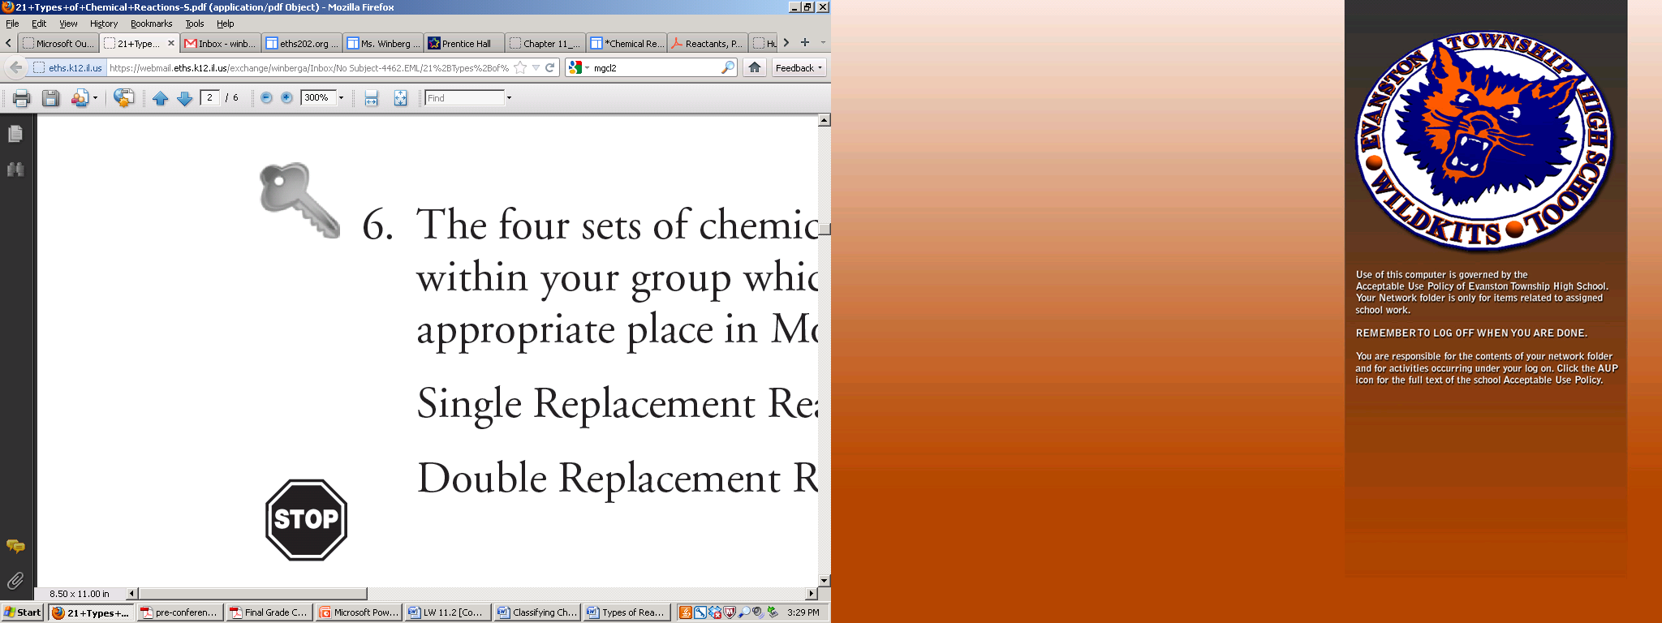

**MODEL 2: Mole $⟷$ Mass Stoichiometry (2-step)**

**Example: Starting with the mole**

Molar Mass H2

(2 x 1.0 g/mol) = 2.0 g/mol

**Question:** Given the following equation:

**1 N2 (*g*) + 3 H2 (*g*) → 2 NH3 (*g*)**

How many **grams of H2** are needed to produce **34.8 moles of NH3**?

Molar Mass

Mole ratio

**Answer:**

34.8 mol NH3 3 mol H2 2.0 g H2 = 104.4 g H2

2 mol NH3 1 mol H2

**Key Questions:**

1. What was the given in the example above?
2. Where did the $\frac{3 molH_{2}}{2 mol{NH}_{3}}$, come from?
3. Where did the, $\frac{2.0 gH_{2}}{1 molH_{2}}$ come from?
4. Look at the periodic table, how much does one mole of a Hydrogen atom weigh? Why is the molar mass of hydrogen (H2) 2.0 g/mol in the example 1 above?
5. Double check to see if 104.4 g H2 is the correct answer. SHOW the math below.
6. What units is the molar mass used to convert between?
7. Why did you have to start with a mole ratio when the question was asking for grams?

**You Try…**

1. Given the following chemical equation
2. P + 5O2 🡪 2 P2O5
3. What is the molar mass of P2O5? (use your periodic table). SHOW the math below
4. How many grams of P2O5 are formed from 3.4 moles of O2? SHOW the math below
5. Acetylene gas (C2H2) and calcium hydroxide are produced by adding water to calcium carbide(CaC2)
6. Write the balanced equation
7. What is the molar mass of acetylene, C2H2? **show your math below.**
8. How many **grams** of acetylene, C2H2, are produced by adding 3 **moles** of CaC2? **show your math below.**
9. What is the molar mass of CaC2? **show your math below.**
10. How many **grams** of CaC2 are needed to react completely with 490.0 **moles** H2O? **show your math below.**

**Example: starting with the mass**

**Question:** Given the following equation:

Molar Mass NH3

14 g/mol + (3 x 1.0 g/mol) = 17 g/mol

**1 N2 (*g*) + 3 H2 (*g*) → 2 NH3 (*g*)**

How many **moles of H2** are needed to produce **34.8 grams** of NH3?

Molar Mass

Mole ratio

**Answer:**

34.8 g NH3 1 mol NH3 3 mol H2 = 3.07 mol H2

17.0 g NH3 2 mol NH3

**Key Questions:**

1. What was the given in the example above?
2. Look at the periodic table, how much does Hydrogen weigh? Nitrogen?
3. Where did the $\frac{1 mol{NH}_{3}}{17 g {NH}_{3}}$, come from?
4. Where did the, $\frac{3 molH_{2}}{2 mol NH_{3}}$ come from?
5. Double check to see if 3.07 mol H2 is the correct answer. SHOW the math below.
6. Why was the molar mass used as the first conversion factor in this case? What is the purpose of the mol ratio?

**You Try…**

1. Given the following chemical equation
2. P + 5O2 🡪 2 P2O5
3. What is the molar mass of O2? **show your math below.**
4. How many **moles of P2O5** are formed from **3.4 grams of O2**? SHOW the math below
5. Titanium is a transition metal used in many alloys because it is extremely strong and light weight. Titanium tetrachloride is extracted from titanium(IV) oxide, using chlorine and coke (carbon). Carbon dioxide is also released.
6. Write the balanced equation
7. Calculate the molar mass of TiO2. **show your math below.**
8. How many **moles** of Cl2 gas are needed to react with 1.25 **grams** of TiO2 ? **show your math below.**
9. How many **moles** of C are needed to react with 1.25 **grams** of TiO2? **show your math below.**
10. Summarize model 2 in 3-4 sentences.

**MODEL 3: Mass $⟷$ Mass Stoichiometry (3-step)**

**Example**

Molar Mass H2

(2 x 1.0 g/mol) = 2.0 g/mol

**Question:** Given the following equation:

**1 N2 (*g*) + 3 H2 (*g*) → 2 NH3 (*g*)**

How many **grams of H2** are needed to produce **34.8 grams of NH3**?

Molar Mass NH3

14 g/mol + (3 x 1.0 g/mol) = 17 g/mol

Molar Mass

Mole ratio

Molar Mass

**Answer:**

34.8 g NH3 1 mol NH3 3 mol H2 2.0 g H2 = 6.14 g H2

17 g NH3 2 mol NH3 1 mol H2

**Key Questions:**

1. What was the given in the example above?
2. What are the 3-steps to solving the mass-to-mass problem above? (Note: these are always the same three steps!)
3. What unit is converted to first every time in a stoichiometry problem (if not given that unit)? Why?
4. Where did the $\frac{3 molH_{2}}{2 mol{NH}_{3}}$, come from?
5. Where did the, $\frac{2.0 gH_{2}}{1 molH_{2}}$ come from?
6. Where did the $\frac{1 mol {NH}_{3}}{17 g {NH}_{3}}$ come from?
7. Double check to see if 6.14 g H2 is the correct answer. SHOW the math below.

**You Try…**

1. Given the following chemical equation
2. P + 5O2 🡪 2 P2O5
3. What is the molar mass of P2O5? (use your periodic table)-**show your math below.**
4. What is the molar mass of O2? (use your periodic table)- **show your math below.**
5. How many **grams of P2O5** are formed from **3.4 grams of O2**? SHOW the math below
6. Use the following balanced equation:

1B2O3 + 3 Mg ---> 3 MgO + 2 B

1. Calculate the molar mass of B2O3.
2. How many **grams of B** can be obtained from **234 grams** of B2O3?
3. How many **grams of** **magnesium** are required to produce **40.0 grams of boron**?
4. One the reactions used to inflate automobile air bags involves sodium azide (NaN3):

___NaN3🡪 ___Na + ___N2

Balance and determine (calculate) the mass of N2, produced from the decomposition of 100.0 g NaN3. SHOW ALL WORK including how you get the molar masses.

