Measuring Transpiration Practical: Potometer Construction

In this lab, you will practice a technique for measuring transpiration in a plant. The primary goal of this practical experience is for you to familiarize yourself with the method, and to troubleshoot it. It would also be a good idea to try changing some variables to see their effects on transpiration rate.

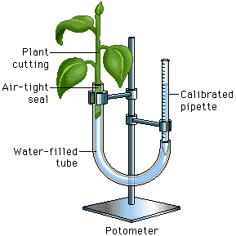More information on the technique as well as practice questions on the topic can be found here: <http://www.phschool.com/science/biology_place/labbench/lab9/intro.html>

The basic setup of a potometer for measuring transpiration can be seen to the left. Keep in mind that this technique could be useful if you wish to investigate transpiration for an internal assessment. Also, there are other methods of potometer construction that may be useful as well. Feel free to investigate. Page 405 and 406 in the IB biology book has another example of potometer construction that you should be familiar with.

Some important tips:

1. Cut a *leafy* shoot from a plant and plunge its base into water. This prevents the xylem from taking up any air. Wetting the leaves themselves will alter the rate of transpiration.
2. Immerse the whole of the potometer into the bucket of water. Move it about until all the air bubbles come out.
3. Re-cut the shoot's stem underwater. This ensures that no air bubbles are introduced into the xylem. While underwater, put the end of the shoot into one end of the plastic tubing and the calibrated pipette into the other end. The goal is to create airtight seals. After lifting the plant end out of the water, wrap it in plastic and/or grease the junction with plenty of petroleum jelly (Vaseline) to ensure an airtight seal.
4. Carefully lift the whole assembly out of the water to ensure that the water doesn’t spill out. Keep the plant end high so that water pressure doesn’t disrupt the seal.

**In Your Assignments Notebook:**

1. **Describe how to construct a potometer and make a diagram of the apparatus. Please also make any notes on important considerations when constructing a potometer.**
2. **Explain how the potometer works to measure transpiration, including the scientific principles involved.**
3. **Design an experiment to test a hypothesis about the effect of temperature or humidity on transpiration rates. You will not carry this out but must be able to design it using the lab format on my website (only do the Exploration Section).**
4. **Extra Points: Print out evidence of completing the following online activity:**

<http://www.phschool.com/science/biology_place/labbench/lab9/intro.html>

To earn the full extra points, you must answer each question, check your answers, and print the pages that have your answers on them. Then staple these pages together and place them in order in your notebook.