V. (Blackberry Solar Cell): Dye-Sensitized TiO₂ Solar Cell

Background:
A solar cell is a light sensitive material that can collect solar energy and convert it into electrical/chemical energy. In this lab you will create a solar cell that uses a process called “artificial photosynthesis.” The solar cell that you will create will be made of simple materials, TiO₂ paste (essentially white pigment), anthocyanin dye (from blackberry juice), electrolyte (I₂ – iodine and KI – potassium iodide), and conductive glass (it’s transparent, but acts like a metal).

A solar cell works similarly to a leaf on a plant. The chlorophyll dye (chlorophyll a) in a leaf absorbs solar energy and converts it into chemical energy (sugar), a solar cell takes solar energy and converts it into electrical energy.
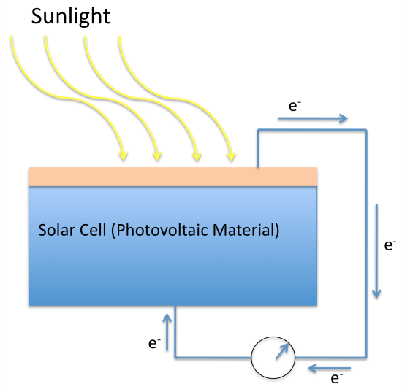
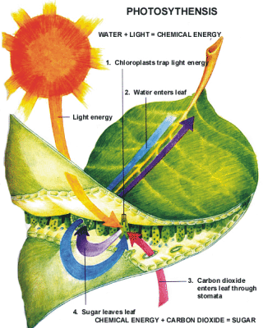

Blackberries contain a strongly light-absorbing dye molecule called anthocyanin, which occurs in many types of fruits and berries. It’s the compound that gives blackberries, raspberries, blueberries, and pomegranates their color. These dyes can be extracted and used in a dye-sensitized TiO₂ solar cell to absorb light and then convert the light into electrical energy.

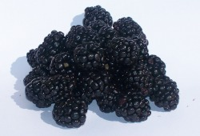

Brian O’Regan and Michael Grätzel at the Ecole Polytechnique Federale De Lausanne in Switzerland invented the dye-sensitized TiO₂ solar cell. This approach has many advantages over other solar energy conversion technologies because of its simple device construction and inexpensive TiO₂ particles and dyes that can be fine-tuned to increase their light absorbing properties. Although there is still much room for improvement, the state-of-the-art device converts solar energy into electricity with efficiencies over 10%, rivaling some Silicon-based technologies (commercial Silicon is typically around 10 – 15%). These devices use specially prepared dyes that absorb a great deal more sunlight than the anthocyanin dyes extracted from blackberry juice.

In this laboratory students will extract the dyes by crushing the plant material with a mortar and pestle (anthocyanin from blackberries and chlorophyll extracted from spinach leaves – chromatography of plant pigments) and then soak specially prepared electrodes that contain a thin layer of TiO₂ paste.

The electrodes are made using a paste of extremely small particles of TiO₂ (nanoparticles) that are spread out in a thin layer on transparent conductive glass electrodes. The particles provide a huge surface area for the dye molecules to stick to, and they provide an electron pathway for the generated electrical current to be collected. A significant portion of light is absorbed by the dye, even though only a single layer of dye molecules is attached to the surface. The dyed electrode goes from white to a dark purple.

The final steps include drying the electrode and then assembling the device with an additional electrode to form a “sandwich” solar cell. The device has two electrodes, the dyed TiO₂ photoelectrode (left side in the picture below – F:SnO₂) and a counter electrode. After the dye is excited with light, it gives an electron to the TiO₂ layer and then gets an electron back from an electrolyte solution. The electrolyte solution is composed of potassium iodide and iodine and provides electrons to the dye attached to the TiO₂ while generated current moves through an external load. The picture below shows the energetics of a finished blackberry-sensitized TiO₂ solar cell and it’s operation under sunlight illumination.
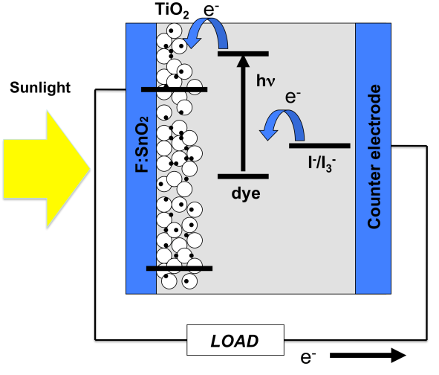

The solar conversion efficiency of these types of berry-sensitized TiO₂ solar cells can reach 0.7% with demonstration cells reaching 1-3 mA/cm² of photocurrent and 0.5 V when using an overhead projector as a simulated sun illumination source. Students typically see photovoltages well over 400 mV and demonstrated good photovoltaic cell stability.

Procedure Day 1:

Materials Needed for Day 1:

- 2X Transparent Conductive Glass Plates (FTO Electrodes)* One electrode is 2.5 cm length x 2 cm width and the second is 2.5 cm length x 1 cm width.
- Nanoparticle TiO₂ Paste* (This contains a mix of TiO₂ nanoparticles, water, and surfactant).
- 3M Scotch tape
- Paste spreader (this can be any rigid straight edge, i.e. glass stirring rod, glass slide, etc.)
- Graphite pencil

*Provided in DSSC kit

Preparing TiO₂ Electrode

1. Take provided single FTO glass electrode and ensure that the conductive side is facing up – use multimeter probes to measure resistance across two points on the glass surface. If no resistance is measured turn the electrode over and measure again. Typical resistances should be around 10-30 ohms. (Carefully handle the sides of the glass electrodes and avoid touching the faces of the electrodes.)

2. Tape the electrode down to a clean, sturdy surface so that the tape masks off about 0.5 cm down along the length of the electrode (Figure 1a). This will create a lane down the center of the electrode where the TiO₂ paste will be spread.

3. Using a pipette, drip a few drops of the TiO₂ solution halfway down the center of the plate and immediately squeegee the solution down with the paste spreader. The tape should act a bumper, allowing for an even coating of the FTO center lane (Figure 1b, c). Allow the electrodes to dry overnight undisturbed until the next lab period.
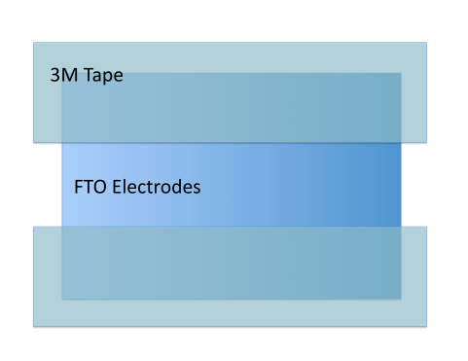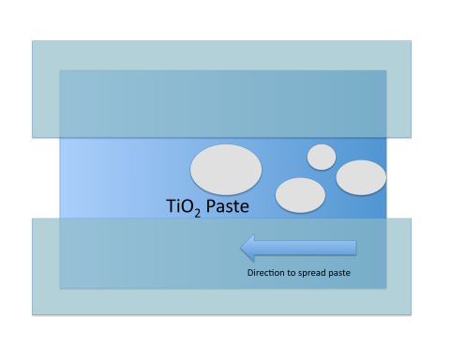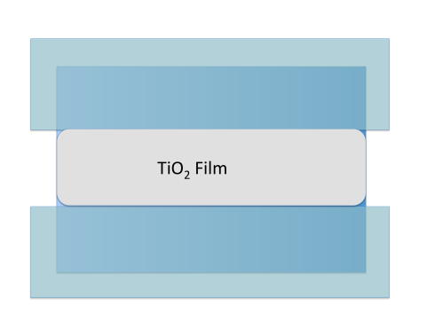
Figure 1 (a, b, c). Steps for depositing TiO₂ paste and “doctor blading”

4. Obtain a narrow piece of conductive glass—this will be the counter electrode. Use a multimeter to find the conductive side (see step 2). Use a pencil to coat electrode surface with graphite (pencil lead), (coat the entire electrode surface with graphite using a pencil).

Day 2 Materials:

TiO₂ electrode (made Day 1)  Counter electrode (made Day 1)  Multimeter (two alligator clips)  Hot plate  Mortar and pestle  1-2 blackberries  Glass pipet  2 binder clips | Waste beaker  Tweezers or beaker tongs  Chemicals:  Isopropyl alcohol (IPA)  ethanol  distilled water  electrolyte solution

Procedure (Day 2):

1. Remove the scotch tape from the dried TiO₂ electrode. Wipe off any remaining white paste off of the bottom of the glass by using isopropyl alcohol (IPA) and a paper towel.

2. Using tweezers carefully place the TiO₂ electrode onto a hot plate 15 minutes. It is ready when it turns bright white (~30 min.). (Do step 3 as you wait.) Use tweezers or tongs to remove the electrode from the hot plate, handling it only on the edges. Allow the electrode to cool for 15 minutes by setting it on the designated tray. (Caution: cooling too quickly can cause the glass electrode to fracture.)

3. As you wait, prepare the dye by thoroughly crushing 1-2 blackberries with a mortar and pestle.

4. Take the cooled electrode and place it white-side-down into the blackberry juice solution for 5 minutes. The white TiO₂ paste should turn purple throughout so there is no white left. Use metal tweezers or tongs to handle the electrode.

5. Using a beaker to catch your waste fluid, rinse the dyed TiO₂ electrode with the bottle of distilled water. Then rinse again with ethanol into the same waste beaker. Allow the dyed electrode to dry for 5-10 minutes.

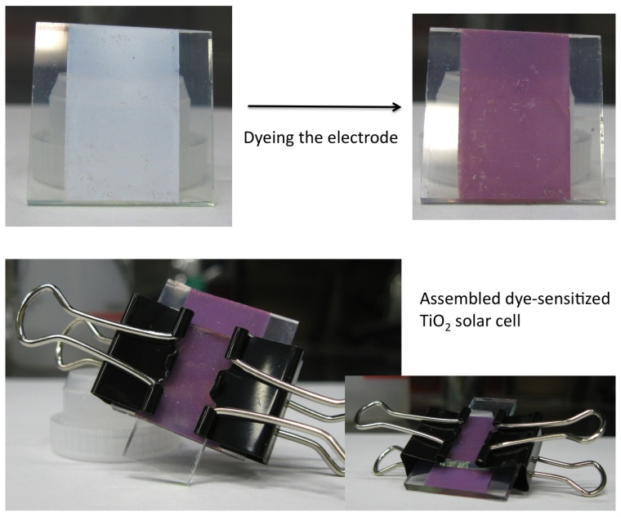
6. Assemble the dyed TiO₂ electrode (larger dyed electrode) with the counter electrode (the one with graphite) using 2 binder clips to form a sandwich thin film cell. Follow the picture to the right, and make sure the graphite coating is touching the purple dyed TiO₂ surface and avoid overlapping the bare glass electrodes (the sides). The thinner graphite coated electrode should line up with the TiO₂ line but is offset so that an alligator clip can be attached to each individual electrode.

7. Use a glass capillary tube to fill the space between the two electrodes with the electrolyte iodide/triiodide - (I⁻/I₃⁻) solution. The space between the glass electrodes should turn slightly yellow.

8. To test your solar cell, clip the positive terminus (red) of the multimeter probe to the graphite electrode and negative terminus (black) to the TiO₂ electrode. Measure the voltage and current obtained in room light, under the overhead projector and outside in the sunshine. Record your results in the data table. Don’t forget to record the weather conditions (sunny, cloudy, etc).

Data Table (include units for voltage and current)
 | Room light | Overhead projector light | Outside light  Weather conditions:
Voltage (V)
Currentt (mA)

Analysis Questions:

1. A Leaf and a solar cell both convert solar energy into another type of energy, what type does a solar cell make, what type does a leaf?

2. Where does the energy come from when we are using the solar cell? (What causes the electrons in the dye to move?)

3. When the dye loses an electron, is the dye oxidized or reduced?

4. How do electrons move in a leaf and what is the movement of electrons used for?

5. In what ways is the blackberry solar cell analogous to what happens in the light dependent reactions in the leaf? Be specific. In what ways is the solar cell different from the leaf? Be specific.

6.What side of the glass electrode did you apply the TiO₂ layer? (Conductive or nonconductive?)

7. Graphite is made up of layers of carbon. What is our source for graphite when we coat our counter-electrode with it?

8. The TiO₂ paste which is used for this lab to create thin film dye-sensitized solar cells is made up of tiny (nanometer sized – 25 nm) TiO₂ particles. One nanometer (nm) is one-billionth of a meter, or 0.00000001m; what is this number in scientific notation?

9. Why is it important to use nanometer-sized particles for the film? Use the words “surface area” in your explanation and include an illustration.

10. The TiO₂ paste is white and used in many commercial products: white paint, toothpaste, powdered doughnuts, etc. Why do we need to use the dark-colored dyes from blackberries to make our solar cell work? (Hint: Think about how light is reflected or absorbed.)

11. Draw in the direction in which the electrons move through the dye-sensitized solar cell in the potential energy diagram below. The photo-excitation arrow is included (light exciting the dye).
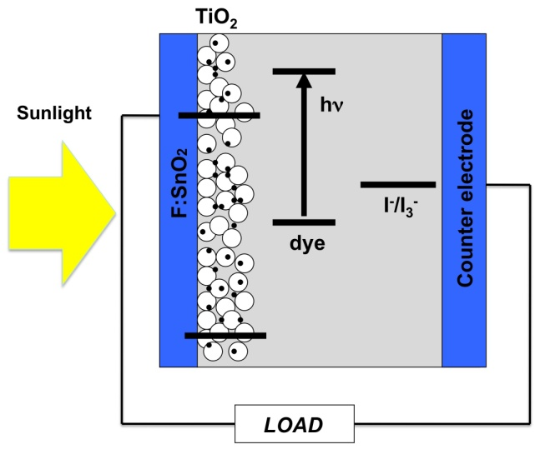

Inquiry Extensions: Dye-sensitized Solar Cell Lab:

The solar cells that have been constructed require a dye (the anthocyanin dye from the blackberry juice), TiO₂ nanoparticles (white paste), and electrolyte (I₂ and KI, iodine and potassium iodide) to function.

What are the effects of removing one or more of these components from the cell? Explain why each component is crucial for the operation of a dye-sensitized solar cell.

- The electrolyte (I₂ iodine and KI potassium iodide)
- TiO₂ nanoparticles
- Anthocyanin dye (from the blackberry juice)

The anthocyanin dye from the blackberry juice absorbs green light. What would happen if you filter the light that the solar cell is exposed to using a green filter? Red filter? Blue filter?

What is the effect of using dyes from other fruits/vegetables…i.e. raspberries, pomegranates, strawberries, beets, or the chlorophyll obtained in the chromatography of pigments laboratory? Note the color of the dyed electrode and the solar cell performance (current and voltage obtained). What are the active dyes in these fruits/vegetables?

Explain the similarities (via electron moving arrows) between the two energy level diagrams shown below with the galvanic cell laboratory on the right and the dye-sensitized cell diagram on the left. What does the large double arrow represent in each diagram? How is it created in each cell?

