Optional design LABS Internal Assessment Ideas/Questions

Instructions: Design your own lab to investigate some aspect of biology that you are interested in. You must determine the problem and variables that you will investigate and generate your own unique lab report.

*You must perform a real scientific investigation!
*You will write a complete lab report, following the IB Format as designated on my website!
* You will be graded on Design, DCP and CE!

Possible ideas:

Photosynthesis and Respiration and PLANTS

- Investigate one factor affecting the rate of respiration in a body of water, or in an organism.
- Investigate one factor affecting the rate of photosynthesis in a plant (aquatic or terrestrial)
- Investigate the role of different pigments.
Ecology

1. Investigate a factor affecting the dissolved oxygen in a body of water.
2. Investigate the effects of different amounts of dissolved oxygen on some aspect of the ecosystem
3. Investigate the hatching of brine shrimp eggs. Choose a specific factor to investigate.
4.Choose an aspect of an invertebrate species’ behavior to investigate and report on your findings.
5. Quadrat sampling of plant populations, choose a factor or area to investigate.
6. Estimate population sizes with capture-mark-release-recapture method.
7. Factor affecting mold growth on pita bread or some other substrate (Trader Joe’s brand is recommended)

Genetics

1. Investigate the inheritance patterns of Wisconsin Fast Plants. You choose what traits to look at.

Physiology
1. factor affecting reflexes, thought processing?
2. factor affecting blood pressure, heart rate
3. physiological effect of a stimulus on some aspect of physiology.

Plants
(Don’t do an experiment that is too similar to your 1st internal!)

1. Investigate one factor that affects the growth or development of Wisconsin fast plants.
2. Investigate a factor affecting some aspect of the growth/health of cuttings (red apple, other iceplants, etc.)
3. Investigate a factor affecting seed germination
Microbiology

- Investigate a factor affecting the growth of bacteria or other microorganism.
- Investigate the effectiveness of some antimicrobial agents.
- 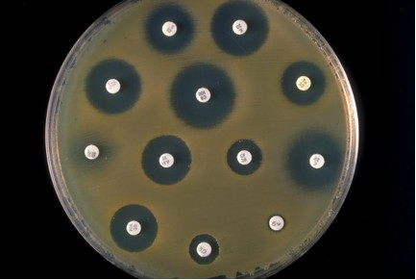

Chemistry of Life

1. Investigate a factor affecting an enzyme.

