Name the Following Creatures!
  1. ________________  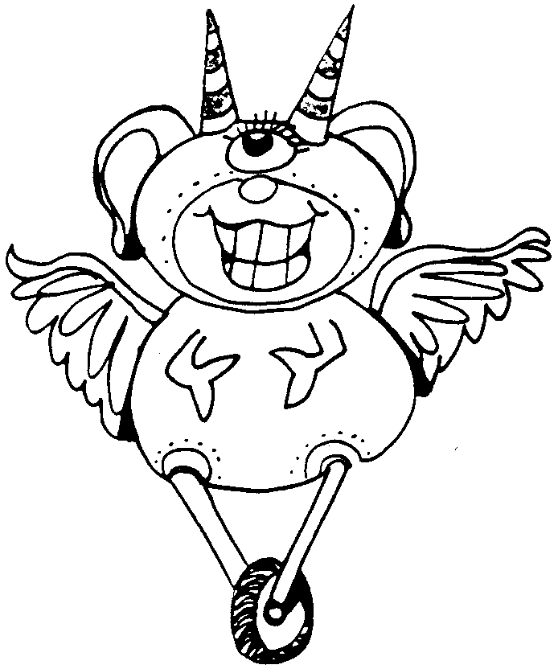  5. _________________  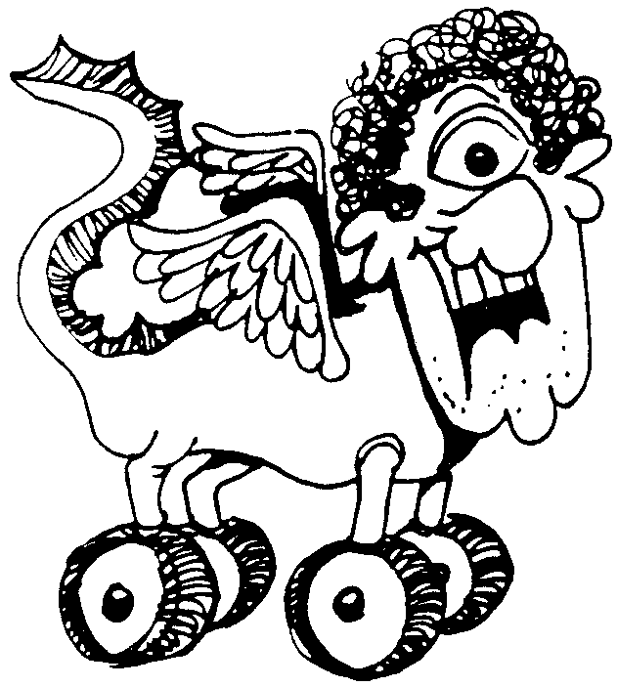  8. ___________________ | 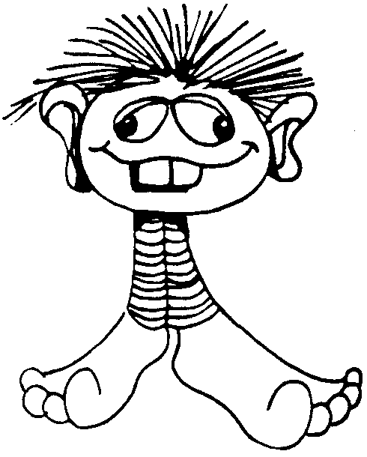  2. ________________    4. __________________  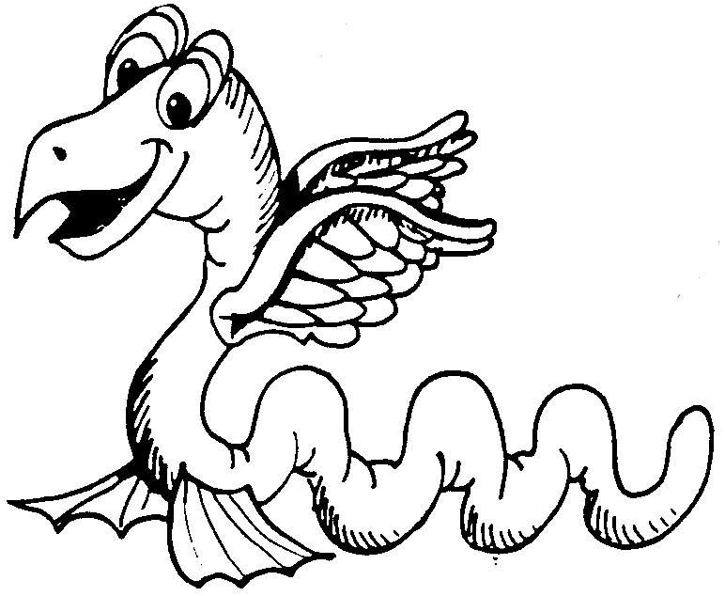  6. __________________    9. ___________________ | 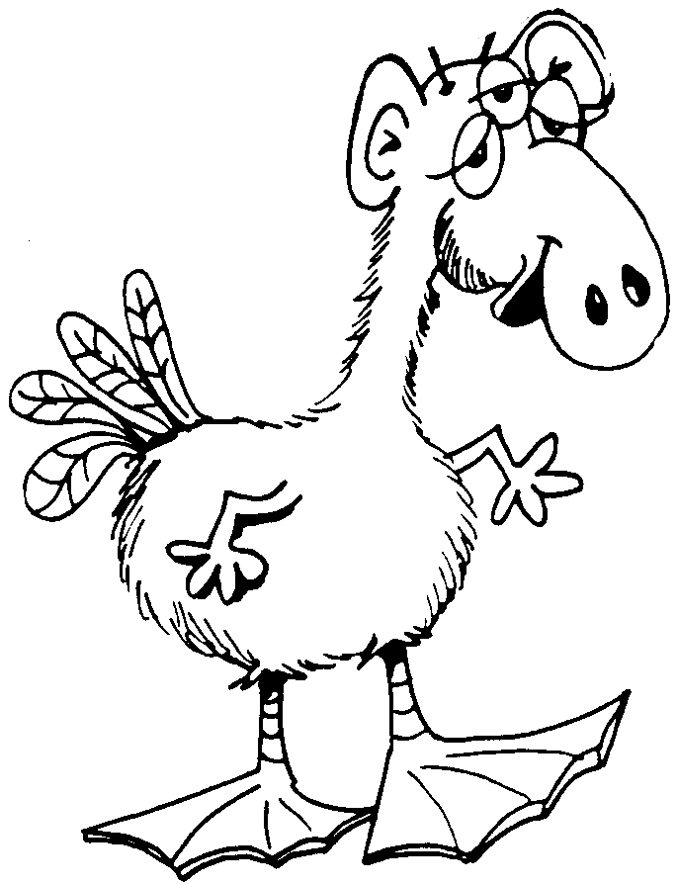  3. __________________    7. _________________  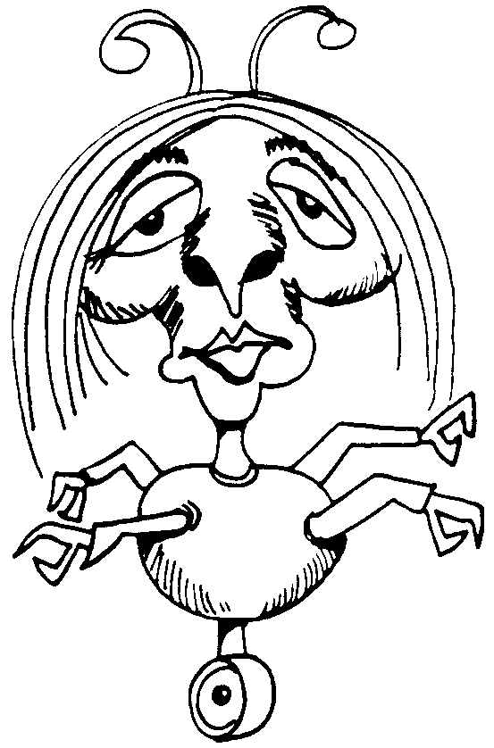  10. __________________
Dichotomous Key Activity
In science we use many helping aids to organize and easily retrieve information. This particular activity is a dichotomous key activity. A dichotomous key is a tool that scientists can use to help identify a particular specimen. The specimen could be a chemical that is identified by its physical properties, an insect identified by its markings and traits, or even a rock sample based on its different properties. The term dichotomous begins with the prefix of "di" which means two. The dichotomous key allows for the scientist to ask a series of questions with yes or no answers. Each question should be phrased so that the answer will either be yes or no. The following pages will show you an example of how to make a dichotomous key for the creatures, which you have just named, on the previous page.
Before you proceed to the next page you need to choose one of the creatures on the previous page. On the next page I will ask you a yes or no question about your creature. I have set this key up as an example. After this activity you will be expected to set up your own dichotomous key.
This activity was developed based on a seminar given by Michael Kobe of Hammond City School District at the 1999 Science Olympiad Summer Institute in Asilomar, CA. Images were taken from handout material given out by Mr. Kobe. http://www.lnhs.org/hayhurst/ips/dichot/index.htm
INSTRUCTIONS:
1. Write the names of your numbered creatures on a separate sheet of paper (keep these secret!)
2. Create a dichotomous key below (There should be instructions for both yes and no answers)
3. Exchange dichotomous keys and see if you can solve the names of each organism.

