The accompanying pedigree is for a rare, but relatively mild, hereditary disorder of the skin.
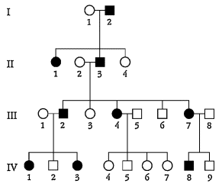
a. Is the disorder inherited as a recessive or a dominant phenotype? State reasons for your answer.
b. Give genotypes for as many individuals in the pedigree as possible. (Invent your own defined allele symbols.)
c. Consider the four unaffected children of parents III-4 and III-5. In all four-child progenies from parents of these genotypes, what proportion is expected to contain all unaffected children?

16. | The accompanying pedigree was obtained for a rare kidney disease.  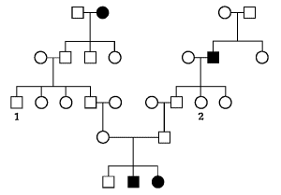  a. Deduce the inheritance of this condition, stating your reasons.  b. If individuals 1 and 2 marry, what is the probability that their first child will have the kidney disease?

The accompanying pedigree concerns a certain rare disease that is incapacitating but not fatal.
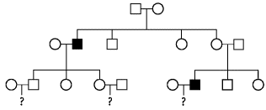
a. Determine the mode of inheritance of this disease.
b. Write the genotype of each individual according to your proposed mode of inheritance.
c. If you were this family's doctor, how would you advise the three couples in the third generation about the likelihood of having an affected child?

A man whose grandfather had galactosemia (a rare autosomal recessive disease) married a woman whose sister had galactosemia. The woman is now pregnant with their first child.
a. Draw the pedigree as described.
b. What is the probability that this child will have galactosemia?
c. If the first child does have galactosemia, what is the probability a second child will have it?

24. | A man whose grandfather on his mother's side had favism (a rare X-linked recessive sensitivity to broad beans) marries a woman whose uncle on her mother's side also had favism.  a. Draw the pedigree as described.  b. What is the probability that their first child will have favism?  c. If the first child does have favism, what is the probability a second child will have favism?

25. | The following pedigree is of a rare hereditary disease of the nervous system:  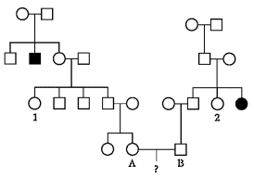  a. Do you think the disease is recessive or dominant? (Explain.)  b. Do you think it is autosomal or X-linked? (Explain.)  c. Under your scheme, what is the probability that the first child of the couple A and B will have the disease?

