**Biotechnology Journal Questions**

**1.** Explain the use of **two** named enzymes in biotechnology.(Total 8 marks)

**2.** Outline a basic technique for gene transfer involving plasmids.(Total 5 marks)

**3.** Outline a method for carrying out gene therapy, using a named example.(Total 8 marks)

**4.** Polygalacturonase (PG) plays an important role in fruit softening by making the pectin of the cell wall more soluble. It is synthesized only when the fruit is ripe.

In order to slow down the ripening of tomatoes (*Lycopersicon esculentum*), antisense RNA technology was used. Messenger RNA from untransformed and transformed fruit was hybridized to a radioactively labelled probe specific to the PG sense strand.

The results of a gel electrophoresis of mRNA are given below. (The size of the mRNA strands is expressed in kilobases, kb.) The histogram shows these results expressed as the percentage of PG mRNA in ripe untransformed fruit.

Lane 1: Ripe untransformed fruit  
Lane 2: Unripe untransformed fruit  
Lane 3: Ripe transformed fruit  
Lane 4: Unripe transformed fruit



[Source: Smith *et al., Nature*, (1988), **334**, pages 724–726]

(a) State the percentage of PG mRNA in ripe transformed fruit. (1)

(b) Compare the results obtained for ripe and unripe fruit.(2)

(c) Using the information provided, explain how the antisense technology affects transformed fruit.(3)

(Total 6 marks)

**5.** Discuss the potential benefits and possible harmful effects of genetic modification.

(Total 7 marks)

**6.** Potatoes with more starch have a lower percentage water content. This has an advantage in the transport, cooking and processing of potatoes.

In a strain of *Escherichia coli* scientists found an enzyme which increases the production of starch. Using biotechnology, the gene for this enzyme was transferred to potatoes, increasing their starch content (transgenic potatoes). The gene was transferred to three potato varieties to create three transgenic lines. The table shows the mean amount of starch and sugar contained in three lines of transgenic potatoes and normal potatoes (control), after storage for four months at 4C.

|  |  |  |  |
| --- | --- | --- | --- |
|  |  | **Carbohydrate / % of fresh weight** | |
| **Potato** | **Line** | **Sugar** | **Starch** |
|  | I | 0.60 | 11.07 |
| Transgenic | II | 1.56 | 11.61 |
|  | III | 1.46 | 12.74 |
|  | Mean | 1.21 | 11.81 |
|  | I | 5.14 | 5.88 |
| Control | II | 5.61 | 3.70 |
|  | III | 4.32 | 6.35 |
|  | Mean | 5.02 | 5.31 |

[Source: Stark *et al*, (1999), *Annals of the New York Academy of Sciences*, **792**, pages 26–36]

(a) State which line of transgenic potato has the greatest amount of starch.(1)

(b) (i) Compare the levels of carbohydrate between the transgenic lines and the control potatoes.(2)

(ii) Suggest reasons for these differences.(2)

Potato tubers were harvested from the field and stored in high humidity at 4C for three months. After this period, the tubers were stored at 16C, and samples were removed after 0, 3, 6 or 10 days, cut into strips, and fried. The colour of the fried potatoes was then measured and values reported using a 04 rating (light to dark), where a score of 2 or lower indicates acceptable colour. The results are shown in the table.

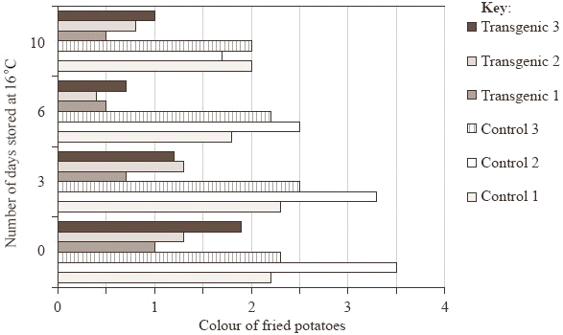

[Source: Stark *et al*, (1999), *Annals of the New York Academy of Sciences*, **792**, pages 26–36]

(c) Evaluate the effect of transferring the *E. coli* gene on the suitability of the potatoes for frying.(2)

An important part of storage management is to delay sprouting of potatoes. A second sample of potatoes was harvested from the field and stored at high humidity for three months at 4C. Storage temperature was then raised to 16C and a sample of potatoes were examined daily and scored for the number of sprouts longer than 0.5 cm. The number of days it took for 50% to sprout is indicated in the graph for control varieties (C1, C2 and C3) and three transgenic varieties (T1, T2 and T3) of potatoes.



[Source: Stark *et al*, (1999), *Annals of the New York Academy of Sciences*, **792**, pages 26–36]

(d) Deduce how the *E*. *coli* gene affects the storage of potatoes.(2)

(e) Discuss **three** possible harmful effects of genetically modified potatoes.(3)

(Total 12 marks)

**7.** Outline the process of DNA profiling (genetic fingerprinting), including ways in which it can be used.(Total 6 marks)

**8.** (a) State **two** procedures used for the preparation of a DNA profile.(1)

The following part of a DNA profile was used as evidence in a criminal investigation. DNA profiles of two suspects labelled S1 and S2 were compared to the DNA profile taken from the scene of the crime labeled E.

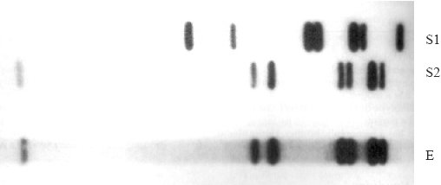

[Source: Solomon and Berg, (1995), *The World of Biology*, Saunders Harcourt Brace College, Publishers Orlando, page 238]

(b) Analyse the profiles to determine which suspect was present at the crime scene.(2)

(Total 3 marks)

**9.** Discuss the ethical arguments for and against the cloning of humans.(Total 4 marks)

**Remove bad question 10.** Weeds growing with crop plants can reduce yields because they compete for nutrients, water and sunlight. Synthetic chemical herbicides are often used to control these weeds. Herbicides are classified by the kinds of plants they kill and their mechanism of action. Broad-spectrum herbicides kill many different kinds of plants, but often kill the crop plant as well. Genetic engineering can create resistance to specific broad-spectrum herbicides which may solve the problem in crop plants.

Different genes from bacterial sources known to protect against the effects of individual herbicides were engineered into corn plants (*Zea mais*). The resistance of normal and genetically engineered corn plants was measured and compared by calculating the percentage of plants that survived for 200 days with regular herbicide treatments.

**Graph 1** Exposure of Normal and Resistant Plants to Different Herbicides



|  |  |  |
| --- | --- | --- |
|  | ***Herbicide*** | ***Resistant Genes*** |
| GP | Glyphosate | GP-R |
| BR | Bromozymil | BR-R |
| GU | Glufosinate | GU-R |
| SU | Sulfonylurea | SU-R |

(a) (i) Calculate the difference between the survival of engineered plants and normal plants treated with Glyphosate (GP).(1)

(ii) Identify the engineered plant which shows the greatest difference in resistance to herbicide treatment.(1)

(iii) Suggest a reason for the difference in survival of the normal plants treated with Glyphosate (GP) and Bromozymil (BR).(1)

(b) (i) Define the term *genetically modified crop*.(1)

(ii) State an example of a genetically modified plant other than corn.(1)

The graph below represents data from experiments in which plants were genetically engineered with more than one resistance gene.

**Graph 2** Exposure of resistant plants to combinations of herbicides



(c) (i) Using both graphs, compare the data for BR-R with the data for SU-R, and for BR-R + SU-R in the same plant.(2)

(ii) Suggest a possible reason for these results.(1)

(d) Evaluate the effects on survival when combining two herbicide resistance genes in the same plant.(3)

(Total 11 marks)