**RESPIRATION DATA ANALYSIS AND ESSAY QUESTIONS**

**1.** The respiratory quotient (RQ) is a measure of the metabolic activity of an animal. It is the ratio of CO2 produced to O2 consumed. In general, the lower the RQ value the higher the energy yield. The RQ is dependent on the diet consumed by the animal. The following table lists the typical RQ values for specified diets.

|  |  |
| --- | --- |
| **Diet** | **RQ** |
| Lipid | 0.71 |
| Carbohydrate | 1.00 |
| Protein | 0.74 |

[Source: Walsberg and Wolf, *Journal of Experimental Biology,* (1995), **198**, pages 213–219. Reproduced by permission of The Company of Biologists Ltd]

In an experiment to assess RQ values for house sparrows, the birds were fed a diet of pure mealworms (beetle larvae) or millet (a type of grain).

The graph below shows the RQ values of a house sparrow fed on a high carbohydrate diet (millet) and a high lipid diet (mealworms).



[Source: Walsberg and Wolf, *Journal of Experimental Biology*, (1995), **198**, pages 213–219. Reproduced by permission of The Company of Biologists Ltd]

(a) Compare the RQ values for millet and mealworms between 1 hour and 6 hours after feeding.(2)

The expected RQ value for house sparrows metabolizing millet is 0.93. The expected value when metabolizing mealworms is 0.75.

(b) Explain why the expected RQ values for millet and mealworms are different.(2)

(c) Suggest reasons for

(i) the high initial RQ values for house sparrows fed on millet.(1)

(ii) the rapid fall in RQ values for house sparrows fed on millet.(1) (Total 6 marks)

**2.** At the start of glycolysis, glucose is phosphorylated to produce glucose 6-phosphate, which is converted into fructose 6-phosphate. A second phosphorylation reaction is then carried out, in which fructose 6-phosphate is converted into fructose 1,6-bisphosphate. This reaction is catalyzed by the enzyme phosphofructokinase. Biochemists measured the enzyme activity of phosphofructokinase (the rate at which it catalyzed the reaction) at different concentrations of fructose 6-phosphate. The enzyme activity was measured with a low concentration of ATP and a high concentration of ATP in the reaction mixture. The graph below shows the results.



(a) (i) Using **only** the data in the above graph, outline the effect of increasing fructose 6-phosphate concentration on the activity of phosphofructokinase, at a low ATP concentration.(2)

(ii) Explain how increases in fructose 6-phosphate concentration affect the activity of the enzyme.(2)

(b) (i) Outline the effect of increasing the ATP concentration on the activity of phosphofructokinase.(2)

(ii) Suggest an advantage to living organisms of the effect of ATP on phosphofructokinase.(1) (Total 7 marks)

**3.** (a) State **two** products of the process of glycolysis.(1)

(b) Explain the significance of polar and non-polar amino acids within the cell.(3) (Total 4 marks)

**4.** Explain the process of aerobic respiration including oxidative phosphorylation. (Total 8 marks)

**5.** Explain the similarities and differences in anaerobic and aerobic cellular respiration. (Total 8 marks)

**6.** Anaerobic respiration occurs in the absence of oxygen while aerobic respiration requires oxygen.

(a) State **one** final product of anaerobic respiration.(1)

(b) Complete the table showing the differences between oxidation and reduction.

|  |  |  |
| --- | --- | --- |
|  | **Oxidation** | **Reduction** |
| Electrons gained or lost |  |  |
| Oxygen or hydrogen gained or lost |  |  |

(2)

(c) The structure of a mitochondrion is shown in the electron micrograph below.

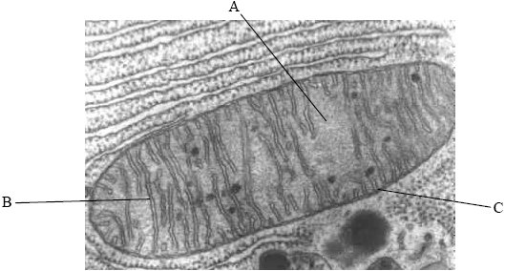

Name the parts labelled A, B and C and state the function of each.

Part A: Name: ..................................................................................................................

Function: .............................................................................................................

Part B: Name: ..................................................................................................................

Function: .............................................................................................................

Part C: Name: ..................................................................................................................

Function: .............................................................................................................

(3)

(Total 6 marks)

**7.** The diagram below shows possible pathways for the breakdown of glucose in various cells.



(a) State the names of processes Q and R. (2)

(b) Deduce the names of substances A and D. (2)

(c) State the organelle in which process R takes place.(1) (Total 5 marks)

**8.** (a) State **two** functions of proteins with a named example of each.(2)

(b) Explain chemiosmosis as it occurs during cell respiration.(2) (Total 4 marks)

**9.** (a) (i) Identify the cell organelle shown in the micrograph below.

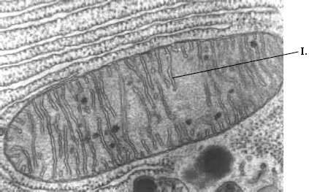(1)

(ii) Identify the structure labelled I above and explain how it is adapted for the organelle to function efficiently. (3)

(b) Describe the role of acetyl CoA in the metabolism of lipids.(2)

(Total 6 marks)

**10.** Explain the process of aerobic cellular respiration.

(Total 8 marks)