Topic 1: Statistical Analysis Practice IB Questions

- The data shows the number of flowers per flower head of a random sample from a white clover (Trifolium repens) population.
36
51
56
62
62
63
65
69
73
83
Mean = 62
Standard deviation = 12.5
What statistical percentage of the population has between 49 and 75 flowers per flower head?
A. 5 %
B. 32 %
C. 68 %
D. 95 %

- The masses of two different populations of sparrows (Passer domesticus) are shown in the table below.
Population 1:  mass of birds/ g | Population 2:  mass of birds / g
24.5 | 26.9
25.0 | 23.2
24.0 | 23.6
25.0 | 31.0
24.5 | 27.9
24.8 | 28.3
(i) Calculate the mean value of the mass of birds for population 1.
(ii) With reference to the data shown, explain what is meant by the term standard deviation. No calculation is expected.

3. To test how temperature affects growth, some plants were grown at 20°C and another group at 30°C . After a number of weeks, the height of the plants was measured. Explain how the t-test could be used to test the significance of the effect of temperature on plant growth.

4. Ten teenage boys, aged 17 or 18, estimated their body fat percentage by measurements of skin fold thickness. The estimates (%) were: 25.6, 12.9, 8.1, 10.2, 10.0, 8.9, 8.1, 15.3, 11.2, 13.7.
a) (i) Calculate the mean estimated body fat percentage
(ii) Calculate the standard deviation

The boys also measured their blood pressure. The boys whose estimated body fat percentages were higher tended to have higher blood pressure.
- (i) What is this type of relationship between two variables called?
(ii) Discuss whether this relationship proves that becoming obese causes high blood pressure.

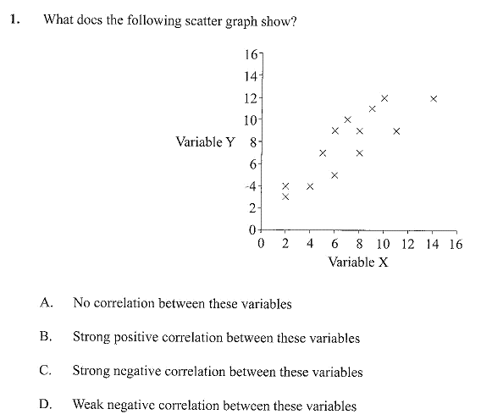
5.
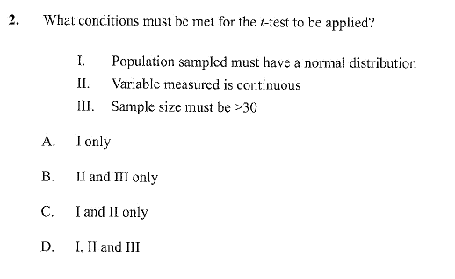
6.

