Statistical Analysis Practical Work Assignment

Overview: You will be directed to several web sites during this activity. Be sure to follow the instructions for each site. Please raise your hand to show me your work.

1) Part 1: Open Door Web Site: MS-EXCEL: USING IT AS A CALCULATOR I: USING PRESET FUNCTIONS: http://www.saburchill.com/IBbiology/ICT/dataprocessing/011.html

Instructions: On this web site, follow the tutorial to calculate the mean (average) and standard deviation of the provided data in Excel. You will need to create a new workbook in Excel. Note: the tutorial is 4 pages long!

2) Part 2: Mean, Standard Deviation, Graph, Error Bars and T-test:

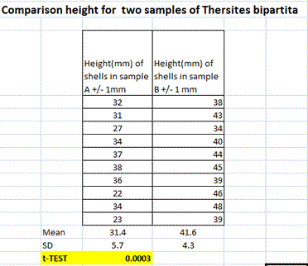
Instructions: Use the same Excel workbook for the following assignment (but enter your data in different cells!)

Step one: Using the data given to the right, make a clearly labeled data table.

Step two: Calculate the Mean (clearly labeled)

Step three: Calculate the Standard Deviation (clearly labeled)

Step four: Graph the data in Excel. Click Insert, Chart. Make a bar chart of your data (in Excel it is called a “column chart.” (you can preview your chart to see how it looks before making the whole thing—Click on “Press and Hold to View Sample.”)

Click the chart.

On the Chart menu, click Source Data, and then click the Data Range tab.

Click Series in rows or Series in columns.

Step five: Add error bars to your graph.

How?

Add error bars to a chart:

In Excel 2010, see this document: http://office.microsoft.com/en-us/excel-help/add-change-or-remove-error-bars-in-a-chart-HP010342159.aspx#BMadderrorbars )

In older versions of Excel, do the following steps:
- Click the data series to which you want to add error bars.
- On the Format menu, click Selected Data Series.
- On the X Error Bars tab or the Y Error Bars tab, select the options you want.
- Use your standard deviation as your error bars:
  - Click on the tab labeled "Y Error Bars" and click the button labeled "Custom:".
  - Then click on the icon to the right of the "+" field adjacent to the "Custom:" button. This will take you back to your Excel workbook to select a custom range of cells that contain the data for the error bars.
  - First click on cell the cell containing the desired standard deviation.
  - Then, while holding down the "control" key, click on the cell for the next desired standard deviation.
  - Then hit ENTER. Do this for both the “+” and “-“ fields.
Note: If you change the worksheet values or formulas associated with the data points in the series, the error bars are adjusted to reflect your changes.

Step six: Follow the directions in the tutorial below to perform a T-Test on the data.

Adapted from: http://click4biology.info/c4b/1/stat1.htm#ttest
The method described here is for Excel 2007 which calculates the the critical P value, but it is essentially the same for earlier versions of Excel.

T-Test Calculation : Screenshots from Excel 2007 (calculating P) Note: This process is very similar in other versions of Excel.
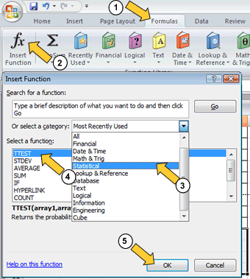
- In Excel 2007 the TTEST to calculate P is accessed by following the routine provided to the left.
- Note that his directly calculates P and not the t statistic
- After clicking OK, a dialog box opens (see below).
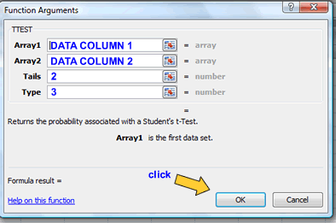
- Enter the settings as shown below, then click OK:

In biology the critical probability is usually taken as 0.05 (or 5%). This may seem very low, but it reflects the facts that biology experiments are expected to produce quite varied results.

Step seven: Answer the following questions in a new Microsoft Word Document

What is the mean and standard deviation of each sample?

Looking only at the mean and standard deviations of each sample, is there any difference between the two samples? Describe.

Imagine that the shells from sample A are from a different location than the shells in sample B. Explain what your graph suggests about the relationship between the location of a shell and the size of a shell. Would you classify this as a correlation or a causal relationship? Explain.

Explain the reason for performing a T-test.

What is the null hypothesis for this experiment? What is the alternative hypothesis?

Clearly explain the result of your T-test. What useful information does the test tell you?

SUMBMITTING YOUR WORK!

Before submitting your work, be sure to let me see it to make sure that everything is good.

Print your work and place it in your Biology Binder

