Name_______________________________
The Neuron
Use the words from the list below to label the following diagram of a neuron in the lines provided.
Word Bank
Axon - Cell Body - Dendrites – Myelin Sheath
Node of Ranvier - Nucleus - Synapse
* Draw in where you would find neurotransmitters *
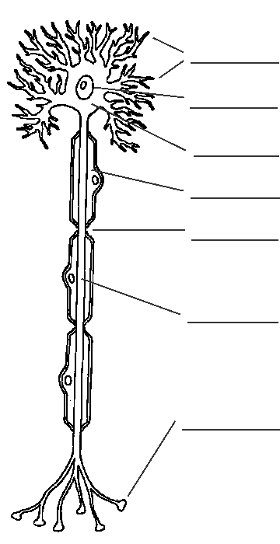

Below is a list of nervous system vocabulary terms. On the lines following each word, write out what that structure does (its function) and where it is located. Also, write or draw something to help you remember the each word’s meaning.
Neuron:______________________________________________________
_______________________________________________________________________________________
Axon:_________________________________________________________________
___________________________________________________________
Cell Body:____________________________________________________________
___________________________________________________________
Dendrites:____________________________________________________________
___________________________________________________________
Myelin:_______________________________________________________________
___________________________________________________________
Sensory Neuron:______________________________________________________
___________________________________________________________
Interneuron:______________________________________________________________
___________________________________________________________
Motor Neuron:______________________________________________________
___________________________________________________________
Synapse:____________________________________________________
_____________________________________________________________________
Neurotransmitters:______________________________________________________
___________________________________________________________
Central Nervous System (CNS):______________________________________________________
___________________________________________________________
Peripheral Nervous System (PNS):______________________________________________________
___________________________________________________________
*** Draw the organization of the nervous system as outlined on page 950 in your textbook

