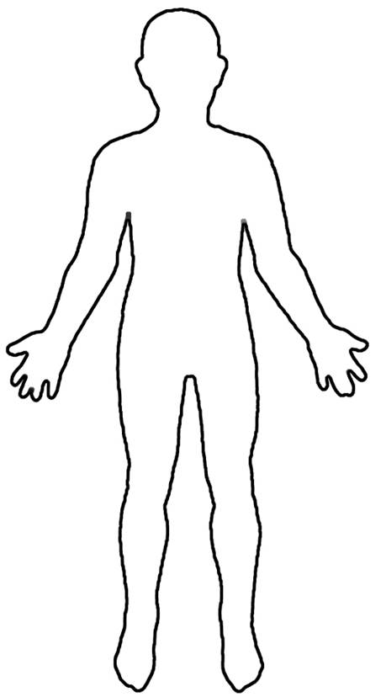
Draw and Label the Digestive System

A. Be sure to include the following organs:
- mouth
- esophagus
- stomach
- small intestine
- large intestine
- pancreas
- liver
- gall bladder

B. Show with arrows how the food flows through the digestive tract. (Remember, some organs don’t have food pass through them.)

C. Write the primary purpose of each organ next to it. Highlight or underline it.

The Digestive System
Across

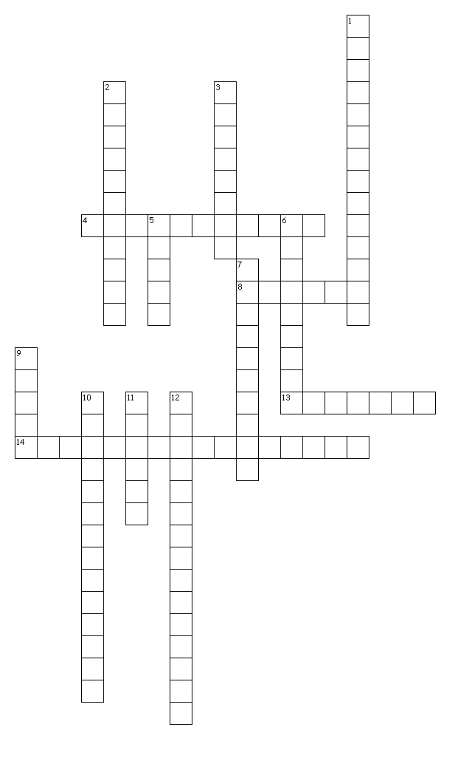
Down
1. This is where carbohydrates, lipids, proteins, and nucleic acids are broken down. Also, nutrients are absorbed here.
2. Involuntary smooth muscle contractions that move food through the digestive tract.
3. this organ makes several enzymes that are secreted into the small intestine.
5. This important organ produces bile, which is used to emulsify (break up) fats. It also filters and detoxifies the blood.
6. This muscular tube moves food down to the stomach.
7. This flap of cartilage prevents food from going into the trachea (windpipe)
9. This is where the digestion of starch (a carbohydrate) begins.
10. This organ is also called the colon. It absorbs water and some vitamins before the indigestible wastes are expelled.
11. This is the end of the colon that stores feces until they are ready to be expelled.
12. This enzyme breaks down starch in the mouth.
14 of 14 words were placed into the puzzle.
Created by Puzzlemaker at DiscoveryEducation.com

4. This organ stores bile until it is necessary to secrete it into the small intestine.
8. This stomach enzyme breaks down polypeptides (proteins).
13. This muscular organ is where the digestion of proteins begins.
14. This type of acid is found in the stomach.
Down
1. This is where carbohydrates, lipids, proteins, and nucleic acids are broken down. Also, nutrients are absorbed here.
2. Involuntary smooth muscle contractions that move food through the digestive tract.
3. this organ makes several enzymes that are secreted into the small intestine.
5. This important organ produces bile, which is used to emulsify (break up) fats. It also filters and detoxifies the blood.
6. This muscular tube moves food down to the stomach.
7. This flap of cartilage prevents food from going into the trachea (windpipe)
9. This is where the digestion of starch (a carbohydrate) begins.
10. This organ is also called the colon. It absorbs water and some vitamins before the indigestible wastes are expelled.
11. This is the end of the colon that stores feces until they are ready to be expelled.
12. This enzyme breaks down starch in the mouth.

