Lab: Graphing Practice in Biology (27 points) Name Pd

Problem: How are line, bar and pie graphs used to organize data in biology and how are those graphs made?

Background Information: Examining columns of numbers in a data table is time consuming and can be difficult. A graph will allow us to look for trends in data and form conclusions quickly. Almost every day we interpret graphs. A good graph provides a large amount of information quickly. There are three types of graphs that are used often in biology: line, bar and pie graphs.

Materials:

Pencil
Calculator
Ruler
Pens/pencils (3 colors)

Procedure:

Part A: Line Graphs
A line graph is the perfect tool to use when you want to illustrate how something changes over time or how one quantity changes in response to changing another quantity. The data that describe the change appear on the graph as dots, connected to form a line or curve. The line that connects all the dots together illustrates the relationship between the two factors in the experiment. On all line graphs, the dependent variable is on the vertical (y) axis, and the independent variable is on the horizontal (x) axis.
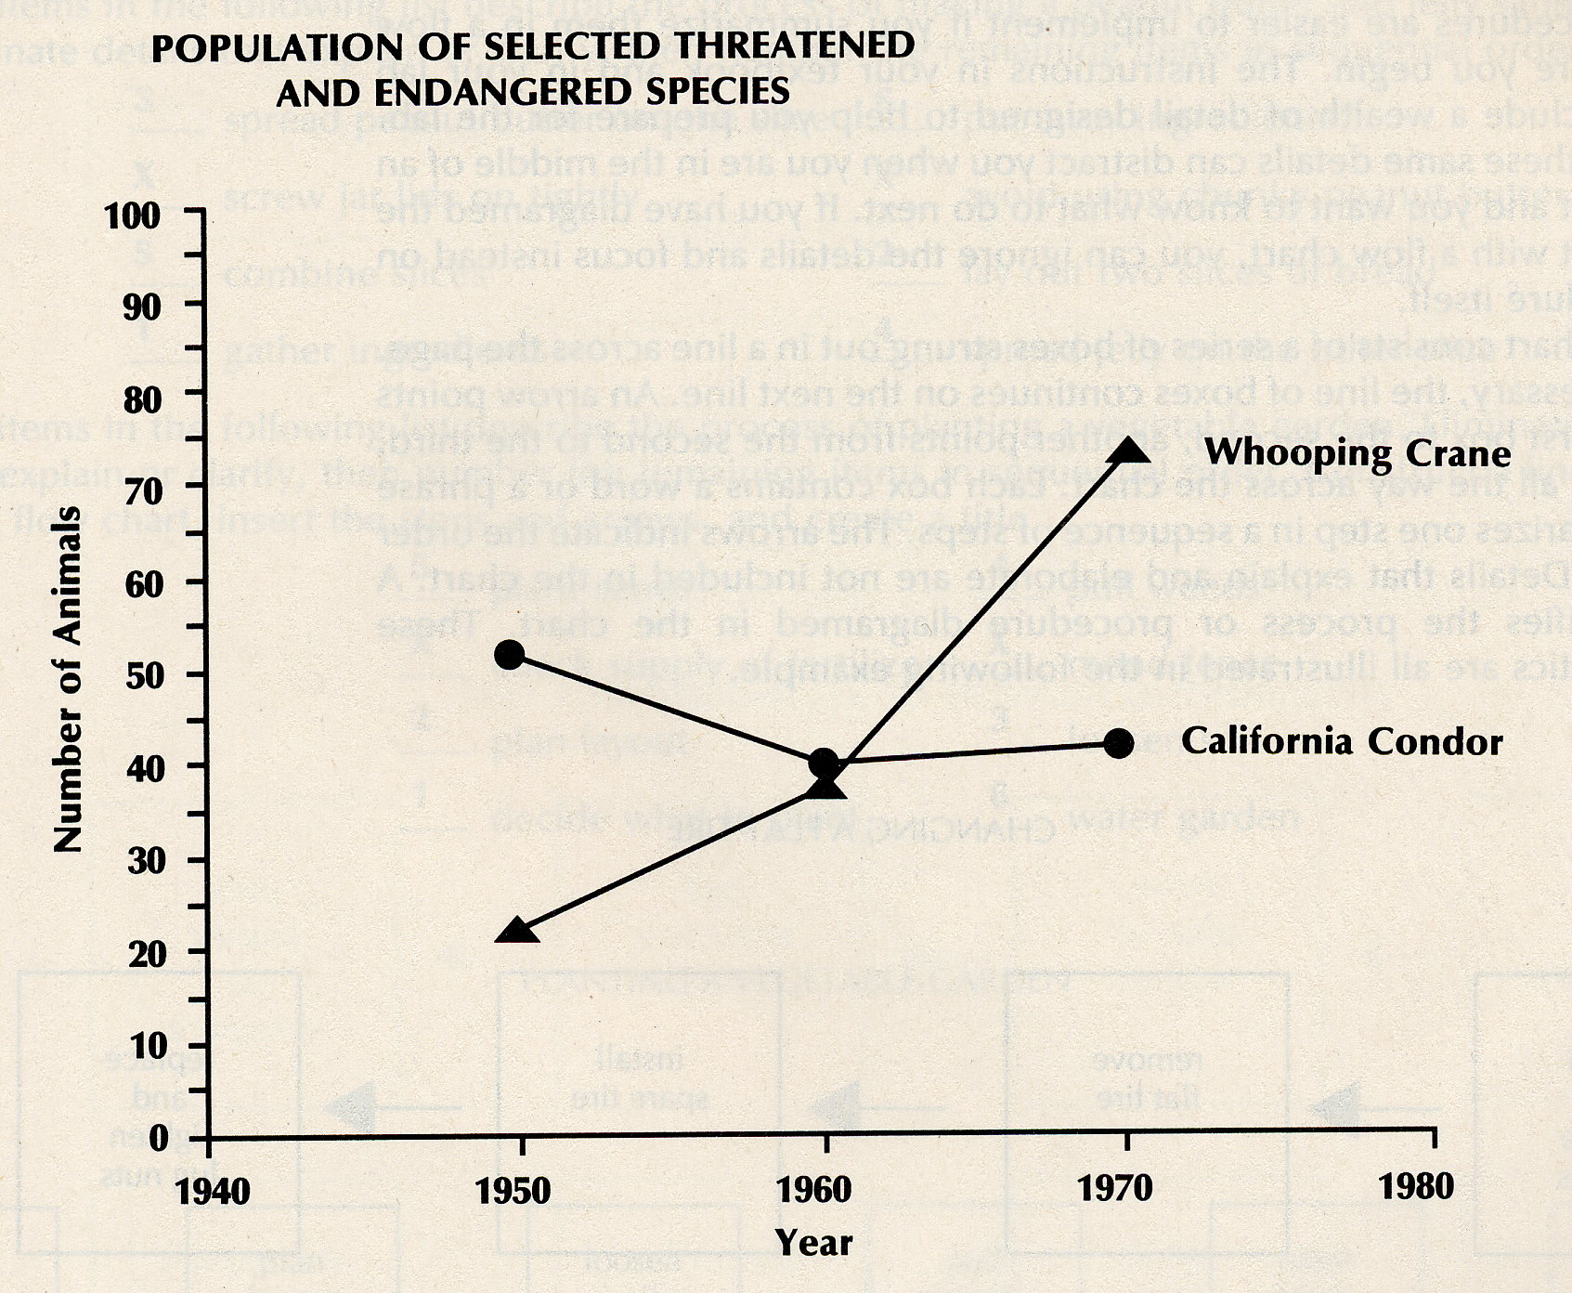
- What specific information can you learn from this graph? [1]

- What does the scale on the horizontal axis measure? (Don’t forget units) [1]

- What quantity does one unit on the vertical scale equal? (Don’t forget units) [1]

- How large was the condor population in 1950? [1]

How to Construct a Line Graph
- Descriptive Title.
- Create the horizontal x-axis and the vertical y-axis that define the bottom and left side of the graph.
- Create scales on both the x- and y-axes. Make sure they will accommodate all of your data. Remember, the dependent variable (what you measure) is on the vertical (y) axis, and the independent variable (what you change) is on the horizontal (x) axis.
- Plot the points by locating the data on the horizontal scale with one finger and the vertical scale with another finger. Then, bring your fingers together and draw a small dot where the two lines cross.
- Connect the dots to create a smooth line or curve.
- If the graph will contain more than one line of data (like the sample graph from above), distinguish the line you just created by using a different color, symbol or labeling the line.
- Repeat steps 3-4 for each additional line of data.

Use information on the following experiment; construct a line graph on the grid provided .

The rate of respiration of a freshwater sunfish was determined at different temperatures. The rate of respiration was determined by counting the number of times the gill covers of the fish opened and closed during 1-minute intervals at the various temperatures. The following data were collected.

- Label the axes and indicate the units. [1]
Temperature (°C) | Gill Cover Opening and Closing / Minute
10 | 15
15 | 25
18 | 30
20 | 38
23 | 60
25 | 57
27 | 25

- Mark an appropriate scale on each axis. Make sure to use equal intervals! [1]

- Plot the data from the data table. Surround each point with a small circle and connect the points. [1]
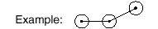

- According to the data, as the temperature increases,
the rate of respiration of the sunfish [1]
  - Increases steadily
  - Decreases steadily
  - Increases, then decreases
  - Decreases then increase

- Which title is appropriate for this graph? [1]
  - The Effect of Temperature on Rate of Respiration in Sunfish
  - The Effect of Gill Movement on Rate of Respiration in Sunfish
  - The Relationship Between Temperature and Dissolved Oxygen
  - The Relationship Between Sunfish Population and Temperature Change in Freshwater Habitats.

Part B: Bar Graphs
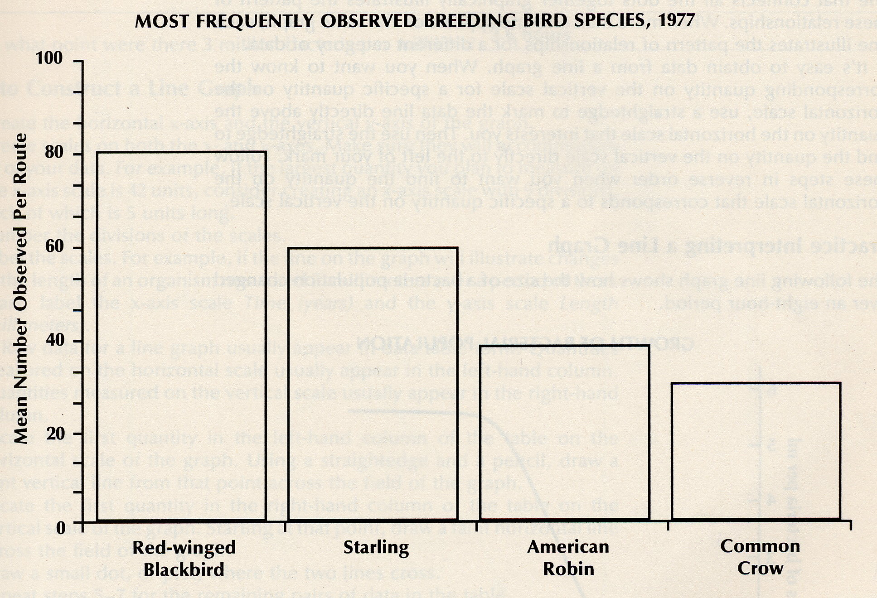
The bar graph is often used in order to present related data side by side so that you can compare data. Each bar represents a different category of data. The bars may be arranged vertically or horizontally. The taller or longer the bar, the larger the quantity it represents. A bar graph can also track multiple categories of data over time by displaying the bars in groups. Each group represents a different period of time, and a legend helps you tell the bars apart within each group.

- What is the most frequently observed bird species? [1]

- What is the least frequently observed bird species? [1]

- What is the mean number of starlings observed? [1]

- Estimate the sum of the observations for all of the birds. [1]

How to Construct a Bar Graph
- Descriptive Title.
- Create the horizontal x-axis and the vertical y-axis that define the bottom and left side of the graph.
- Generally, it is best to put the independent variable on the x axis and the dependent variable on the y axis. Make sure the scale for your y axis will accommodate all of your data.
- Number the divisions on the scale.
- Label your axes specifically (with units). For example, if each bar on the graph will represent the mass of an organism measured in grams, label the scale Mass of Organism (grams).
- Draw and label the bars. If appropriate, fill in each bar with a pattern or color. Create a legend that identifies the category of data represented by each pattern or color.

Use information in the following table; construct a bar graph on the grid provided.

ENDANGERED ANIMAL SPECIES IN THE UNITED STATES
Mammals: 35 | Birds: 66 | Reptiles: 11 | Amphibians: 6 | Fishes: 28

- Label the axes and indicate the units. [1]
- Mark an appropriate scale on each axis. [1]
- Draw and label the bars. [1]
- Which two categories do most of the endangered species in the United Sates fall into? [1]

- Make a prediction to what would happen to the graph if environmental regulations in the United States were relaxed and it became easier for companies to dispose of hazardous chemicals in local waterways. [1]

Part C: Pie Graphs
The pie graph, also called a circle graph, is used to show proportions. By definition, the whole circle is 100%, and all of the triangular sections of the graph (or “pie slices”) represent a proportion of the whole. The bigger the slice, the larger the quantity it represents. The smaller the slice, the smaller the quantity it represents.
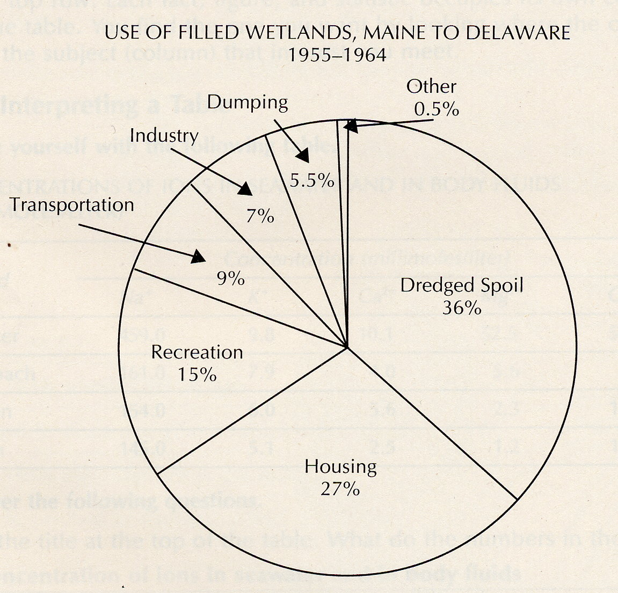
- What information does the graph contain? [1]

- What does the number in each wedge-shaped section signify? [1]

- What is the second largest category? [1]

- What quantity is represented by the graph as a whole? [1]

How to Construct a Circle Graph
- Calculate the percentage of data represented by each category. To do this, find the sum of all the data that is given. Then, divide each of the individual data points by the sum to find the percentage that it represents.
- Draw a circle.
- Divide the circle into wedge-shaped sections, one for each category of data. In general, you can estimate the size – it doesn’t have to be perfect, but it should be relatively close. (For example, if a category represents 25% of the circle, then it should look like it has a 90° angle. Another example, a wedge that is 35% should not be bigger than a wedge that is 50%.)
- Label each section and the quantity it represents. Be sure to include units (%).
- Give the graph a title.

Use information in the following table; construct a pie graph in the space provided. [2]

MAJOR VERTEBRATE SUBSPECIES IN NEW YORK

Mammals: 97 | Birds: 414 | Reptiles: 38 | Amphibians: 32 | Fish: 190

- What is the sum of all the data? [1]

- What % of the sum does ‘Mammals’ represent? [1]

- Which species has the lowest representation in NY? [1]

- Which subspecies is more represented in New York, Fish or Mammals? [1]

- Make an educated guess about why Birds might have the highest representation? [1]

