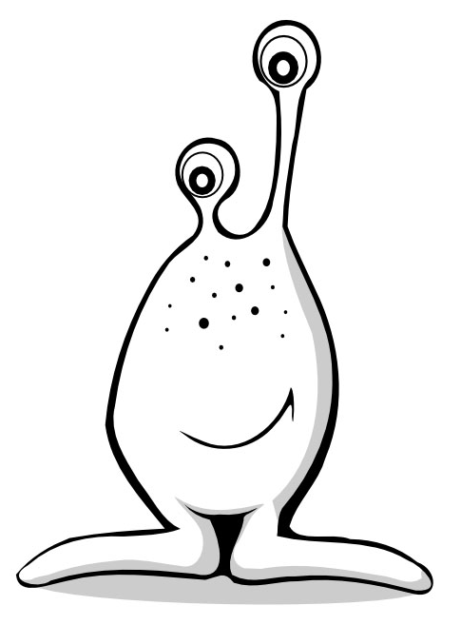
How Does DNA Determine the Traits of an Organism?
Introduction: In this simulation, you will examine the DNA sequence of a fictitious organism - the Snork. Snorks were discovered on the planet Dee Enae in a distant solar system. Snorks only have one chromosome with ten genes on it. Your job is to analyze the mRNA sequences that were transcribed from the genes of several snorks and determine what traits each organism has. Then sketch one of the snorks (be sure to clearly label each trait). For simplicity, the gene sequences are much smaller than real gene sequences found in living organisms. Each gene has two or more alleles (versions) that result in a different trait being expressed in the snork.
Genes | Amino Acid Sequence of Protein | Trait (caused by Protein)
Gene 1 - body covering | met - val - ser - leu | hairless
Gene 1 - body covering | met - val - ser - lys | hairy
Gene 2 - body style | met - tyr - pro - gln - gln - lys | plump
Gene 2 - body style | met - val - pro - thr - pro - lys | skinny
Gene 3 - legs | met - leu - leu - leu - pro | 3 legged
Gene 3 - legs | met - leu – phe – leu - pro | 1 leg
Gene 3 - legs | met - leu - leu - ser - ala | 2 legged
Gene 4 - head shape | met - ala - val - val | round head
Gene 4 - head shape | met - val - ala - ala | square head
Gene 5 - tails | met - his - ile | tail
Gene 5 - tails | met - his - his | no tail
Gene 6 - body pigment | met - ser - pro - val | blue pigment (hair/skin)
Gene 6 - body pigment | met - val - phe - tyr | red pigment (hair/skin)
Gene 7 - eyes | met - asn - ile - leu - leu - pro - thr | small slanted eyes
Gene 7 - eyes | met - asn - ile - leu - pro - pro - thr | large round eyes
Gene 8 - mouth | met - val - asn - asn - ala | circular mouth
Gene 8 - mouth | met - asn - asn - asn - ala | rectangular mouth
Gene 9 - ears | met - phe - ser - his | pointed standing-up ears
Gene 9 - ears | met - phe - phe - his | rounded floppy ears
Gene 10 - arms | met - arg - tyr - cys - lys | long spaghetti like arms
Gene 10 - arms | met - arg - arg - asp - thr | short stumpy arms
DNA samples were taken from volunteer Snorks. The DNA was then transcribed to its complimentary mRNA strand. These mRNA strands are shown below. Your job is to analyze each mRNA sample and determine the phenotype (how each organism looks) based on the sequence. Remember that AUG is a start codon, and it signifies the beginning of each gene. UAA, UAG, and UGA are STOP codons and signify the end of a gene. The genes are in order from gene 1 to gene 10.
#1 Snicker Snork mRNA
AUG GUC AGC AAA UGA | AUG UAC CCC CAA CAG AAA UAG | AUG CUC UUA AGU GCG UAA | AUG GCU GUU GUG UAA | AUG CAU CAU UGA | AUG GUU UUU UAC UAA | AUG AAU AUC UUA CUG CCC ACC UAA | AUG AAU AAC AAU GCC UAA | AUG UUU UCU CAC UGA | AUG CGU UAU UGU AAA UAG
#2 Snuffle Snork mRNA
AUG GUA UCU AAA UGA | AUG GUU CCU ACU CCA AAG UGA | AUG CUU CUC CUC CCC UAA | AUG GUU GCG GCU UAG | AUG CAU CAC UAG | AUG GUA UUU UAU UAA | AUG AAU AUU CUU CCC CCC ACA UAA | AUG AAU AAU AAU GCA UAA | AUG UUC UCG CAC UGA | AUG AGA CGC GAU ACA UAA
#3 Snapple Snork mRNA
AUG GUC AGC AAA UGA | AUG UAC CCC CAA CAG AAA UGA | AUG CUC UUA AGU GCG UAA | AUG GUU GCG GCU UGA | AUG CAC AUU UGA | AUG UCU CCC GUA UAA | AUG AAU AUU CUC CUC CCC ACC UAA | AUG GUU AAU AAU GCA UAA | AUG UUC UUU CAU UAA | AUG AGG AGG GAC ACG UAA
#4 Snoopy Snork mRNA
AUG GUA UCC CUC UAG | AUG UAC CCC CAA CAG AAA UAG | AUG UUA UUC CUG CCC UAG | AUG GUG GCA GCU UAG | AUG CAU AUU UAG | AUG UCU CCC GUA UAG | AUG AAC AUU CUU CCC CCC ACA UAG | AUG AAU AAC AAU GCC UAG | AUG UUU UCU CAC UAG | AUG CGC UAC UGC AAG UAG
Data Table: Snork Phenotypes as a Result of Genetic Code
Genes | Description | Snicker Snork | Snuffle Snork | Snapple Snork | Snoopy Snork
Gene 1 -  body covering | hairless
Gene 1 -  body covering | hairy
Gene 2 -  body style | plump
Gene 2 -  body style | skinny
Gene 3 -  legs | 3 legged
Gene 3 -  legs | 1 leg
Gene 3 -  legs | 2 legged
Gene 4 -  head shape | round head
Gene 4 -  head shape | square head
Gene 5 -  tails | tail
Gene 5 -  tails | no tail
Gene 6 -  body pigment | blue pigment (hair/skin)
Gene 6 -  body pigment | red pigment (hair/skin)
Gene 7 -  eyes | small slanted eyes
Gene 7 -  eyes | large round eyes
Gene 8 -  mouth | circular mouth
Gene 8 -  mouth | rectangular mouth
Gene 9 -  ears | pointed standing-up ears
Gene 9 -  ears | rounded floppy ears
Gene 10 -  arms | long spaghetti like arms
Gene 10 -  arms | short stumpy arms

