Protein Synthesis Simulation

Materials needed: paper, writing utensil, 1 pipe cleaner, beads (you will get these later).
Here’s your job: You will simulate protein synthesis. First you will simulate Transcription.
Steps:
- This paper represents the NUCLEUS. It has all the instructions that you will need to complete your task. Do NOT write on the nucleus (this would be a mutation). The DNA cannot leave the nucleus, so we need to transcribe the code of the DNA onto a strand of mRNA.
- The following DNA Sequence represents one gene. Remember, a gene is only a small piece of DNA. The rest of the DNA molecule would be much longer. Transcribe strand 1 ONLY onto a separate piece of paper:

DNA gene to transcribe (remember ONLY transcribe strand 1:
TACCAAAGAGGCCCCCTTCTAAAATACCAAAGAGGCCCCCTTCTAAAA (strand 1)

ATGGTTTCTCCGGGGGAAGATTTTATGGTTTCTCCGGGGGAAGATTTT (strand 2)

3. Write your answers to the following questions below your transcription.

Q1: What does the sequence of letters on your paper represent?
Q2: A sequence of three nitrogen bases is called a _______.
Q3: Where would this molecule travel to next?

4. Now that we’ve accomplished transcription, our mRNA molecule leaves the nucleus and moves to the ribosome where translation occurs. Move your mRNA paper away from this instruction paper so they no longer touch.

5. Translate the mRNA using the codon chart on the back of this page. Write your amino acid sequence on your paper.

6. The different colored beads represent different amino acids.(see the codon chart on the back of this page.)Send one of your group members to pick up the first amino acid in the sequence. This group member will represent a tRNA. This group member must know the correct colored bead to pick up and the amino acid that it represents. He or she must also know the anticodon on the tRNA that corresponds to the codon on mRNA.

7. Answer the following questions:
Q4: What does the group member who went to pick up the amino acid represent?
Q5: Codons are found on ________.
Q6: Anticodons are found on ______.
8. Take turns as group members being tRNA molecules (see #6). Retrieve beads in the correct order.
9. As you retrieve the beads, add them onto the pipe cleaner in the order specified by the mRNA codons.
10. When you are finished, carefully bring your completed polypeptide chain to your teacher.
11. One final thing: The function of proteins is due to the 3-D shape of the protein. This 3-D shape is due to the attractions between specific amino acids. After you have shown your teacher your protein chain, follow the following rules to give it a 3-D shape.
a. fold your pipe cleaners so that all blue beads are touching each other, all green beads are touching each other, all purple beads are touching each other, and all orange beads are touching each other.
This should give a rough idea of how proteins fold into specific shapes. The shape of a protein is critical to its function.

Light blue
Light orange

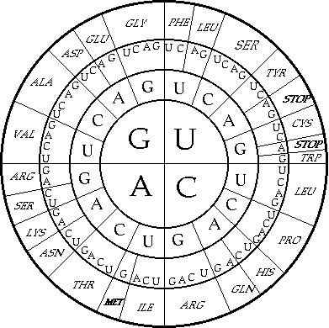
Dark green
Light purple
Dark purple
Dark orange
Lightyellow
Dark purple
Dark blue
Light green
Dark red
Light red
Dark Pink
Bright pink
peach
peach
white
periwinkle
Bright yellow
chartreuse
magenta
Teal

Teacher’s key for final protein
sequence: dark green, dark blue, dark purple, dark orange, light blue, light green, light purple, light orange, dark green, dark blue, dark purple, dark orange, light blue, light green, light purple, light orange,

