Chapter 11: DNA worksheet name_________________________

*** Use Notes and book as needed***
- What does DNA stand for? ______________________________________

- What are chromosomes?

- Where in the cell are chromosomes located? ________________

- What two scientists established the structure of DNA? ____________ and ______________

- DNA is sometimes described as a twisted ladder. What is this shape called? ___________________

- Draw and label a nucleotide (3 main parts-see NOTES) (A simple diagram is sufficient)

- What forms the backbone of DNA? _______________________ and _______________________

- What forms the rungs of the ladder of DNA? ____________________________________

- Write the names of the nitrogenous bases in pairs:
_______________ and _________________
________________ and ______________

- What does the word complementary mean?

- Which nitrogen bases are complementary to each other?

- Create a matching (complementary) DNA sequence for the following strand:
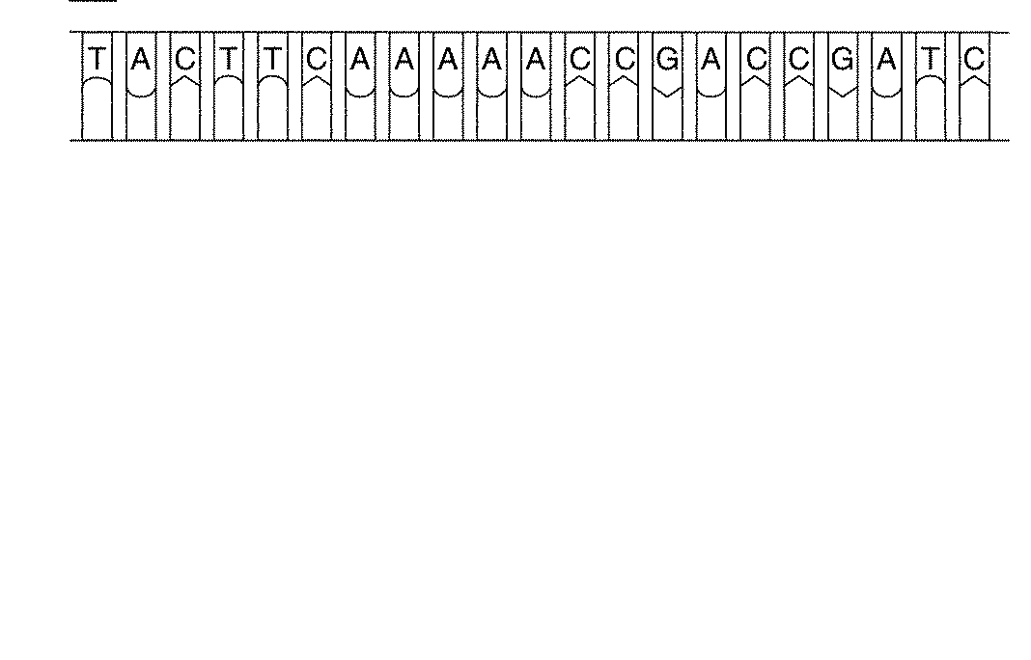

DNA Replication

- What is DNA replication? Describe in your own words.

- Why do cells need to perform DNA replication?

- DNA must “unzip” to replicate. Describe how DNA “unzips”. Include the name of the enzyme involved.

- What is the importance of DNA polymerase?

- Study the diagram below. Fill in the missing nitrogen base letters. Then, label the parts of the diagram using the following word bank:

Phosphate | Nitrogen base pairs
Nucleotide | Deoxyribose Sugar

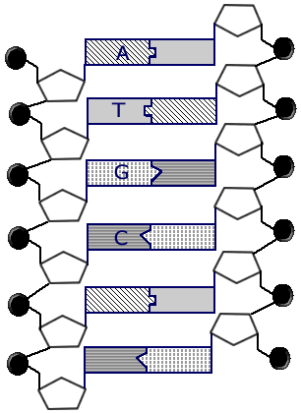

Protein Synthesis

- What is transcription?

- What is a gene?

- Why can’t DNA leave the nucleus?

- What does DNA code for?

- What does RNA stand for?

- Create a matching (complementary) mRNA sequence for the following strand of a DNA molecule:

- Describe the different functions for the three types of RNA.

- Where does messenger RNA (mRNA) go?

- What is a codon?

- List each codon from the mRNA molecule in #23 (put a dash between each separate codon).

- What is translation?

- What is an anticodon?

- Where are proteins made in the cell? _____________________________

- Use the following amino acid chart to translate the sequence of codons (from # 23) and write the amino acid sequence that results below:

Amino Acid Sequence:

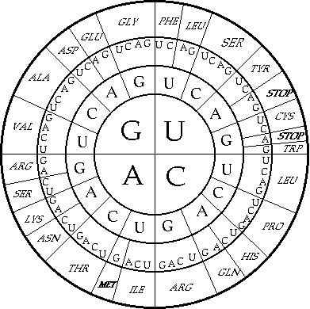
- Why are proteins important?

- What is a mutation? Explain how a mutation alters the protein made by a gene.

- Explain how the DNA code is used to make proteins in a paragraph or two. Be sure to address the roles of both transcription and translation.

- Explain how and why each of the following biotechnology techniques is used, giving an example of each one:
  - Genetic Engineering/ Recombinant DNA

  - PCR (Polymerase Chain Reaction)

  - Gel Electrophoresis

