DNA: The Double Helix

Nucleic acids are very large molecules made of carbon, oxygen, hydrogen, nitrogen, and phosphorus. There are two kinds of nucleic acids: DNA and RNA.

Recall that the nucleus is a small, spherical organelle in a cell. It is often called the “control center” because it controls all the activities of the cell. Chromosomes are microscopic, threadlike strands composed of DNA (short for deoxyribonucleic acid) that are found in the nucleus. DNA controls the production of the proteins within the cell. Think of proteins as the building materials for an organism; proteins make up your skin, your hair, parts of individual cells, etc. How you look is largely determined by the proteins that are made. The proteins that are made are determined by the sequence of DNA in the nucleus.

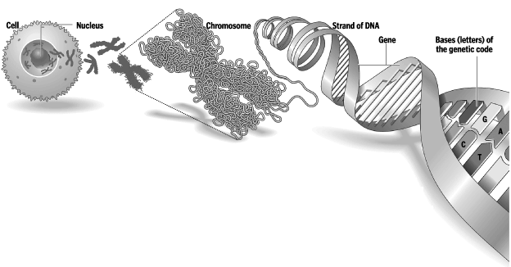

Chromosomes are made up of genes, which are segments of DNA that code for a particular protein. These genes code for a trait, or particular characteristic. This is why you hear it commonly referred to as the “gene for baldness” or the “gene for blue eyes.” DNA is the chemical that genes and chromosomes are made of.

In 1953, James Watson and Francis Crick determined the structure of DNA. The shape of DNA is a double helix, which is like a twisted ladder.
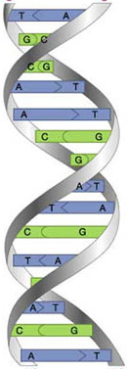
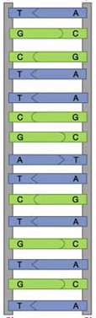

Ladder shape → ← “Twisted ladder” shape
or
double helix

The sides of the ladder are made of alternating sugar and phosphate molecules held together by covalent bonds. The sugar in DNA is deoxyribose.

The “rungs” or steps of the ladder are made of pairs of 4 types of nitrogen bases; Adenine, Thymine, Guanine, and Cytosine. These bases are known by their coded letters A, T, G, and C. These bases always bond in a certain way. Adenine will only bond to Thymine, and Guanine will only bond to Cytosine. This is known as the “Base-Pair Rule.” Note that the bases attach to the sides of the ladder at the sugars and not the phosphate.
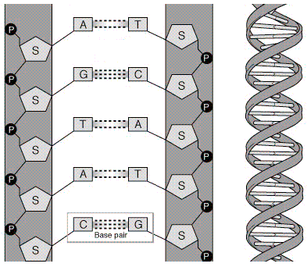

P = phosphate

S= sugar

The bases can occur in any order along a strand of DNA. The order of these base pairs is the code that contains the instructions. For example,

ATGCACATA would code for a different gene than AATTACGGA. A strand of DNA contains millions of bases.
The DNA helix is made of repeating units called nucleotides. Each nucleotide is made up of three molecules: a sugar (deoxyribose), a phosphate, and one of the four bases.

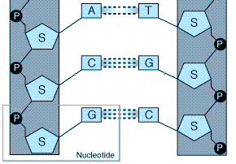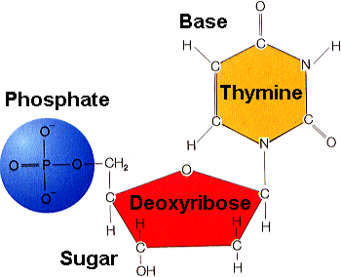

The two sides of the DNA ladder are held together loosely by hydrogen bonds. The DNA can actually “unzip” when it needs to make a copy of itself. The hydrogen bonds are represented by the small dots in the picture below.

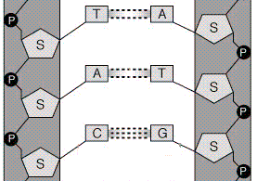

So, we know that the nucleus controls the cell’s activities through a chemical called DNA, but how?

It is the sequence of bases in DNA that determines which protein is to be made, but it is the ribosomes that actually make the proteins. The ribosomes need information from the DNA to make these proteins, but the DNA is inside of the nucleus, and the ribosomes are outside of the nucleus.
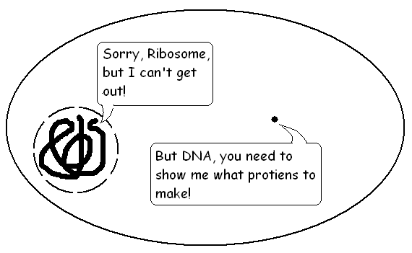
How does the DNA get information to the ribosomes?

ribosome
nucleus with
DNA inside

DNA is too big to fit through the nuclear pores (the “holes” in the nuclear membrane) to come out of the nucleus and get to a ribosome, so a chemical is used to read the DNA in the nucleus. This chemical is messenger RNA. The messenger RNA (mRNA) is small enough to go through the nuclear pores into the nucleus. It takes a “message” from the DNA to the ribosomes that tells the ribosomes what proteins to make.

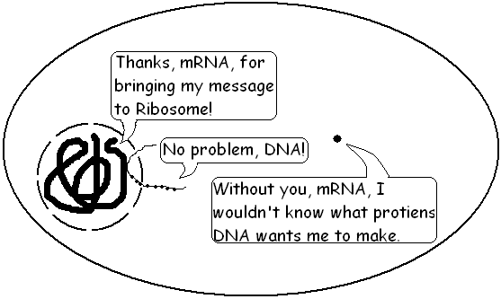

Messenger RNA is similar to DNA, except that it is a single strand, and it has no Thymine. Instead of Thymine, mRNA has Uracil instead. mRNA also has the sugar ribose instead of deoxyribose. RNA stands for ribonucleic acid.
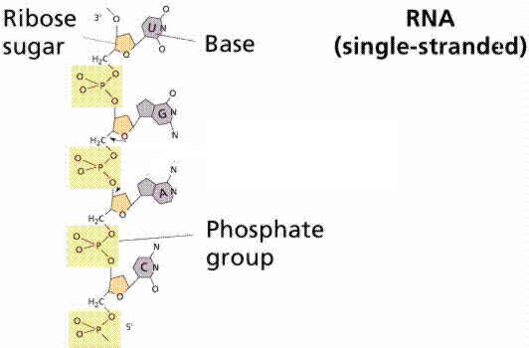
Every cell in your body has the same DNA. Like the blueprints of a house tell the builders how to construct a house, the DNA "blueprint" tells the cell how to build the organism. Yet, how can a heart be so different from a brain if all the cells contain the same instructions? A cell has the ability to turn off most genes and only work with the genes necessary to do a specific job.

