Cell Unit Exam Intervention Opportunity

Purpose: The goal of this activity is for you to rehearse your Cell Biology standards. If you have been given this activity, unfortunately you did not achieve a passing score on the Cell Unit Exam. This is a mandatory intervention that will provide you with an opportunity to become proficient in the Cell Standards as well as raise your grade. After completing the review activities, you will take the QuizNinja Cell Unit Intervention as a opportunity to raise your grade.

Directions: You will be responsible for completing a series of educational games and quizzes that are pertaining to the Cell Unit. You must complete ALL of the games and quizzes listed below, continuing to replay/retake the games and quizzes until you get an 80% or higher.

Games:

Cell Explorer- http://biomanbio.com/GamesandLabs/Cellgames/CellExplorerAnimalCell.html
Cell Defense- http://biomanbio.com/GamesandLabs/Cellgames/celldefense.html
Photosynthesis and Respiration Game- http://biomanbio.com/GamesandLabs/PhotoRespgames/phorespgame.html

Quizzes:

Cell Quizzes 1 &2: http://biomanbio.com/Quizzes/cellquizzes.html
Photosynthesis Quiz: http://biomanbio.com/Quizzes/photorespquizzes.html

Study Guide:
Make sure you understand your study guide completely.

Directions to use BiomanBio.com:

- Play the game or do the quiz that is assigned by clicking on the appropriate links above.
- When you are done, submit your score to your teacher’s email address. See below for instructions:
  - Your score is available on the “score sheet” for the games and will be visible at the end of the quiz.
  - You will need to click on the button that says “Submit Score Online to Your Teacher.”
  - It is very IMPORTANT to fully complete the score submission process. You will then receive the following message: “Congratulations, you have successfully submitted your score!” It will look like this:
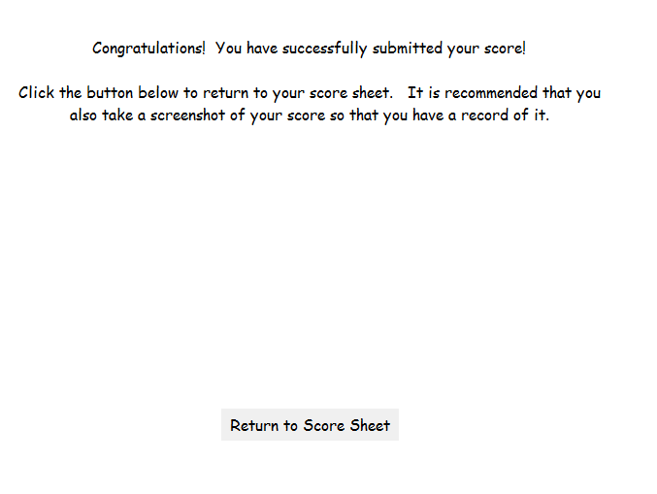

- It is also recommended that you take a screenshot of your score sheet as proof of your score and proof that you finished.
  - To take a screenshot, press the Print Screen button on your keyboard. It will look like nothing happened but then you can open a Word document and click paste. Then, save your document and keep it as proof of finishing.
- Bonus: Several of the games can be saved from the score sheet as well, so if you don’t finish the whole game at one time you can save your progress online.

The below three tutorial sites can be found by typing in their titles into the YouTube search bar. These tutorials are a great way to practice the cell unit standards in order to best prepare you for your cell exam retake:
1. Amoeba Sisters
- offers tutorials for osmosis, cell respiration, photosynthesis, and prokaryotic vs. eukaryotic cells
2. Crash Course
- offers tutorials for Eukaryotic cells (Eukaryopolis), membranes & transport (In da Club), photosynthesis, and ATP Respiration
3. Bozeman Biology
- offers tutorials for Prokaryotes vs Eukaryotes (A Tour of the Cell), Photosynthesis, Cellular Respiration, Cell Membranes, and Transfer Across Cell Membranes

Once you have completed all the review activities, and you have studied the material again and feel confident that you understand it, take the CELL UNIT INTERVENTION on QuizNinja.net. You can only take this once and it will be in lockdown mode so you can’t navigate to other webpages or it will shut down.

If you score better than your original test score, your grade can improve up to a C- if you failed.

