Cellular Respiration and Photosynthesis Worksheet

Respiration

- What is the overall purpose of cellular respiration?

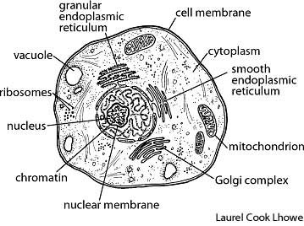
- Write the equation for cellular respiration below. Label the reactants and the products.

- What are the 3 phases of the cellular respiration process?

- Where in the cell does glycolysis occur? Label the location on the cell diagram →

- Where in the cell does the Krebs (Citric Acid) cycle occur? Label the location on the cell diagram →

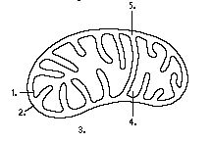
- Where in the cell does the electron transport chain occur? Label the location on the cell diagram →

- Label the location of the Krebs cycle on the mitochondrion→

- Label the location of the Electron Transport Chain (ETC) on the mitochondrion→

- How many ATP (net gain) are made in glycolysis?

- How many ATP are made in the Krebs (Citric Acid) Cycle?

- How many ATP are made in the electron transport chain?

- Which phase of cellular respiration makes the most ATP?

- In which phase of cellular respiration is carbon dioxide made?

- In which phase of cellular respiration is water made?

- In which phase of cellular respiration is oxygen a substrate?

- In which phase of cellular respiration is glucose a substrate?

- What would happen to the cellular respiration process if the enzyme for one step of the process were missing or defective?

- What is anaerobic respiration (fermentation) and why does it occur?

- There are two main types of fermentation. What are they and how do they differ?
Photosynthesis

- What is chlorophyll?

- In which organelle is chlorophyll located?

- Which part of the plant contains the most chlorophyll?

- Why does this part of the plant have the most chlorophyll?

- Answer the following question in the table below:
What is the equation for photosynthesis?

In words:

In symbols:

- Answer the following questions in the table below: What are the most important things that happen during the:

Light-DEPENDENT reactions of photosynthesis? | Light-INDEPENDENT reactions of photosynthesis?  (Calvin Cycle)

- Write the equation for photosynthesis in the space below. Above each of the “reactants”, write if they are used in the light-DEPENDENT or light-INDEPENDENT reactions. Above each of the products, write if they are produced during the light-dependent or light-independent (Calvin Cycle) reactions.
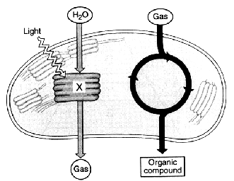

- Where do the light dependent reactions occur? Draw an arrow to the location on the diagram to the right.

- Label the diagram to the right more specifically (label “X”, the gasses, the organic compound, and the processes occurring.)

- Describe the thylakoid and its role in photosynthesis.

- How do the light-dependent reactions use facilitated diffusion to make ATP? Explain. You may want to use a diagram.

- What is another name for the light-independent reactions?

- Where do the light-independent reactions occur?

- Describe the stroma and why it is important in photosynthesis.

- During which part of photosynthesis is glucose made?

- What are the reactants needed for photosynthesis to occur?

- Would photosynthesis happen very effectively if a plant was exposed to light in the green wavelength? Explain.

- Deforestation, cutting down trees, destroys habitat for animals. Think about the reactants in the photosynthesis equation. What is a consequence to humans if we continue to cut down forests?

- Think about the products of photosynthesis. What is another consequence to humans if we continue to cut down forests?

- Draw and label a simplified chloroplast in the space below. Include the following: double membrane, thylakoid, stroma.

Analyzing the van Helmont Photosynthesis Experiment

Jean Baptista van Helmont (1577-1644) performed a classic experiment on photosynthesis. In paragraph below, van Helmont describes his experiment. Read the paragraph and then address the questions that follow.

I took an earthen pot and in it placed 200 pounds of earth which had been dried out in an oven. This I moistened with rain water, and in it planted a shoot of willow which weighed five pounds. When five years had passed the tree which grew from it weighed 169 pounds and about three ounces. The earthen pot was wetted whenever it was necessary with rain or distilled water only. It was very large, and was sunk in the ground, and had a tin plated iron lid with many holes punched in it, which covered the edge of the pot to keep air-borne dust from mixing with the earth. I did not keep track of the weight of the leaves which fell in each of the four autumns. Finally, I dried out the earth in the pot once more, and found the same 200 pounds, less about 2 ounces.

- Write down the weights van Helmont measured:
- Initial weight of soil =
  - Initial weight of plant =
  - Final weight of soil =
  - Final weight of plant =
  - Change in weight of plant =

- What question was van Helmont trying to answer? Restate in your own words the experiment.

- Based on the information above, what is your conclusion from this experiment? Also, write down any questions you have concerning the experiment.

4. In van Helmont’s experiment, light energy was necessary for the willow to gain mass. What happened to the light energy after it reached the willow plant? Write down the specific equation for photosynthesis and relate the equation to this question.

- In the space below show, explain what happened during this experiment. Show in particular where the new mass in the plant came from. Also show the specific types of energy conversions.

- Explain in detail what molecule produces the mass change in the plant and how this occurs. (Hint: water is NOT the molecule that produces most of the mass change)

