Gel Electrophoresis – Virtual Lab
Directions to Virtual Lab
From the Internet: http://www.classzone.com/cz/books/bio_07/resources/htmls/virtual_labs/virtualLabs.html Under Labs, select virtual labs. Then select Gel Electrophoresis from the list of labs.
Background
In newspapers, on television, and in movies, you often hear about DNA evidence being used to solve crimes. Scientists use a method called gel electrophoresis to separate DNA molecules on the basis of size.
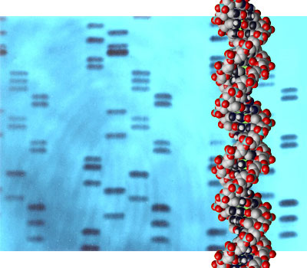
Unless you have an identical twin, your complete set of DNA, or your genome, is unique. This variation in DNA among people is the basis of DNA fingerprinting. A DNA fingerprint is a representation of parts of an individual’s DNA that can be used to identify a person on a molecular level. The greatest differences in DNA among people are found in regions of the genome that are not parts of genes. As a result, DNA fingerprinting focuses on noncoding regions of DNA, or DNA sequences outside of genes. Each person’s DNA differs in the number of copies of the repeats of these noncoding regions. When there are more repeats, a DNA fragment is larger. The pattern of DNA fragments on a gel represents the uniqueness of a person’s DNA. Individuals might have some of the same fragments in common, but it is very unlikely that all of them would be the same.
Usually DNA fingerprinting compares at least five regions of the genome. That way it is more certain that the pattern of DNA fragments in the fingerprint is unique. The more regions of DNA that are studied, the less likely is becomes that another person would have the same DNA fingerprint. For this reason, DNA fingerprinting is considered very reliable for identification purposes.
So how exactly does DNA fingerprinting with gel electrophoresis work? To state it as simply as possible, gel electrophoresis separates DNA fragments according to their size. Typically, a DNA molecule is broken apart with restriction enzymes, and the gel electrophoresis is used as a diagnostic tool to visualize the fragments. An electric current is used to move the DNA molecules across a gel, which is a polysaccharide matrix that functions as a sort of sieve to help "catch" the molecules as they are transported by the electric current. The phosphate molecules that make up the backbone of DNA molecules have a high negative charge. When DNA is placed on a field with an electric current, these negatively charged DNA molecules migrate toward the positive end of the field, which in this case is the gel. The DNA molecules are pulled to the positive end by the current, but they encounter resistance as they move. The smaller fragments of DNA are able to navigate faster than the larger ones, so they make it further down the gel than the larger molecules. The larger DNA fragments travel slower due to resistance and will be closer to the original side of the gel. This is how gel electrophoresis separates different DNA molecules according to their size. The gel is stained with ethidium bromide so you can visualize how these DNA molecules resolved into bands along the gel.
Purpose: To use gel electrophoresis to create a DNA Fingerprint

Procedure: Follow the steps to the lab given on the screen until you complete all twelve (12) steps.

Data/Results:
- Draw the results from your gel in your notebook.
- Copy the following data table. Using the data from your electrophoresis gel, record the base pair lengths of the marker DNA. Then, using this information, estimate the size of the rest of the DNA bands.

Data Table: Lengths of DNA fragments from Crime Scene Evidence
Band | Marker DNA  (bp) | Victim DNA  (bp) | Suspect 1 DNA  (bp) | Suspect 2 DNA  (bp) | Evidence DNA  (bp)
1
2
3
4
5
6

Discussion:

1) Evaluate: Does the DNA found on the hair match suspect 1, suspect 2, or the victim? Explain your reasoning.

2) Analyze: Why do a series of bands appear on the gel?

3) Identify: Why is the largest DNA fragment band found closest to the well in which it was placed?

4) Infer: What is true for the DNA fragment band closest to the positive end of the gel?

5) Predict: Based on what you observed in the lab, do DNA fragments used in gel electrophoresis have a positive or negative charge to them?

6) Apply: Why is DNA Fingerprinting more conclusive when proving a person’s innocence rather than their guilt?

7) Apply: Realistically, there is not enough DNA in a single hair follicle to run gel electrophoresis. Explain how you would amplify the hair follicle DNA prior to performing electrophoresis.

