Biotechnology
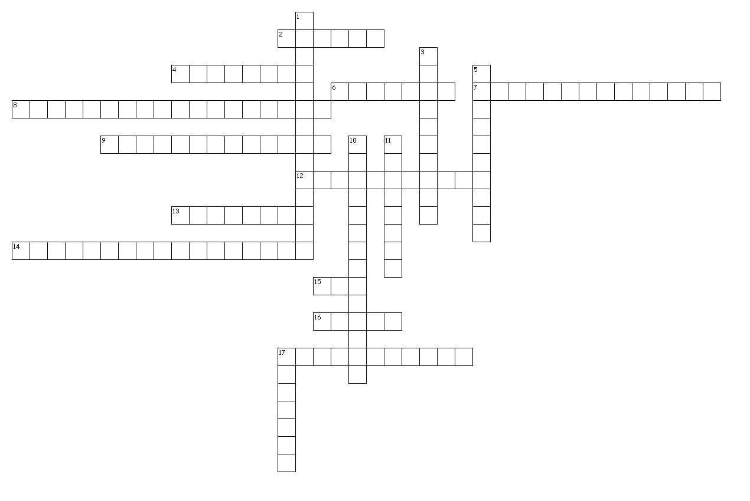
Across
2. something that carries foreign DNA into a cell
4. In nature, restriction enzymes are found in ________ and are used to defend against invasion by viral DNA.
6. This protein is produced by transgenic bacteria, and helps people with diabetes
7. DNA from one species that has been inserted into another species
8. separates DNA fragments based on their size
9. A sequence of ______ that reads the same forward on one strand as it does backward on another is known as a palindrome.
12. all of the DNA found in human beings is the ________. Hint: there's a project named after it that has sequenced all of the DNA in a person.
13. Plasmids are ______ pieces of bacterial DNA
14. This type of protein cuts DNA at specific sites called restriction sites.
15. Technique that replicates crime scene DNA in a test tube.
16. A type of vector that can make people sick, but that is being investigated for gene therapy.
17. nitrogen base sequence that reads the same forward on one strand as it does backward on another. Restriction sites are often these.

Down
1. DNA moves through the electrophoresis gel because it has a _____.
3. What are the single-stranded pieces of DNA produced when DNA is cut with restriction enzymes called?
5. Any organism that has DNA from two different sources is _______.
10. the unique pattern produced when DNA from an individual is run through an electrophoresis gel is sometimes called a ______.
11. DNA has a ______ charge.
17. A type of vector that is a circular ring of DNA

18 of 18 words were placed into the puzzle.

Created by Puzzlemaker at DiscoveryEducation.com

