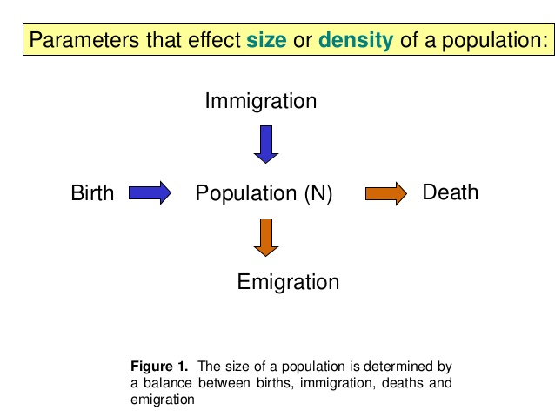
A population of crocodiles has changed from the previous year’s sample. Since the last sample, 400 crocodiles have been born, 250 have died, 100 have immigrated, and 50 have emigrated.
Calculate the PGR from the time of the previous sample. Show your work! What does your number mean about the population change? (hint: increasing or decreasing? How do you know?)

