Interpreting Meiosis Graphs
1.
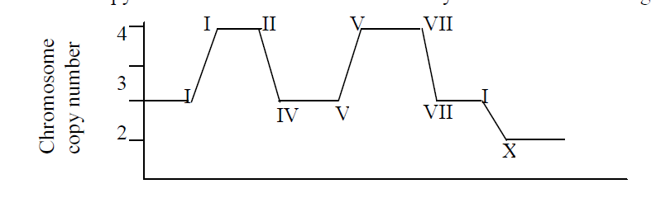
QUESTION 1: Give 2 pieces of evidence that this graph represents Meiosis.
QUESTION 2: Give this graph an X-axis label, y-axis #’s, and a title.

2. 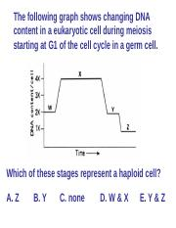
+ why?
QUESTION 3:

3. 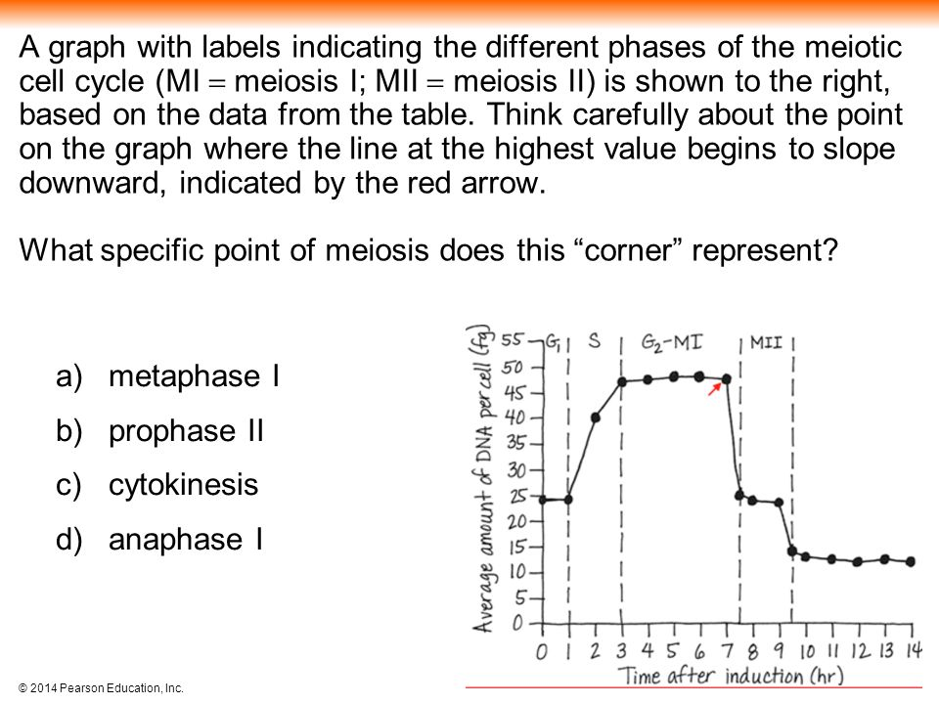
+ why do you think that?
QUESTION 4:

