Ch. 10 – 14 Midterm Study Guide
CHAPTER 10
1. What is energy? What are some common units of energy?

2. Define the terms system and surroundings. Draw and label a diagram to help with this.

3. Explain what is meant by the terms exothermic and endothermic. Give an example of each type of reaction. Also, describe what sign “q” would have for each.

4. For each of the following amounts of energy, perform the indicated conversion of units.
a. 459 J to calories
b. 55.31 kJ to joules
c. 84.1 kJ to kilocalories
5. Calculate the mass (in grams) of each of the following substances that could be warmed over the indicated temperature range by application of exactly 1.0 kJ of energy.
a. water, from 15°C to 42°C
b. iron, from 25°C to 125°C
c. carbon, from -10°C to 47°C
6. A friend of yours reads that the process of water freezing is exothermic. This friend tells you that this can’t be true because exothermic implies “hot”, and ice is cold. Is the process of water freezing exothermic? If so, explain it so your friend can understand it. If not, explain why not.

7. You place 100.0 g of a hot metal in 100.0 g of cold water. Which substance (metal or water) undergoes a larger temperature change? Why is this?
CHAPTER 11
8. Explain what it means for an atom to be in an excited state and what it means for an atom to be in its ground state. Draw and label a diagram to help with this.

9. Why are the valence electrons more important to the atom’s chemical properties than the core electrons? How is the # of valence e-‘s in an atom related to the atom’s position on the periodic table?

10. How many electrons can be placed in a given s subshell? In a given p subshell? In a specific p orbital?

11. How does electron spin affect the total number of electrons that can be accommodated in a given orbital?
12. Write the electron configurations for the following atoms. Draw orbital diagrams for them, too.
a. Na c. Sr
b. N d. Be
13. Arrange the following atoms from largest to smallest atomic radius AND from highest to lowest ionization energy. What is the relationship between atomic radius and ionization energy? (pattern)
a. Na, K, Rb b. C, O, F c. Na, Si, O

CHAPTER 12
14. In general, what do we mean by a chemical bond? Distinguish between ionic & covalent bonds.

15. Define electronegativity. Describe this pattern on the periodic table.
16. How does the polarity of a bond depend on the difference in electronegativities of the two atoms participating in the bond? If two atoms have exactly the same electronegativity, what type of bond will exist between the atoms? If two atoms have vastly different electronegativities, what type of bond will exist between them?
17. In writing Lewis structures for molecules:
a) what is meant by the duet rule? To which element does the duet rule apply?
b) what do we mean by the octet rule? Why is attaining an octet of electrons important for an atom when it forms bonds to other atoms?
18. Write Lewis structures for the following molecules & predict their molecular geometry / shape:
a. PF₃
b. SiCl₄
c. H₂S
CHAPTER 13
19. Convert 1.20 atm to units of
a) mm Hg b) torr c) pascals.
20. Describe the relationship between (& identify the Law that concerns) the following variables:
a) Pressure and Volume
b) Temperature and Volume
c) Volume and Amount of Moles
21. What temperature scale is defined with its lowest point as the absolute zero of temperature? What is absolute zero in Celsius degrees?

22. What does “STP” stand for? What conditions correspond to STP?

23. A sample of gas in a 10.0-L container exerts a pressure of 565 mm Hg. Calculate the pressure exerted by the gas if the volume is changed to 15.0 L at constant temperature.

24. A sample of gas in a 5.00-L container at 35.0°C is heated at constant pressure to a temperature of 70.0°C at constant pressure. Determine the volume of the heated gas.

25. A 4.50 mol sample of a gas occupies a volume of 34.6 L at a particular temperature and pressure. What volume does 2.50 mol of the gas occupy at these same conditions of pressure and temperature?

26. What mass of helium gas exerts a pressure of 1.20 atm in a volume of 5.40 L at a temperature of 27°C?

27. A sample of oxygen gas is collected over water at 27°C. The total pressure is 0.95 atm and the water vapor pressure at 27°C is 26.7 torr. Determine the partial pressure of the oxygen gas collected.

28. When calcium carbonate is heated strongly, carbon dioxide gas is produced: CaCO3(s) → CaO(s) + CO2(g)
a) Is this a balanced equation? Why would that matter?
b) Determine the volume occupied by the carbon dioxide produced by the decomposition of 23.5 g of calcium carbonate. The carbon dioxide is collected at 1.10 atm and 24°C.

CHAPTER 14
29. Sketch a heating/cooling curve for water. Label freezing point, melting point, boiling point, evaporation, melting, freezing, and condensation.

30. What do the plateaus on the heating/cooling curve mean show? Why is one longer than the other?

31. What type of forces must be overcome to melt or vaporize a substance (are these forces intramolecular or intermolecular)? What specific IMF must be overcome between water molecules?

32. Fill in the blanks of the table below:
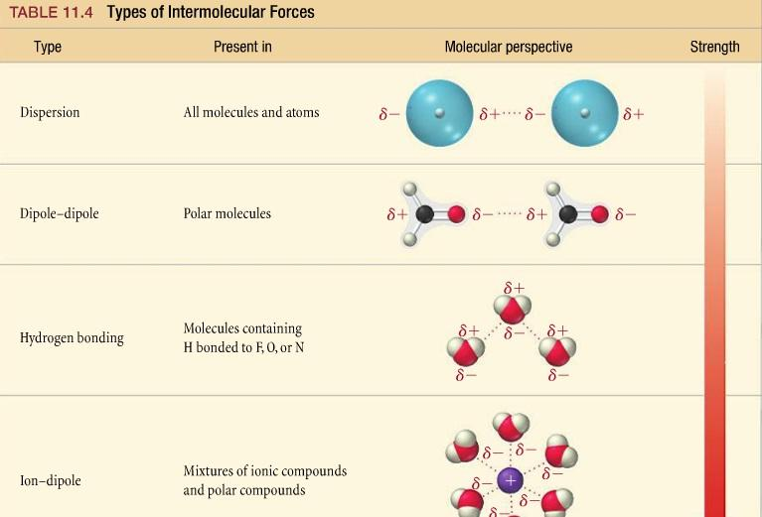
33. What is the relationship between “vapor pressure” and “volatility?”

34. Explain why the boiling point of a liquid is related to the atmospheric pressure. (hint: why does the bp of a liquid change depending on the altitude?) Draw and label a diagram to help with this.

35. Define crystalline solid. Describe in detail some important types of crystalline solids and name a substance that is an example of each type of solid. Explain how the particles are held together in each type of solid (the interparticle forces that exist).

