Cell Lab Make-Up

First: Make sure you have downloaded and printed out the Cell Lab Sheet from my website... You’re completing the same thing as everyone else, without the fun of using the microscope ☹

Second: Observe the slides pictures below and draw one cell from each on your lab sheets in the appropriate field of view circles, making sure to label the necessary cell features. Also remember to note the TOTAL MAGNIFICATION.

Remember total magnification is:

(Magnification of eye piece 10X)(Magnification of objective lens) = Total Magnification

Part 1: Elodea Cell

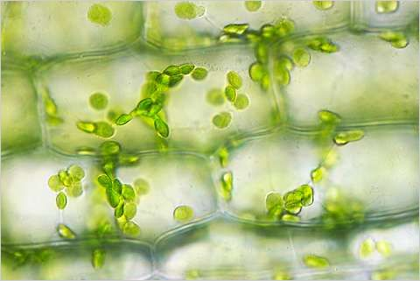
Viewed using an 40X objective lens
Part 2: Onion Cell

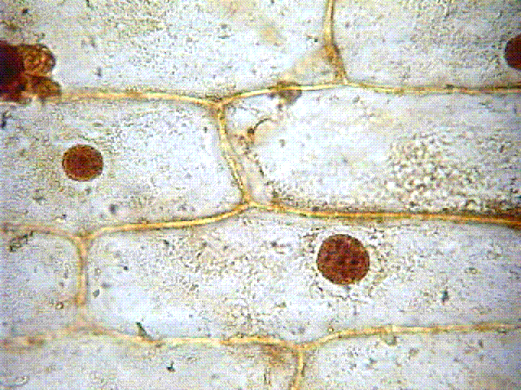
Viewed using a 40X objective lens

Part 3: Cheek Cells
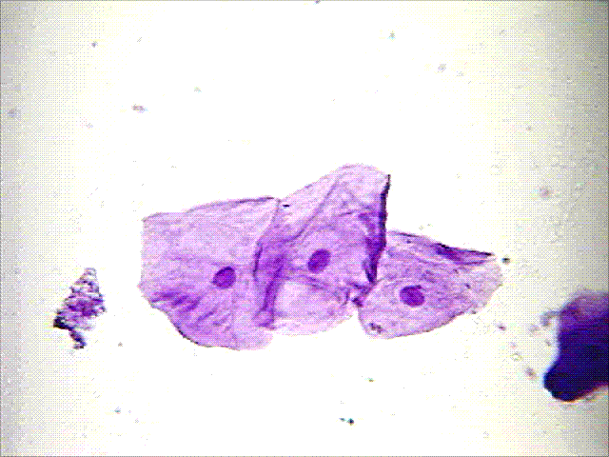
Viewed using a 40X objective lens

Part 4: Bacteria Cells

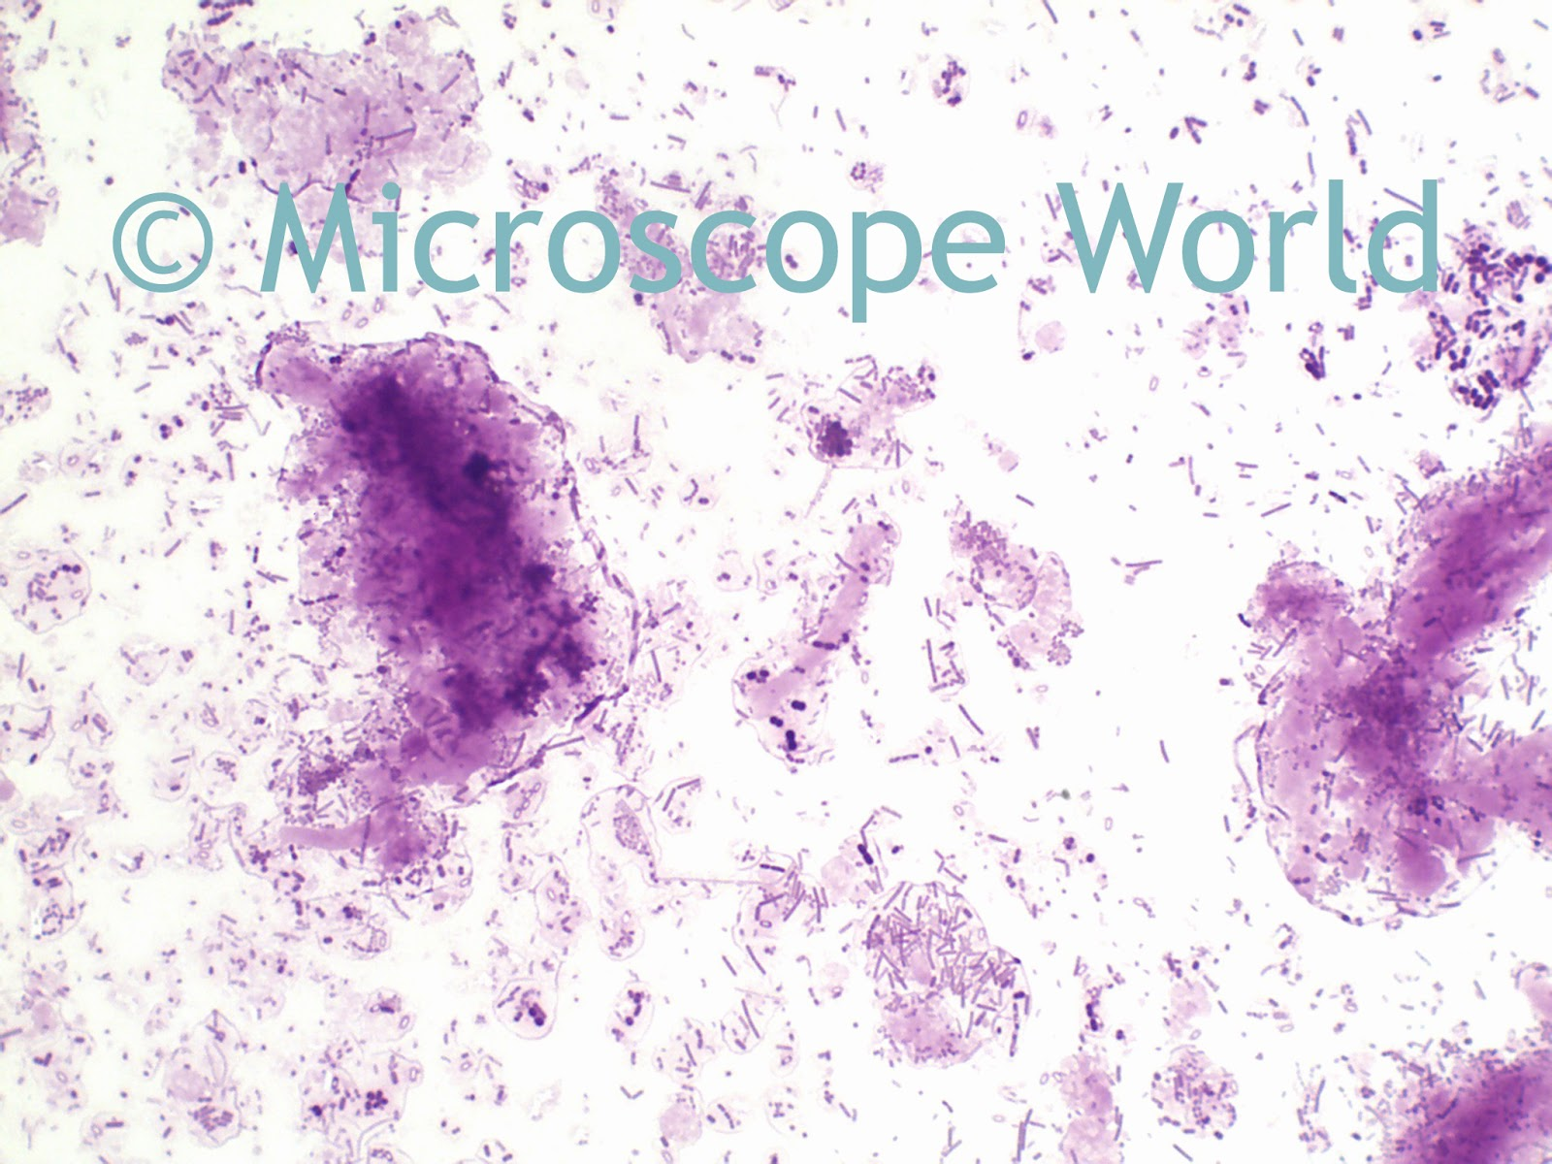
Viewed using a 40X objective lens

