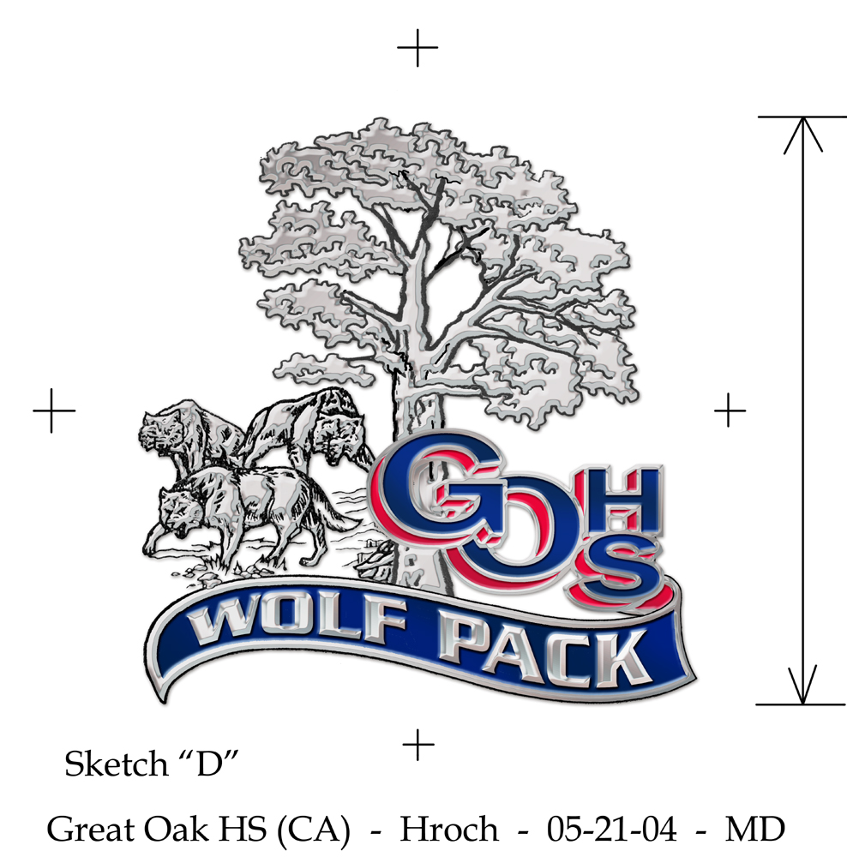

RE: Science Laboratory Donation

Dear Parent(s):

The Science Department at Great Oak High School wants to provide the optimum experience for your student as he/she takes science classes. The cost for providing the best laboratory experiences for our students has become increasingly expensive.

In addition to replacing broken equipment, lab donations assist with the purchase of the following supplemental materials:

- Expendable materials for Biology laboratories,
- Rare earth chemicals that would allow for a broader range of student-led laboratory experiments in Chemistry that are normally done as demonstrations,
- Physics student-led experiments and expendable equipment,
- Disposable materials so students can do Global Science laboratories that would otherwise be done as teacher demonstrations,
- Expendable materials for AP/IB Biology (HL1 and HL2) and Forensics laboratories,
- Rare earth chemicals that would allow for a broader range of student-led laboratory experiments in AP/IB Chemistry (SL) that are normally done as demonstrations, and
- Laboratory dissection specimens for Anatomy/Physiology and Marine Biology.

Voluntary lab donations would be appreciated and will be accepted at the beginning of the first semester of the class in which your child is enrolled. The money collected will be used to buy materials to enhance the program for all science students.

The donation is voluntary and will not impact your student grades or participation in any laboratory experiments or using supplemental materials purchased. If your son/daughter has more than one science class per semester, there will be only one lab donation for the entire year. We look forward to a very successful year for your sons and daughters in our science program.

Please make checks out to GOHS Science.

