Advanced Placement Chemistry

2002 Multiple Choice Questions
Notes
- Note: For all questions involving solutions and/or chemical equations, assume that the system is in pure water at room temperature unless otherwise noted.

Questions 1-4 refer to the following types of energy.
(A) Activation energy
(B) Free energy
(C) Ionization energy
(D) Kinetic energy
(E) Lattice energy
1. The energy required to convert a ground-state atom in the gas phase to a gaseous positive ion
2. The energy change that occurs in the conversion of an ionic solid to widely separated gaseous ions
3. The energy in a chemical or physical change that is available to do useful work
4. The energy required to form the transition state in a chemical reaction
Question 5-8 refer to atoms for which the occupied atomic orbitals shown below.
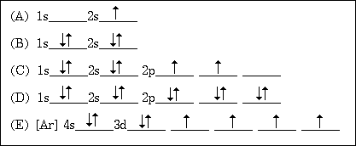
5. Represents an atom that is chemically unreactive
6. Represents an atom in an excited state
7. Represents an atom that has four valence electrons.
8. Represents an atom of a transition metal.

Question 9-12 refer to aqueous solutions containing 1:1 mole ratios of the following pairs of substances. Assume all concentrations are 1 M.
(A) NH₃ and NH₄Cl
(B) H₃PO₄ and NaH₂PO₄
(C) HCl and NaCl
(D) NaOH and NH₃
(E) NH₃ and HC₂H₃O₂ (acetic acid)
9. The solution with the lowest pH
10. The most nearly neutral solution
11. A buffer at a pH > 8
12. A buffer at a pH < 6
Questions 13-16 refer to the following descriptions of bonding in different types of solids.
(A) Lattice of positive and negative ions held together by electrostatic forces.
(B) Closely packed lattice with delocalized electrons throughout
(C) Strong single covalent bonds with weak intermolecular forces.
(D) Strong multiple covalent bonds (including bonds.) with weak intermolecular forces
(E) Macromolecules held together with strong polar bonds.
13. Cesium chloride, CsCl (s)
14. Gold, Au(s)
15. Carbon dioxide, CO₂(s)
16. Methane, CH₄(s)
Question 17-18 refer to the following elements.
(A) Lithium
(B) Nickel
(C) Bromine
(D) Uranium
(E) Fluorine
17. Is a gas in its standard state at 298 K
18. Reacts with water to form a strong base

Directions: Each of the questions or incomplete statements below is by five suggested answers or completions. Select the one that is best in each case and then fill in the corresponding oval on the answer sheet.
19. Which of the following best describes the role of the spark from the spark plug in an automobile engine?
(A) The spark decreases the energy of activation for the slow step.
(B) The spark increases the concentration of the volatile reactant.
(C) The spark supplies some of the energy of activation for the combustion reaction.
(D) The spark provides a more favorable activated complex for the combustion reaction.
(E) The spark provides the heat of vaporization for the volatile hydrocarbon.
20. What mass of Au is produced when 0.0500 mol of Au₂S₃ is reduced completely with excess H₂?
(A) 9.85 g
(B) 19.7 g
(C) 24.5 g
(D) 39.4 g
(E) 48.9 g
21. When a solution of sodium chloride is vaporized in a flame, the color of the flame is
(A) blue
(B) yellow
(C) green
(D) violet
(E) White

22. Of the following reaction, which involves the largest decrease in entropy?
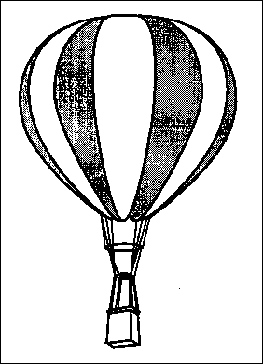
(A) CaCO₃(s) ---> CaO(s) + CO₂(g)
(B) 2 CO(g) + O₂(g) ---> 2 CO₂
(C) Pb(NO₃)₃ + 2 KI ---> PbI₂ + 2 KNO₃
(D) C₃H₈ + O₂ ---> 3 CO₂ + 4 H₂O
(E) 4 La + 3 O₂ ---> 2 La₂O₃
23. A hot-air balloon, shown right, rises. Which of the following is the best explanation for this observation?
(A) The pressure on the walls of the balloon increases with increasing temperature.
(B) The difference in temperature between the air inside and outside the balloon produces convection currents.
(C) The cooler air outside the balloon pushes in on the walls of the balloon.
(D) The rate of diffusion of cooler air is less than that of warmer air.
(E) The air density inside the balloon is less than that of the surrounding air.

24. The safest and most effective emergency procedure to treat an acid splash on skin is to do which of the following immediately?
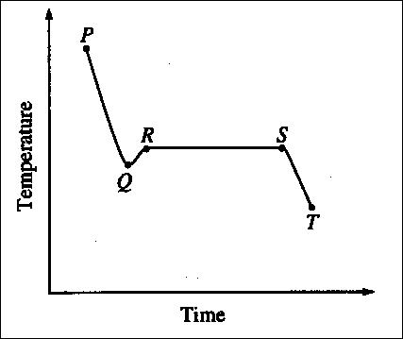
(A) Dry the affected area with paper towels
(B) Sprinkle the affected area with powdered Na₂SO₄(s)
(C) Flush the affected area with water and then with a dilute NaOH solution
(D) Flush the affected area with water and then with a dilute NaHCO₃ solution
(E) Flush the affected area with water and then with a dilute vinegar solution
25. The cooling curve for a pure substance as it changes from a liquid to a solid is shown right. The solid and the liquid coexist at
(A) point Q only
(B) point R only
(C) all points on the curve between Q and S
(D) all points on the curve between R and T
(E) no point on the curve

. . .C₁₀H₁₂O₄S(s) + . . O₂(g) ---> . . . CO₂(g) + . . . SO₂(g) + . . . H₂O(g)
26. When the equation above is balanced and all coefficients are reduced to their lowest whole-number terms, the coefficient for O₂(g) is?
(A) 6
(B) 7
(C) 12
(D) 14
(E) 28
27. Appropriate uses of a visible-light spectrophotometer include which of the following?
I. Determining the concentration of a solution of Cu(NO₃)₂
II. Measuring the conductivity of a solution of KMnO₄
III. Determining which ions are present in a solution that may contain Na⁺, Mg²⁺, Al³⁺
(A) I only
(B) II only
(C) III only
(D) I and II only
(E) I and III only

28. The melting point of MgO is higher than that of NaF. Explanations for this observation include which of the following?
I. Mg²⁺ is more positively charged than Na⁺
II. O²¯ is more negatively charged than F¯
III. The O²¯ ion is smaller than the F¯ ion
(A) II only
(B) I and II only
(C) I and III only
(D) II and III only
(E) I, II, and III
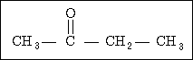
29. The organic compound represented above is an example of
(A) an organic acid
(B) an alcohol
(C) an ether
(D) an aldehyde
(E) a ketone
30. Which of the following is true regarding the reaction represented above?
(A) The oxidation number of O does not change.
(B) The oxidation number of H changes from -1 to +1.
(C) The oxidation number of F changes from +1 to -1.
(D) The oxidation number of Se changes from -2 to +6.
(E) It is a disproportionation reaction for F.
31. If the temperature of an aqueous solution of NaCl is increased from 20 °C to 90 °C, which of the following statements is true?
(A) The density of the solution remains unchanged.
(B) The molarity of the solution remains unchanged.
(C) The molality of the solution remains unchanged.
(D) The mole fraction of solute decreases.
(E) The mole fraction of solute increases.
32. Types of hybridization exhibited by the C atoms in propene, CH₃CHCH₂, include which of the following?
I. sp
II. sp²
III. sp³
(A) I only
(B) III only
(C) I and II only
(D) II and III only
(E) I, II, and III
33. A 1.0 sample of an aqueous solution contains 0.10 mol of NaCl and 0.10 mol of CaCl₂. What is the minimum number of moles of AgNO₃ that must be added to the solution in order to precipitate all of the Cl¯ as AgCl(s)? (Assume that AgCl is insoluble.)
(A) 0.10 mol
(B) 0.20 mol
(C) 0.30 mol
(D) 0.40 mol
(E) 0.60 mol
Questions 34-35 refer to an electrolytic cell that involves the following half-reaction.
AlF₆³¯ + 3 e¯ ---> Al + 6F¯
34. Which of the following occurs in the reaction?
(A) AlF ₆³¯ is reduced at the cathode.
(B) Al is oxidized at the anode.
(C) Aluminum is converted from the -3 oxidation state to the 0 oxidation state.
(D) F¯ acts as a reducing agent.
(E) F¯ is reduced at the cathode.
35. As steady current of 10 amperes in passed though an aluminum-production cell for 15 minutes. Which of the following is the correct expression for calculating the number of grams of aluminum produced?
(1 faraday = 96,500 coulombs)
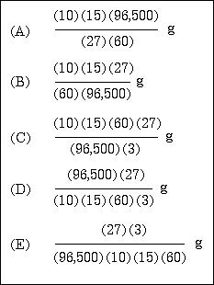
36. The initial-rate data in the table above were obtained for the reaction represented below. What is the experimental rate law for the reaction?
Experiment | Initial [NO]  (mol L¯¹ | Initial [O₂]  (mol L¯¹ | Initial Rate of  Formation of NO₂  (mol L¯¹ s¯¹)
1 | 0.10 | 0.10 | 2.5 x 10¯⁴
2 | 0.20 | 0.10 | 5.0 x 10¯⁴
3 | 0.20 | 0.40 | 8.0 x 10¯³
(A) rate = k[NO] [O₂]
(B) rate = k[NO] [O₂]²
(C) rate = k[NO]² [O₂]
(D) rate = k[NO]² [O₂]²
(E) rate = k[NO] / [O₂]
Ionization Energies for element X (kJ mol¯¹)
First | Second | Third | Fourth | Five
580 | 1815 | 2740 | 11600 | 14800
37. The ionization energies for element X are listed in the table above. On the basis of the data, element X is most likely to be
(A) Na
(B) Mg
(C) AI
(D) Si
(E) P
38. A molecule or an ion is classified as a Lewis acid if it
(A) accepts a proton from water
(B) accepts a pair of electrons to form a bond
(C) donates a pair of electrons to form a bond
(D) donates a proton to water
(E) has resonance Lewis electron-dot structures
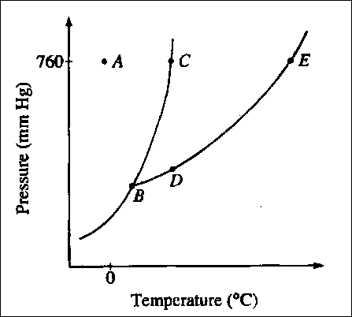
39. The phase diagram for a pure substance is shown above. Which point on the diagram corresponds to the equilibrium between the solid and liquid phases at the normal melting point?
(A) A
(B) B
(C) C
(D) D
(E) E

40. Of the following molecules, which has the largest dipole moment?
(A) CO
(B) CO₂
(C) O₂
(D) HF
(E) F₂
. . . Li₃N(s) + . . . H₂O(l) ---> . . . Li⁺ (aq) + . . . OH¯(aq) + . . . NH₃(g)
42. When the equation above is balanced and all coefficients reduced to lowest whole number terms, the coefficient for OH¯(aq) is
(A) 1
(B) 2
(C) 3
(D) 4
(E) 6
43. A sample of 61.8 g of H₃BO₃, a weak acid is dissolved in 1,000 g of water to make a 1.0-molal solution. Which of the following would be the best procedure to determine to molarity of the solution? (Assume no additional information is available.)
(A) Titration of the solution with standard acid
(B) Measurement of the pH with a pH meter
(C) Determination of the boiling point of the solution
(D) Measurement of the total volume of the solution
(E) Measurement of the specific heat of the solution
44. A rigid metal tank contains oxygen gas. Which of the following applies to the gas in the tank when additional oxygen is added at constant temperature?
(A) The volume of the gas increase.
(B) The pressure of the gas decreases.
(C) The average speed of the gas molecules remains th same.
(D) The total number of gas molecules remains the same.
(E) The average distance between the gas molecules increases.
45. What is the H⁺(aq) concentration in 0.05 M HCN (aq) ? (The K_{a} for HCN is 5.0 x 10¯¹⁰)
(A) 2.5 x 10¯¹¹
(B) 2.5 x 10¯¹⁰
(C) 5.0 x 10¯¹⁰
(D) 5.0 x 10¯⁶
(E) 5.0 x 10¯⁴
46. Which of the following occurs when excess concentrated NH₃(aq) is mixed throughly with 0.1 M Cu(NO₃)₂(aq) ?
(A) A dark red precipitate forms and settles out.
(B) Separate layers of immiscible liquids form with a blue layer on top.
(C) The color of the solution turns from light blue to dark blue.
(D) Bubbles of ammonia gas form.
(E) The pH of the solution decreases.

47. When hafnium metal is heated in an atmosphere of chlorine gas, the product of the reaction is found to contain 62.2 percent Hf by mass and 37.4 percent Cl by mass. What is the empirical formula for this compound?
(A) HfCl
(B) HfCl₂
(C) HfCl₃
(D) HfCl₄
(E) Hf₂Cl₃
48. If 87.5 percent of a sample of pure ¹³¹I decays in 24 days, what is the half-life of ¹³¹I?
(A) 6 days
(B) 8 days
(C) 12 days
(D) 14 days
(E) 21 days
49. Which of the following techniques is most appropriate for the recovery of solid KNO₃ from an aqueous solution of KNO₃?
(A) Paper chromatography
(B) Filtration
(C) Titration
(D) Electrolysis
(E) Evaporation to dryness
50. In the periodic table, as the atomic number increases from 11 to 17, what happens to the atomic radius?
(A) It remains constant.
(B) It increases only.
(C) It increases, then decreases.
(D) It decreases only.
(E) It decreases, then increases.
51. Which of the following is a correct interpretation of the results of Rutherford's experiments in which gold atoms were bombarded with alpha particles?
(A) Atoms have equal numbers of positive and negative charges.
(B) Electrons in atoms are arranged in shells.
(C) Neutrons are at the center of an atom.
(D) Neutrons and protons in atoms have nearly equal mass.
(E) The positive charge of an atom is concentrated in a small region.
52. Under which of the following sets of conditions could the most O₂(g) be dissolved in H₂O(l)?
 | Pressure of O₂(g)  Above H₂O(l)  (atm) | Temperature  of H₂O(l)  °(C)
A) | 5.0 | 80
B) | 5.0 | 20
C) | 1.0 | 80
D) | 1.0 | 20
E) | 0.5 | 20

W(g) + X(g) --> Y(g) + Z(g)
53. Gases W and X react in a closed, rigid vessel to form gases Y and Z according to the equation above. The initial pressure of W(g) is 1.20 atm and that of X(g) is 1.60 atm. No Y(g) or Z(g) is initially present. The experiment is carried out at constant temperature. What is the partial pressure of Z(g) when the partial pressure of W(g) has decreased to 1.0 atm?
A) 0.20 atm
B) 0.40 atm
C) 1.0 atm
D) 1.2 atm
E) 1.4 atm
2NO(g) + O₂(g) <===> 2 NO₂(g)
ΔH < 0
54. Which of the following changes alone would cause a decrease in the value of K_{eq} for the reaction represented above?
A) Decreasing the temperature
B) Increasing the temperature
C) Decreasing the volume of the reaction vessel
D) Increasing the volume of the reaction vessel
E) Adding a catalyst
10 HI + 2 KMnO₄ + 3 H₂SO₄ --> 5 I₂ + 2 MnSO₄ + K₂SO₄ + 8 H₂O
55. According to the balanced equation above, how many moles of HI would be necessary to produce 2.5 mol of I₂, starting with 4.0 mol of KMnO₄ and 3.0 mol of H₂SO₄?
A) 20
B) 10
C) 8.0
D) 5.0
E) 2.5
56. A yellow precipitate forms when 0.5 M NaI(aq) is added to a 0.5 M solution of which of the following ions?
A) Pb²⁺(aq)
B) Zn²⁺(aq)
C) CrO₄²¯(aq)
D) SO₄²¯(aq)
E) OH¯(aq)
M(s) + 3 Ag⁺(aq) --> 3 Ag(s) + M³⁺(aq) | E = +2.46 V
Ag⁺(aq) + e¯ --> Ag(s) | E = +0.80 V
57. According to the information above, what is the standard reduction potential for the half-reaction M³⁺(aq) + 3 e¯ --> M(s)?
A) -1.66 V
B) -0.06 V
C) 0.06 V
D) 1.66 V
E) 3.26 V
58. On a mountaintop, it is observed that water boils at 90°C, not at 100°C as at sea level. This phenomenon occurs because on the mountaintop the
A) equilibrium water vapor pressure is higher due to the higher atmospheric pressure
B) equilibrium water vapor pressure is lower due to the higher atmospheric pressure
C) equilibrium water vapor pressure equals the atmospheric pressure at a lower temperature
D) water molecules have a higher average kinetic energy due to the lower atmospheric pressure
E) water contains a greater concentration of dissolved gases
59. A 40.0 mL sample of 0.25 M KOH is added to 60.0 mL of 0.15 M Ba(OH)₂. What is the molar concentration of OH¯(aq) in the resulting solution? (Assume that the volumes are additive)
A) 0.10 M
B) 0.19 M
C) 0.28 M
D) 0.40 M
E) 0.55 M
NH₄NO₃(s) --> N₂O(g) + 2 H₂O(g)
60. A 0.03 mol sample of NH₄NO₃(s) decomposes completely according to the balanced equation above. The total pressure in the flask measured at 400 K is closest to which of the following? ( The value of the gas constant, R, is 0.082 L atm mol¯¹ K¯¹)
(A) 3 atm
(B) 1 atm
(C) 0.5 atm
(D) 0.1 atm
(E) 0.03 atm
C₂H₄(g) + 3 O₂(g) --> 2 CO₂(g) + 2 H₂O(g)
61. For the reaction of ethylene represented above, ΔH is - 1,323 kJ. What is the value of ΔH if the combustion produced liquid water H₂O(l), rather than water vapor H₂O(g)? (ΔH for the phase change H₂O(g) --> H₂O(l) is -44 kJ mol¯¹.)
A) -1,235 kJ
B) -1,279 kJ
C) -1,323 kJ
D) -1,367 kJ
E) -1,411 kJ
HC₂H₃O₂(aq) + CN¯(aq) <===> HCN(aq) + C₂H₃O₂¯(aq)
62. The reaction represented above has an equilibrium constant equal to 3.7 x 10⁴. Which of the following can be concluded from this information?
A) CN¯(aq) is a stronger base than C₂H₃O₂¯(aq)
B) HCN(aq) is a stronger acid than HC₂H₃O₂(aq)
C) The conjugate base of CN¯(aq) is C₂H₃O₂¯(aq)
D) The equilibrium constant will increase with an increase in temperature.
E) The pH of a solution containing equimolar amounts of CN¯(aq) and HC₂H₃O₂(aq) is 7.0.
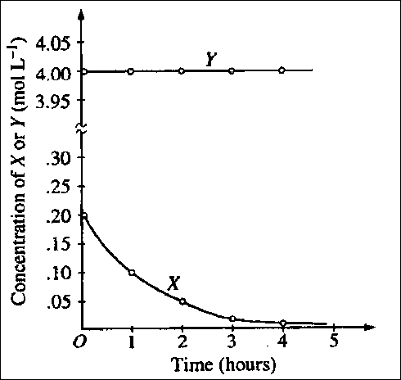
63. The graph above shows the results of a study of the reaction of X with a large excess of Y to yield Z. The concentrations of X and Y were measured over a period of time. According to the results, which of the following can be concluded about the rate of law for the reaction under the conditions studied?
A) It is zero order in [X].
B) It is first order in [X].
C) It is second order in [X].
D) It is the first order in [Y].
E) The overall order of the reaction is 2.
64. Equal numbers of moles of He(g), Ar(g), and Ne(g) are placed in a glass vessel at room temperature. If the vessel has a pinhole-sized leak, which of the following will be true regarding the relative values of the partial pressures of the gases remaining in the vessel after some of the gas mixture has effused?
A) P_{He} < P_{Ne} < P_{Ar}
B) P_{He} < P_{Ar} < P_{Ne}
C) P_{Ne} < P_{Ar} < P_{He}
D) P_{Ar} < P_{He} < P_{Ne}
E) P_{He} = P_{Ar} = P_{Ne}
65. Which of the following compounds is NOT appreciably soluble in water but is soluble in dilute hydrochloric acid?
A) Mg(OH)₂(s)
B) (NH₄)₂CO₃(s)
C) CuSO₄(s)
D) (NH₄)₂SO₄(s)
E) Sr(NO₃)₂(s)

66. When solid ammonium chloride, NH₄Cl(s) is added to water at 25 °C, it dissolves and the temperature of the solution decreases. Which of the following is true for the values of ΔH and ΔS for the dissolving process?
 | ΔH | ΔS
A) | Postive | Positive
B) | Positive | Negative
C) | Positive | Equal to zero
D) | Negative | Positive
E) | Negative | Negative
67. What is the molar solubility in water of Ag₂CrO₄? (The K_{sp} for Ag₂CrO₄ is 8 x 10¯¹².)
A) 8 x 10¯¹² M
B) 2 x 10¯¹² M
C) (4 x 10¯¹² M)^{1/2}
D) (4 x 10¯¹² M)^{1/3}
E) (2 x 10¯¹² M)^{1/3}
68. In which of the following processes are covalent bonds broken?
A) I₂(s) --> I₂(g)
B) CO₂(s) --> CO₂(g)
C) NaCl(s) --> NaCl(l)
D) C(diamond) --> C(g)
E) Fe(s) --> Fe(l)
69. What is the final concentration of barium ions, [Ba²⁺], in solution when 100. mL of 0.10 M BaCl₂(aq) is mixed with 100. mL of 0.050 M H₂SO₄(aq)?
A) 0.00 M
B) 0.012 M
C) 0.025 M
D) 0.075 M
E) 0.10 M
70. When 100 mL of 1.0 M Na₃PO₄ is mixed with 100 mL of 1.0 M AgNO₃, a yellow precipitate forms and [Ag⁺] becomes negligibly small. Which of the following is a correct listing of the ions remaining in solution in order of increasing concentration?
A) [PO₄³¯] < [NO₃¯] < [Na⁺]
B) [PO₄³¯] < [Na⁺]<[NO₃¯]
C) [NO₃¯] < [PO₄³¯] < [Na⁺]
D) [Na⁺] < [NO₃¯] < [PO₄³¯]
E) [Na⁺] < [PO₄³¯] < [NO₃¯]
71. In a qualitative ananlysis for the presence of Pb²⁺, Fe²⁺, and Cu²⁺ ions in a aqueous solution, which of the following will allow the separation of Pb²⁺ from the other ions at room temperature?
A) Adding dilute Na₂S(aq) solution
B) Adding dilute HCl(aq) solution
C) Adding dilute NaOH(aq) solution
D) Adding dilute NH₃(aq) solution
E) Adding dilute HNO₃(aq) solution
72. After completing an experiment to determine gravimetrically the percentage of water in a hydrate, a student reported a value of 38 percent. The correct value for the percentage of water in the hydrate is 51 percent. Which of the following is the most likely explanation for this difference?
A) Strong initial heating caused some of the hydrate sample to spatter out of the crucible.
B) The dehydrated sample absorbed moisture after heating.
C) The amount of the hydrate sample used was too small.
D) The crucible was not heated to constant mass before use.
E) Excess heating caused the dehydrated sample to decompose.
73. The volume of distilled water that should be added to 10.0 mL of 6.00 M HCl(aq) in order to prepare a 0.500 M HCl(aq) solution is approximately
A) 50.0 mL
B) 60.0 mL
C) 100. mL
D) 110. mL
E) 120. mL
74. Which of the following gases deviates most from ideal behavior?
A) SO₂
B) Ne
C) CH₄
D) N₂
E) H₂
75. Which of the following pairs of liquids forms the solution that is most ideal (most closely follows Raoult's law)?
A) C₈H₁₈(l) and H₂O(l)
B) CH₃CH₂CH₂OH(l) and H₂O(l)
C) CH₃CH₂CH₂OH(l) and C₈H₁₈(l)
D) C₆H₁₄(l) and C₈H₁₈(l)
E) H₂SO₄(l) and H₂O(l)

