Procedure: You will be recording/collecting data from an online source. You will then import the data into Excel and create a graph of your property vs. atomic number. Please record your data in a table that you have created in an excel file for the first 36 elements on the periodic table.

Periodic Trends
In 1870, Dmitri Mendeleev first proposed a new way of studying and organizing the then known 63 elements. The modern form of the table has been modified and improved many times since Mendeleev’s tables. Pioneers like Moseley (1913) and Seaborg (1941) have made the properties of the elements much simpler to study and understand.
In this activity, you are going to discover some of the trends of the properties that exist on the modern periodic table. To do this, you are going to graph a property to determine the trend then share your trends with the class.

DATA

Property _______________________________________________ Units ____________

Atomic Symbol Atomic Number Group
(coded) Value Atomic Symbol Atomic Number Group
(coded) Value 1 1.1 26 8.4 2 18.1 27 9.4 3 1.2 28 10.4 4 2.2 29 11.4 5 13.2 30 12.4 6 14.2 31 13.4 7 15.2 32 14.4 8 16.2 33 15.4 9 17.2 34 16.4 10 18.2 35 17.4 11 1.3 36 18.4 12 2.3 37 1.5 13 13.3 38 2.5 14 14.3 39 3.5 15 15.3 40 4.5 16 16.3 41 5.5 17 17.3 42 6.5 18 18.3 43 7.5 19 1.4 44 8.5 20 2.4 45 9.5 21 3.4 46 10.5 22 4.4 47 11.5 23 5.4 48 12.5 24 6.4 49 13.5 25 7.4 50 14.5

PROCESSING THE DATA
1. Define your property and how it is determined.
2. What is the trend as you move across a period (row)?

3. What is the trend as you move down a group (column)?

4. On the representation of the periodic table below, draw arrows to represent an increasing trend for period and group.

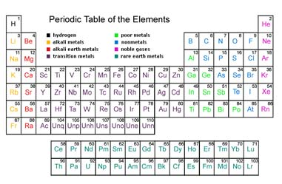
5. Share your results with your class. Compare the trends of your property with trends of other physical properties. If directed to do so by your teacher, complete the Periodic Trends Summary Sheet to record the class data.

