ENERGY OF A PEANUT: AN EXPERIMENT IN CALORIMETRY
©2002, 1995, by David A. Katz. All rights reserved.

INTRODUCTION:
In this experiment, the energy of a peanut will be determined using a simplified set-up. The peanut will be burned in air, instead of pure oxygen. Instead of a heavy metal bomb, an aluminum can is used. To eliminate the determination of the specific heat of the metal can (the heat needed to heat the metal that composes the can), the experimental conditions are modified to maintain a constant temperature of the can by filling it with a large quantity of ice. This will maintain a temperature of 0ºC, as long as all the ice does not melt. The heat evolved by the burning peanut will melt some of the ice and the amount of liquid water formed will be measured to give the heat of combustion of the sample. After determining the energy of a peanut 3 trials), the procedure may be repeated using other snack foods if you wish.

1. MATERIALS NEEDED:
An aluminum can with the top removed
wire stand to hold the peanut
150ºC thermometer
graduated cylinder, 50-mL
tongs or forceps
funnel
peanuts or other nuts such as almonds, cashews, pecans, walnuts, etc.
ice

2. SAFETY PRECAUTIONS:
Wear safety goggles or glasses at all times in the laboratory.
CAUTION – HEALTH HAZARD: This procedure involves burning nuts. If you are allergic to
nuts, or have any severe food allergies, inform your instructor immediately so that you may be
excused from this experiment. Do not stay in the laboratory. . There are no safety hazards with
any of the materials used in this experiment.
The metal stand holding the sample will get hot during the reaction. Handle it using tongs or
forceps. Do not eat any of the foods used in this experiment. It is assumed that they may be contaminated
with laboratory chemicals.

3. DISPOSAL:
There are no disposal problems with materials in this experiment. Burnt peanuts, or snack food, can be
disposed of in the trash. Ice and water should be placed in sink.

4. EXPERIMENTAL PROCEDURE:
Obtain a metal can. If necessary, wipe any carbon deposits off the bottom of the can using a paper
towel. Set up the apparatus as shown in Figure 1. Use a large adjustable clamp to hold the metal can.
Place a metal stand for holding the peanut on the base of the ring stand. Loosen the clamp and
move the metal can off to the side of the apparatus.
Select a peanut (or other nut), weigh it, and record its mass.
Add ice to the can so it is at least half-filled.
Place the peanut (or other nut used) on the stand and light it using a match or a burner. Move the
can over the burning peanut and position it so that the top of the flame just touches the bottom of
the can. Allow the peanut to burn completely. If the flame goes out and the peanut is not
completely burned, relight the peanut. Remember to move the can away from over the peanut
when relighting it. After the nut, or other food material, is burned, some charcoal remains. Carefully transfer the remaining material to a preweighed piece of weighing paper, or a weighing dish, and weigh it.
Determine the mass of the remaining material. The mass of peanut, or food, burned is equal to the initial mass of the peanut, or other food, minus the mass of the remaining material. After the peanut has burned out, using the clamp holding the can as a handle, carefully pour the liquid water (but no ice) from the can into the graduated cylinder. Placing a funnel on top of the graduated cylinder will prevent any solid ice from falling into the cylinder. Determine the volume of the water and record it in your notebook.
Repeat the procedure with another peanut (or the same kind of nut previously used) for 3 trials.

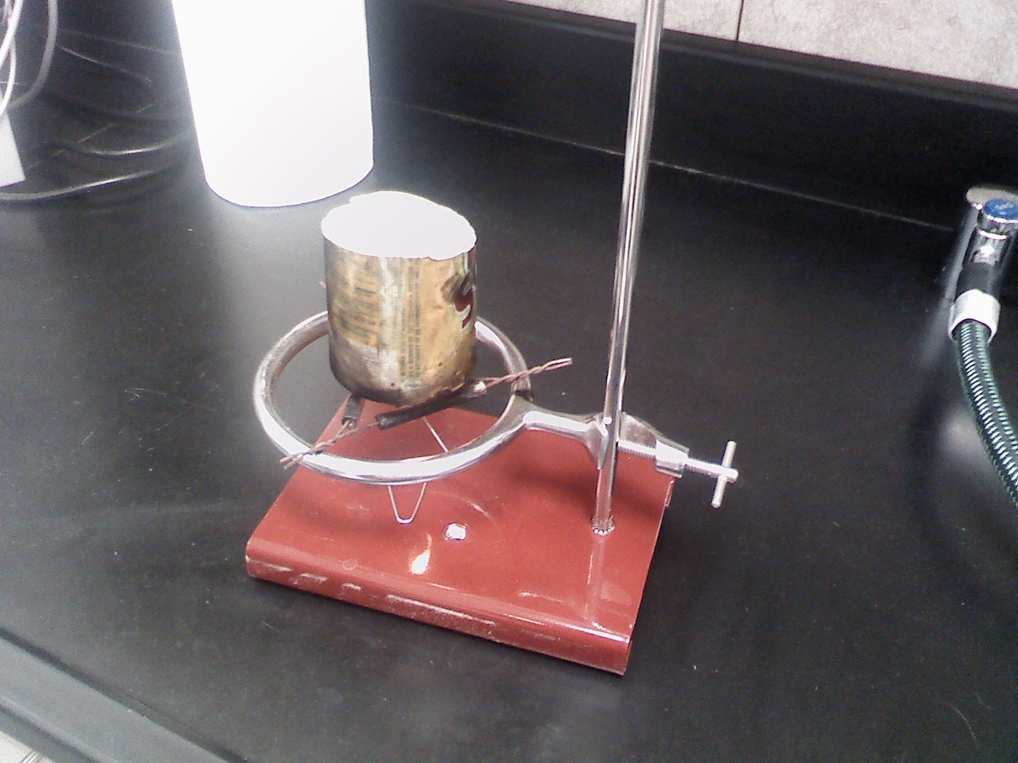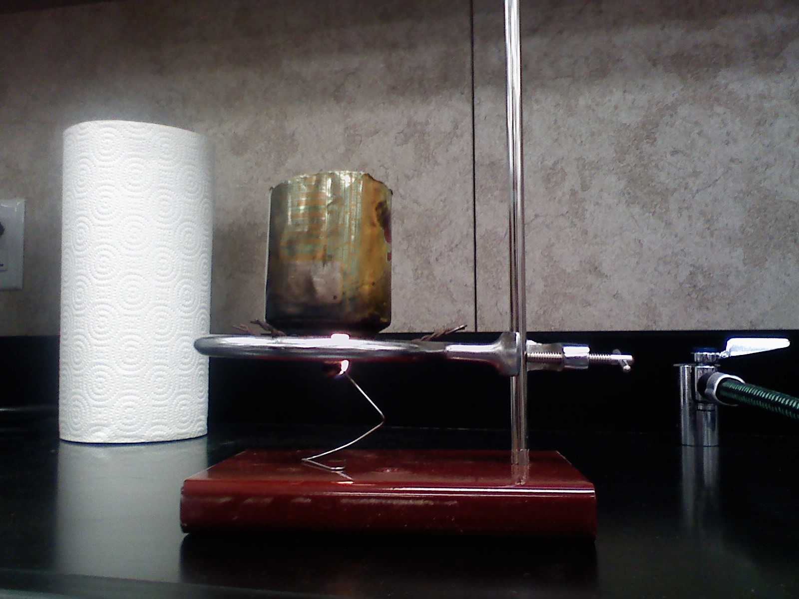
Figure 1. Apparatus for determination of the energy of a peanut

5. CALCULATIONS:
In this experiment, heat is measured in joules. 4.18 joules is the quantity of heat needed
to raise the temperature of one gram of water by 1ºC. Due to the excess of ice in the metal can, the temperature of the system should remain constant at 0ºC, thus we are melting ice into liquid water at a constant temperature. The heat needed to melt 1 g of ice to water at 0ºC is known as the heat of fusion and has a value of 334 J/g for water. Calculate the value of the Δ H per gram of your peanut using your knowledge of heat for each trial and then compare the average of the three trials with the value listed on the package.

Conclusion and Evaluation:
The usual…

DCP and CE will be assessed for this lab.

Tips for success
Print out the PSOW form and look over the rubric before you begin the lab. This will remind you of what you will be assessed on and hopefully direct your lab write-up.

Checklist for data collection and processing of H_{comb} of Peanut Lab --Our rubric for this lab

Aspect 1: recording raw data

□ I have recorded my data independently
□ I have data which is quantitative (numerical) and qualitative (direct obs.)
□ I have chosen a suitable format in which to record the raw data
□ The variable that is measured or recorded is clearly stated (e.g. in the column
heading in a table). It is clear what was measured.
□ The units are given for every variable (e.g. in any column headings)
□ An indication is given of the uncertainty of measurements (e.g. in any column
headings)
□ A complete and descriptive title is given to any table that is used
□ The same level of precision (number of decimal places) is used for all the items of
a variable.

Aspect 2: processing raw data

□ I have calculated the amount of heat needed to melt the volume of ice that was
melted using the appropriate equation.
□ I have calculated the heat of combustion /g of the peanut in units of Joules/g.
□ I have used correct sig- figs and labeled all numbers with the correct units.
□ I have propagated the uncertainty correctly.
□ I have calculated the average of the three trials.
□ I have calculated the % error of the average of three trials using the value on the
peanut container as the accepted literature value.

Aspect 3: presenting processed data

□ I have explained the process and shown the set-up for each step in the calculation
of the heat of combustion of a peanut.
□ I have shown the average heat of combustion of the peanut.
□ I have calculated the average Δ H of the three trials.

Checklist for conclusion and evaluation

Aspect 1: concluding

□ I have stated what the average heat of combustion of the peanut is as I measured it.
□ I have stated what the label value is in units of Joules/g .
□ I give a justification for my conclusion
□ I have compared my calculated value with the label value of the heat of combustion and
discussed whether this error could be attributed to random error or systematic error.

Aspect 2: evaluating procedures

□ I have commented on the design and method of the investigation.
□ I have commented on the quality of the data.
□ I have listed the weaknesses of the process.
□ I have assessed the importance of each of these weaknesses
□ I have commented on the precision and accuracy of the measurements.
□ In evaluating the procedure, I have specifically looked at the processes, the use of
equipment and the management of time.
□ I have not listed “human error” as a systematic error.
□ I have commented only on weaknesses or items that I have noted in the qualitative data
area of the lab.

Aspect 3: improving the investigation ( What you would do differently if you wanted better results)

□ My suggestions for improvements are based on the weaknesses and limitations identified in aspect 2
□ I address modifications to the experimental technique. These modifications are process centered.
□ The modifications that I propose are realistic and clearly specified

