The empirical formula of a compound
Reference: Chapter 1, Section 1.2, pages 21–24
Please note
- A full risk assessment should be carried out prior to commencing this experiment.
- Personal safety equipment should be worn.
- Chemicals should be disposed of safely and with due regard to any environmental considerations.
Aim
To determine the empirical formula of the compound which forms between magnesium and oxygen.
Introduction
The empirical formula of a compound shows the simplest ratio of atoms present.
In this experiment we will calculate the empirical formula of the compound magnesium oxide, formed by the combustion of magnesium in the air. We will calculate the change in the mass of magnesium on heating it, and assume that the increase in mass is due to the oxygen that has combined.
But when magnesium burns in air, the temperature becomes high enough for it to combine with both the oxygen and the nitrogen in the air. The magnesium therefore forms a mixture of magnesium oxide and magnesium nitride after combustion. So we need to convert the magnesium nitride in this mixture to magnesium oxide, before we can calculate the change in mass. The conversion of magnesium nitride is done in two steps:
step 1 add water to convert magnesium nitride to magnesium hydroxide, releasing ammonia, NH₃
step 2 heat the magnesium hydroxide to convert it to magnesium oxide.
Pre-lab questions
1 What are the formulas of magnesium nitride and magnesium hydroxide? (Look at Chapter 4, pages 116–118, if you are unsure of the formulas of the ions.)
2 Write an equation for the reaction in which magnesium nitride forms when magnesium burns in air.
3 Write an equation for the reaction described in step 1 above.
4 Write an equation for the reaction described in step 2 above.
Method
1 Record the mass of a clean, dry crucible with its lid. (Handle the crucible with tongs, not your fingers, to avoid moisture and oil from your fingers being transferred.)
2 Use fine sand paper or steel wool to scrape the oxide coating from the surface of a strip of magnesium ribbon approximately 2 cm length. Cut the ribbon into small pieces, place in the crucible, and weigh the crucible, its lid, and contents.
3 Heat the crucible in a hot flame for 10 minutes, ensuring that the magnesium is exposed to air but that no solid escapes. After this time the magnesium should have been converted to a white powder.
4 Allow the crucible to cool and then add 10 drops of water to convert the magnesium nitride to magnesium hydroxide.
5 Heat the crucible gently to drive off any water, then strongly for 3 minutes to convert the magnesium hydroxide to magnesium oxide.
6 Allow the crucible to cool. Weigh the crucible, its lid, and the product of the reaction.
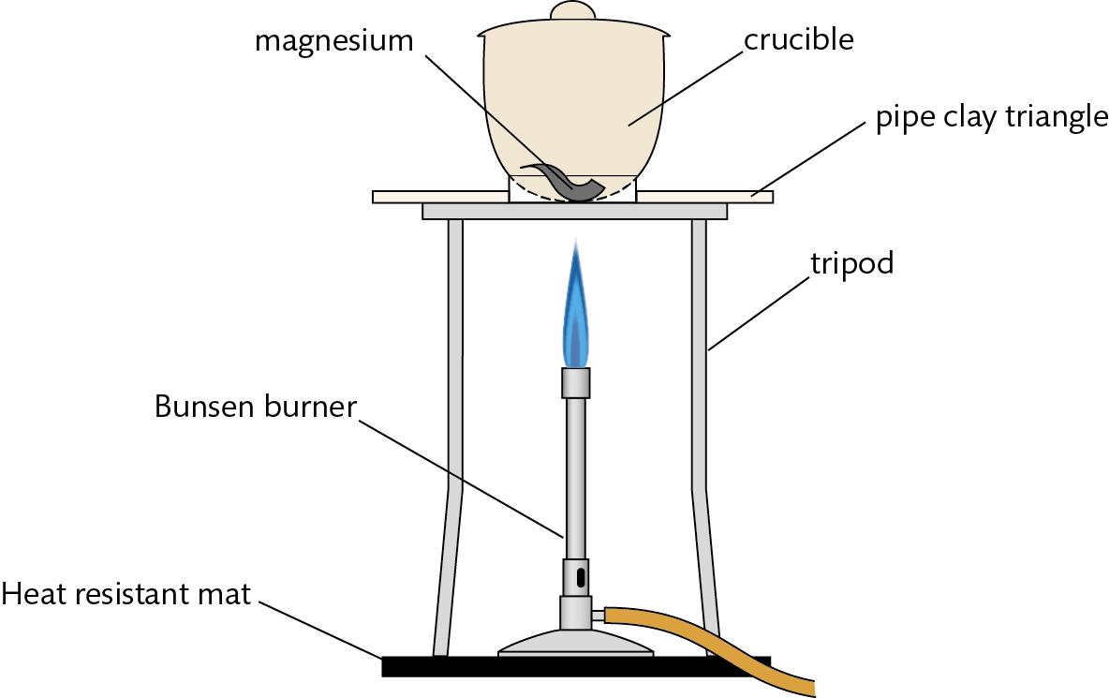
Results
Mass / g ± 0.001
Mass of crucible + lid
Mass of crucible + lid + Mg before heating
Mass of crucible + lid + product after heating

Qualitative data
 | Before heating | During heating | After heating
Appearance of crucible contents

Analysis
 | Magnesium, Mg | Oxygen, O
Mass /g ± 0.002
M / g mol^{–1}
moles / mol

Work out the simplest ratio of magnesium atoms to oxygen atoms and so the empirical formula of magnesium oxide.
Conclusion and evaluation
- The theoretical result for the formula of magnesium oxide is MgO.
- Compare your result for the empirical formula of magnesium oxide with the theoretical result, MgO. Calculate the % error.
- Calculate the % error arising from random errors in the experiment and compare this with the figure above.
- Itemize systematic errors and suggest modifications to the experiment to reduce these.
For consideration (Not assigned)
1 What can you deduce from the fact that magnesium metal is generally covered in an oxide layer?
2 How could you verify that ammonia gas, NH₃, is released during step 4 of the method?
3 What is meant by ‘heating to constant mass’? Explain how this could be applied to this experiment.
Equipment list
Chemicals / material
magnesium ribbon: approx. 6 cm per group (to allow for repeat trials)
fine sand paper
Apparatus (per group of students)
crucible + lid
tongs
pipe-clay triangle / gauze
stand / tripod
Bunsen burner
balance accurate to at least two decimal places

