**Specific Heat of a Metal Laboratory**

*HS-PS3-4 Plan and conduct an investigation to provide evidence that the transfer of thermal energy when two components of different temperature are combined within a closed system.*

**Target: What is the specific heat of a given metal?**

**Materials**

Balance Tap water

Calorimeter Metal sample

250-mL beaker Thermometer

100-mL graduated cylinders Hot plate

Safety goggles Lab apron

Tongs

**Procedure**

Calorimeter Apparatus

The calorimeter used in this experiment is made of two white foam polystyrene coffee cups. Foam polystyrene, as you know from experience, is an excellent insulator. Stack two Styrofoam cups, pierce the bottom of the top cup to insert a thermometer. The thermometer should touch the bottom of the inner cup. Make a tight-fitting hole for the thermometer. (See Figure 1.) The Calorimeter

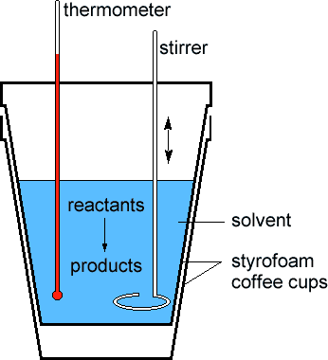

**Procedure**

1. Fill a 250 mL beaker with about 200 ml of water. Place it on your hot plate or heating

apparatus and begin heating the water to boiling.

2. Place exactly 100 ml of water in the calorimeter and measure the exact volume. Note

and record the temperature and volume in your Data Table.

3. Obtain a metal sample. Note and record the mass of the metal sample in your Data

Table. Place the metal sample in the boiling water bath for about 3 minutes. This is to

ensure that the temperature of the metal is 100°C, the temperature of boiling water.

Note: The metal sample is hot. Use beaker tongs to QUICKLY remove your metal sample from the boiling water.

4. Quickly and carefully transfer the metal sample at 100°C to the room temperature water in the calorimeter. Quickly place the lid containing the thermometer back on the

calorimeter.

5. Note and record the highest temperature reached by the contents of the calorimeter.

6. Repeat the experiment two more times, starting with fresh, cool water in the calorimeter and a dry sample metal.

**Data Table:**

|  |  |  |  |
| --- | --- | --- | --- |
|  | **Trial 1** | **Trial 2** | **Trial 3** |
| **Volume of Water in your calorimeter** |  |  |  |
| **Mass of Water in your calorimeter** |  |  |  |
| **Initial Temp of Water in your calorimeter** |  |  |  |
| **Final Temp of Water in your calorimeter** |  |  |  |
| **Temp of Water (Final Water - Initial Water)** |  |  |  |
| **Mass of Metal Sample** |  |  |  |
| **Initial Temp of Metal Sample** | **100 Celsius** | **100 Celsius** | **100 Celsius** |
| **Final Temp of Metal Sample** |  |  |  |
| **Temp of Metal (Final Metal - Initial Metal)** |  |  |  |

**Questions and Analysis**

1. Calculate the quantity of heat gained by the water, using q = (mwater )(T)(4.184 J/g °C). Report the results of all trials, as well as an average (mean) value. You need to show your work for all of the trials.

2. Assume that the quantity of heat lost by the metal is equal to the quantity of heat gained by the water. Use qmetal = (mmetal)(C) (T) : (solve for C) to determine the specific heat, C, of the metal. Be sure you use T for the metal in your calculation. Report the result for each trial, as well as a mean value. Show the calculations all trials. Determine the specific heat metal you have.

3. Consider the assumption you were asked to make in 2.

a. Explain why the assumption is not valid.

b. Does using the assumption in 2 give a value for the specific heat of the metal that is too high or too low? Explain.

4. Look up the value of the specific heat of your metal in the Handbook of Chemistry and Physics. Calculate your percent error, using the following equation (note the "absolutevalue" signs).

% error = (accepted value) - (experimental value) X100 = (accepted value)

5. Any calorimeter absorbs a certain amount of the heat released. Knowing this, is your value of the specific heat of the metal more likely to be higher or lower than the accepted value? Explain

**Conclusion / Analysis**

6) What is the purpose of this lab?

7) What physical properties, other than specific heat, could you use to help you identify the metal samples?

8) Why is water an excellent material to use in the calorimeter? In an insulated environment, HEAT LOST = HEAT GAINED.

9) What substance lost heat in this experiment?

10) What substance gained heat?

11) Metals have a lower specific heat than that of water. Was this true in what you observed?